THE BEST YEARS TO BE ALIVE IN THE HISTORY OF THE WORLD

Russell Rulon Bateman History

**Chapter 14 Amateur Radio and related History**

**The FCC, Federal Communications Commission, established amateur radio as a voluntary, non-commercial, radio communications service. It allows licensed radio operators to improve their communications and technical skills, while providing the nation with a pool of trained radio operators and technicians who can provide essential communications during emergencies.**

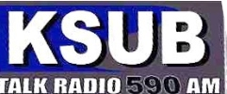My interest in Radio began in 1943, at the age of 13. It started with a Herschel Urie who was about the age of my beautiful Sister and had a crush on her. At a young age, he was the Engineer and Manager of Radio Station KSUB (Southern Utah Broadcasting). He encouraged me to hang around the Studio/Transmitter which was located near the South West corner of the BAC College (Branch Agriculture College) Campus which I could easily access riding my bike.

At that time, the transmitter was a small 80 Watt unit and only covered the Cedar City Area. The Transmitter went off the air due to a failed Capacitor. It was war time and parts were very difficult to find. Herschel asks me if I wanted to ride to St. George with him on a Saturday where he heard that there was a part available.

We arrived at a home in St. George that had a bunch of wires above the house. Herschel told me that the owner was an Amateur Radio Operator, but the equipment couldn’t be used on the air due to the War and the owner was somewhere serving in the military. After removing a “Capacitor” from the Amateur Radio Transmitter, we return to Cedar City. While driving back to St. George, Herschel told me about Amateur Radio.

*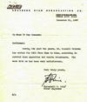KSUB Southern broadcasting Cedar City Utah*

*December 31, 1947*

*To whom it may Concern:*

*Gentlemen:*

*During the past two years, Mr. Russell Bateman has worked for KSUB from time to time accessing and controlling operations and remote broadcast. His work with us has been very satisfactory.*

*Yours very truly,*

*Hurschell G. Urie  
 Chief Engineer*

Over the next couple of years, we did a lot of fun things together. I was permitted to put the large (about 16”) records on the player and play them over the air. These records were like “Hymns of all churches” and “the lone ranger”. I would even go on the air noting the next program that was to be played. There was a regular radio in the studio that you would have to turn down the volume so that you wouldn’t get the squealing – feedback when you went on the air. After having that experience a few times, I learned how to do it.

A man by the name of “Woody” open up a Radio store called “Paramount Radio”. I don’t remember much about his back ground other than he was severely injured in the great earth Quake in the San Francisco. He had his chest crushed so had to leave large indent area of his chest. We got to be great friends and he let me hang around his radio shop.

I remember that we tried to do some drama radio programs that evolved Herschel, Woody and a couple of others including me. Herschel came up with some script for the radio program and we would act out our parts. I remember that there wasn’t enough in number to take all the parts, so Herschel would put marbles in his mouth so that he would sound like a different person. These programs would originate in Woody’s store and feed the KSUB Station via telephone lines.

At the Paramount Radio Store, I tore radios apart for the parts to be used for repairing radios in that new radio tubes and arts were very hard to get. I Tested radio tubes from the old radios etc and did some repair on radios. I was never paid for my participation of activities at KSUB or Paramount Radio but was rewarded with experience and a lot of good fellowshipping.

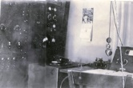Arriving back in St. George, I went to work at the two theatres in St. George for MacKay Larson. McKay and I did some code practices, but had a hard time getting together. I also made friends with a Neil Lundberg who had a radio shop in St. George. We worked a little on learning the International Morse Code so that we could get our Amateur Radio license when the FCC would again open up the Amateur Radio program at the end of the War. Some way, Neil lost interest in continue studying for the test and I started studying with MacKay.

KSUB Radio Station obtained a high power Transmitter and you could hear the station in St. George. KSUB was still the only station in Southern Utah. At the request of Herschel, I set up the equipment and we broadcasted the Dixie – BAC Football game from the old Dixie College football stadium in St. George. This was the first Radio Broadcast from St. George. The broadcast was put over the telephone lines to Radio Station KSUB in Cedar City.

Studying for the Amateur Test was set aside as I was too busy working and had no one interested in studying with me.

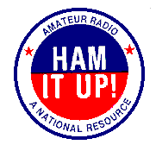

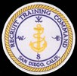After I finished Basic Training, I was sent to radio operator’s school. I went to the administration Office and told that that I had joined to go to Radio Material School. The Navy told me that once I completed the operator school, I could put in for the Electronics Technician School, but I had to have good grades from the Radio Operator’s school.

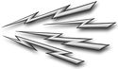Part way through operator’s school, I went to the San Diego FCC office and took my Class “B” Amateur Radio Test from the FCC Engineer and had no problem passing it. A couple of weeks later I received my Class B W7NFT license (Issued 16 March 1949). A class “C” license was the test taken by mail and was the lowest class license. At that time, you had to be a Class “B” licensee for a year before you took the Class “A” test. Each step up, gave you access to more frequencies.

October 1, 1948, I purchased my first Amateur Radio receiver. It was a Hallicrafter S-53 Receiver Serial AB85688 $82.21 Radio Supply Company in SLC1 Utah.

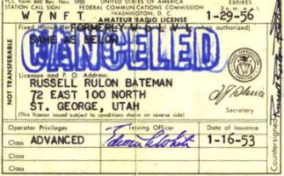I missed the last two weeks of school in that I had the measles. I still came out with a good grade and after graduation rushed to the Administration Office in to request E. T. School and told that I would have to wait until I got out in the Fleet assignment to request the School.

Shortly after, I was stationed at Adak Alaska and immediately requested the E. T. School. I was then told that once you have attended a Class “A” radio operators school, you can’t go to a Class ”A” E.T. school. The Navy had been lying to me all along.

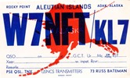I was stationed at the Navy Transmitter Station and our assignment was to operate the many transmitters, changing frequencies and retuning as requested by the Hart Lake Receive Station. I found an old surplus AM transmitter with four 807 tubes in parallel and an old receiver and got on the air as W7NFT/KL7.

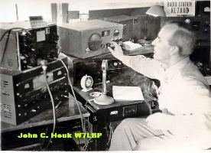I took the Class “A” Amateur Radio Test from a Naval Testing officer and passed. I put in for a change in my license (as was required at that time) and at the same time and another Amateur Radio Licensee. He received KL7ZB and mine came back KL7AAD, third KL7 three letter call. In those days, a “two letter” call had a lot of prestige, and I had missed it by three assignments.

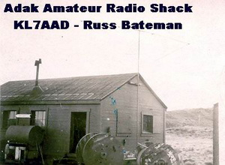In talking with my friend Jim Holland W6UD and several other “Ham” I suggested that we set up a “Base Amateur/MARS Radio Station” and found a lot of interest. We found an unused small office building, but it had no power. One of the licensed operators was a Contactor John Houk W7LBP that was on Adak doing some construction work. He said that if we got permission to use the building, he could find the underground power cable.

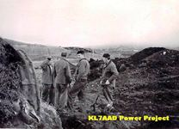I put in the request for the building and it was approved and I was made the “Station Trustee.”

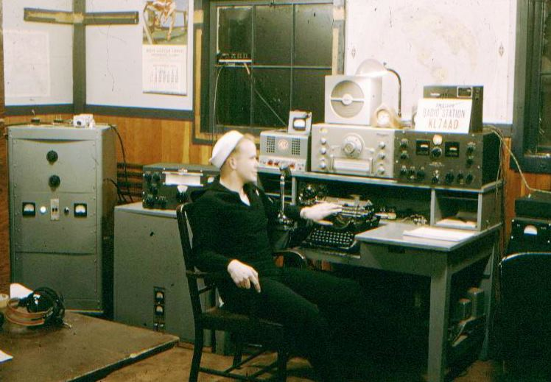I was only a “three striper” lowest rating of any of the new members of the Adak Amateur Radio Club. We had a lot of work to do to get the station operational. With several other licensed Amateur Radio Operators, we got to work putting in the underground power cables and putting up the antennas.

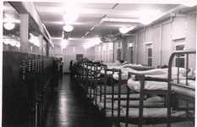I would like to say that I was the Station Master because of my years of experience, but I had less experience than any of the other members. John Houk took me under his wing and trained me. As a contractor, he could still operate the station, but it had to be a Navy person in charge. I lived there, any time that I was not on duty, the building had a small room that with a small bed where I slept. I didn’t like the large 50 bed Navy barracks.

In those days, you had to log everything in your station log. You had to make an entry when you contacted someone and when you finished your contact. The called used had to be KL7AAD, but other operators could sign into the log with their call signs.

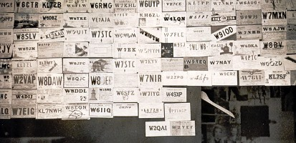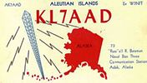We set up schedules and took shifts in permitting some of the base personnel to talk to their families back in the lower States. At that time, there was no telephone or other means for base personnel to make contact with their families other than mail.

We had acquired a surplus Hallicrafter BC610 Transmitter and later build a RF amplifier using a 610 Transmitting tube. Being Chrystal Controlled was a problem so we tried to build a “VFO” variable Frequency Oscillator which gave a lot of problems with drifting. I ordered a Collins 310B exciter really made a nice station. At that time, there were very few Alaska “KL7” stations on the Air. Many Amateurs were looking for KL7 stations to complete their “Work all states certificate”. When you would put out a CQ (invitation to transmit-contact). A large number of stations would reply wanting you to confirm the contact with a “QSL Card.” These stations were not only the United States, but many other countries such as England and Germany. The next step was to exchange QSL card confirming that you had made the contact. We covered our wall with the QSL card from people all over the world that we talked too, you were considered to be a successful “Ham” once you acquired a shoe box full of QSL Cards. (I had two shoe boxes full with cards from all over the world, which were later destroyed by our pet Hamsters.)

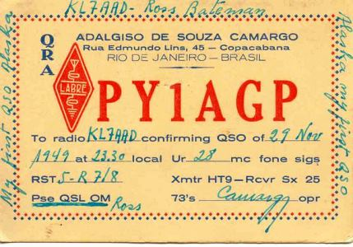Several times, I would hear my call sign (KL7AAD) being fraudulently used by ships out in the bay where licensed and non-licensed radio operators would boot leg using my call as they were not legally permitted transmit on Amateur Frequencies on ship board.

The last six months of my 2 year duty assignment on Adak, I was stationed at a Navy Intelligence station on the other side of Adak called “Radio City”. My assignment was not part 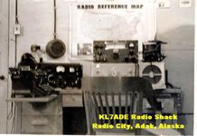of the Intelligence activity, but a supporting position as outlined in my Military Adak Chapter. (see the Aleutians chapter)

The Authorize Amateur call was KL7ADE belong to Vern Sitze. Vern Original call was W9HLY and as required back then, modified his call to KL7ADE. He and Gary Stein KL7ZD made a room (Ham Shack) in the back of the Radio City Carpenter Shop. Thy both had left by time I got there and the call posted was KL7ADE. When we set up the Adak I think that I only met him a couple of time during my assignment there, but had use of the station any time I wanted. I was using the call KL7ADE at the Radio City location and other licensed Amateur was using KL7AAD back at the MARS building. Today standards anyone could use their own call sign,.

The Radio City Theatre was closed as there was no one who knew how to be the projectionist and letting them know that I was a projectionist, was a real moral builder. The theatre now could have movies that I ran several times a week. There were still plenty of free time to be on the amateur frequencies and talking to people all over the world. One time I was chatting with a VE0 (Victor Echo Zero-Canadian Call sign) I noted that I had never communicated with a victor Echo zero station before and he changed his call to UA0**( Uniform Alfa zero), which was Russian. We were not permitted at that time to contact Russian Stations, especially at an Intelligence Station. I never changed from using the VE0** call station, noting I had to leave due to the “QRM” (interference).

At the end of my six months I returned to the Adak NOB for assignment. Visiting my old Base Amateur Station, they were still using my KL7AAD, but my things had all be moved out, which was a concern to me as I had lost my position being in charge of the MARS (military affiliate Radio Station) operation due to my absents. In the past, I had put a bed in the little back room and slept down there most of the time as I didn’t like the new 50 bed rooms.

So I was “treading water” waiting for my new assignment for a couple of days when I told to report to my new Division Officer who I had not met previously. I felt that he would give me my assignment where I was to report to. Tour of Duty on Adak in the past was one year, but due to the Korean War, all personnel were” Frozen and no transfers permitted”. I have been there two years. I went to the office of my new Division Officer, and as I entered, he ask “HOW DID YOU DO THAT?”, in a very nice tone of Voice. I was puzzled. I answered “Do what Sir? He told me of how many times he had applied to join the Navy Intelligence Group. He said that he had received priority orders transferring me to the Naval Security Group in Washington D.C.

I noted that I needed my Collins 310B exciter as I was transferring. The base said that it was necessary to continue the Base MARS program and they reimbursed me for the equipment.

Arriving at Washington D. C., I was sent to the SESP (Special Electronic Search Project Training center) at Cheltenham, MD (See chapter 08).

While I was at Cheltenham, I modified my Amateur Radio Call from KL7ADD (Alaska) to W3RIO (Washington D. C. area). Back then, when you moved into a different call area, you had to change your Amateur radio call sign, My training was interrupted when I was about half way through, telling me that I was the only one with enough training to be assigned to the emergency requirement. I was assigned to the Navy Department, London England to be assigned to special teams that would be stationed on ship visiting ports in the European and Mediterranean areas. (See Chapter 08).

While I was in London, I looked up several “Amateur Radio Operators” and visited their stations. Their calls started with “G” (for Great Britain). I noted that their Radios were US made military surplus Radios WWII type. It was particular interesting that their equipment knobs were rotated 180 degrees so that you turned the switch down to turn the unit on where before they follow the US standard of pushing the switch up. Reference the light switches in an American home.

Where I visited, you sat there with your coat on freezing as you operated your radio station. Why? It was still only five or six years after the WWII means to heat a home was still not available. A lot of things were still in the War time conditions, food ration was still in place.

I went to the British office of telecommunications (now called British Telecom) to see if I could get a “G” call and License as I knew that some countries would give a visiting Amateur Radio Operator a temporary License. They very nicely said no, that at that time it was not permitted, but they did talk me into joining the “RSGB” (Radio Society of Great Britain-19 June 1951) which is similar to our ARRL (Amateur Radio Relay League).

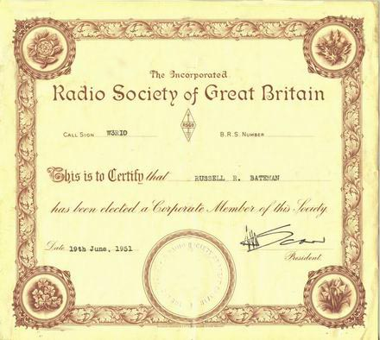

Even if I had been able to get a temporary permit, I really had no opportunity to use it. So for about the next year as I traveled around Europe, if I couldn’t find the LDS Church Contact, I would look up Amateur Radio operators in my international call book.

In Tromso Norway, I found two listings in the call book. Asking one of the city official’s information in contacting one of the names I found. She put me in a Taxi that drove me way out in the mountains. The taxi stopped at a large building with a lot of Antennas and dropped me off. I went up to the door and pushed the button. A man came to the door but spoke no English. We spent an hour, looking around the facility. I could tell that it was a “Radio Free Europe” radio station beamed into Russia from the directional antennas. This gentleman was a 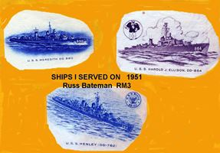typical Radio Engineer that really felt uneasy trying to entertain an American Sailor in uniform.

The other Amateur radio operator that I visited in Tromso, Norway, spoke very good English. He was a Maritime Ship Radio Officer that was on a six month vacation from his normal assignment on ships out of New York City.

Another incident was in Palermo Sicily where I took a Horse pulled taxi. Arriving at the address listed in the Ham Call Sign book, I knocked on the door. He asks me if I spoke Italian. I said no. Do you speak French? I said no. Do you speak German? I said no. Then he said, “I don’t speak English so very well, but I will try. His call letters of his radio station was IT1BXX.

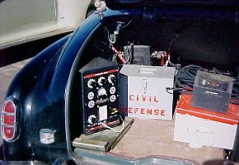I called “ CQ from IT1BXX” and someone came back to me saying that I had very good English.

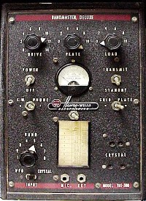Up on return to the US and after I picked up my new 1951 Desoto in Detroit , I headed west for my new duty station at Imperial Beach Naval Radio Station. I stopped at Council Bluff, Iowa at the World (Amateur) Radio Store and purchase a Harvey Well TBS-50, and An HF Radio converter for my Car Radio and other material to install my Amateur Radio in my car. Install the radio equipment at home as I passed through

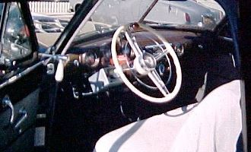

St. George on my way to California.

The Antenna was 80 through 10 meters, a great big honking Antenna with a large coil in the middle. There was very little traffic on the highway in those days. When I came up the agricultural inspection station, entering California, I could see that the height of the ceiling of where you drove through was not much higher than the top of a car, so I drove to the end where the truck passed through. It was night time and only one inspector was on duty. He screamed at me to get my car back and drive through the regular port. I tried to tell him about my antenna and he told me to “Shut up and do what he told me to do.” So I backed up and drove through the port 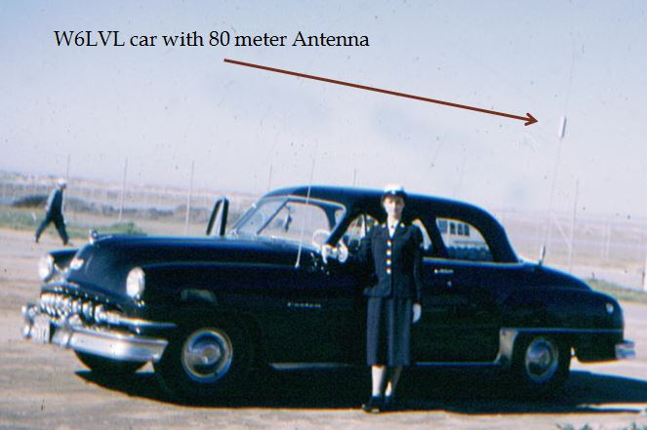where he told me to drive. I will be honest; I was hoping that my antenna would have knocked out one of his florescent light. It sure made a racket and I was afraid that I would damage my antenna. On that trip, I came up on an accident where people were badly injured; a Volkswagen Bug was cut into and people lying on the ground. I contact an Amateur Radio Operator somewhere near the coast and gave him the location and details. He past the information to the Police and they sent an urgent teletype to the proper agency to respond.

Very few cars had radios, the Amateur Radio cars about the only mobile radios. Some police had radios in their cars and many still used the frequencies that were just above the AM Broadcast Band. A cell phone was not even dreamed of. The next few years, I reported many, 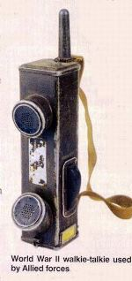many accidents. Again, a two-way radio in a care was very unusual in 1953. We would drive my car up to a “drive in” (in those days the waitress would come out to your car to take an order). We would then roll down the windows and walk to about 20 feet behind the car. The Army made the BC611 hand held radio during WWII and these radios could be retuned to 80 meters) When the waitress cane out to the car to take our order, she would see no one there, we would start talking to her over the car radio. They would really freak out! Usually, they would also call other waitress over.

When the FBI interrogated me in 1952 ( see Chapter 7) they kept asking about the radio in my car. The FBI agent was not acquainted with Amateur Radio.

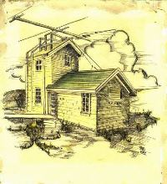 (I remember in 1947 I was riding with my friend Bud Bowman in his new 1947 Studebaker- Lancaster. He was driving fast going up highway 91 between St. George and Cedar City. Utah Highway patrol, Blonde Porter took out after us in his new 1946 Ford. He could do nothing but let us go and UHP cars had no radios back then. Bud latter became a Highway Patrolman).

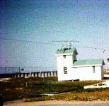In the San Diego area, there were not many Amateur Radio cars with Radios. At that time, 80 meters was the most popular band to use and we had about a dozen or so, on our radio net. My main call was W6LVL and my Station on base was W6KXN

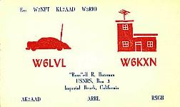At the Imperial Beach Naval radio station where I was stationed, there was an old Direction finding building on the beach that I was able to get permission to use for the base Amateur Radio Station. However, I got a lot of area people mad at me for all the TV interference after I put up my Large Beam Antenna, but didn’t have any equipment even on the air yet.

This was the early days of TV; there were no TV Stations in the San Diego area. There was an unusual condition that brought Las Angles TV to the San Diego area. I purchased my first TV Set. It was made by Pilot and a 3” screen on it. However, the signal strength was very lot and cause Amateur Radio a lot of problems. But I hadn’t built my Transmitter yet.

I built it in a large equipment rack and was not encased. I think that it ran about 600 Watts AM (amplitude modulation) and I used it on 80, 40 and 20 meter bands.

I had the station all to myself and there weren’t any other licensed Hams on the Base, at the U. S. Naval Radio Station, Imperial Beach, California. It had an upper room were the Direction Finding Antenna one was, that you had to climb a ladder to get into it. Again, I had a bed and did a lot of my sleeping there as I didn’t like sleeping in the barracks where we had four men dorms.

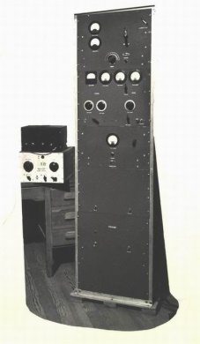While I was in Training in Cyrillic code training, I decided to go the San Diego FCC Office. These tests had to be taken before the FCC Field Engineer. I tried for some more licenses. I took my third class Radio Telephone license and it was an easy exam. I took the Commercial Radio Telegraph second class test and flunked the code part. That was because I started writing the code down in Cyrillic as I was doing in school, and that to be highly classified, so I was trying to erase what I was writing. The Engineer had me go walk around the block and come back and try it again. The next time I made it. I also took the second class Radio Telephone. The FCC Engineer laid a very large sheet of paper on a table and said, draw me an FM Transmitter with all the parts. That part took me about 45 minutes to accomplish. There were also a lot of multiple choice questions. I felt like I was on a winning street, so I took the first class radio telephone test and didn’t make it. Several years later, I took the test a couple of time and finial past it.

As I got more active the E-men and Gleaner activity, I didn’t seem have much time for the Amateur Radio. The when I was elected at President of the E-men- Gleaner San Diego Area, I did little Amateur Radio work. I was also going to San Diego Junior college as well as working my navy assignments. In addition to that, I had met and dated a beautiful Redhead and had to commute 500 miles for dates.

At the end of my extended enlistment, I took two months leave that I had on the books and married that beautiful girl (WA7QME) Also, during the two months, I was able to get a good job at Convair.

I went back for a couple of days to get my discharge from the Navy. I had taken my tools from the Ham Sack with my, but tried to go back and get my personal things. I had several pieces of equipment, including my TV and foldup bed. My old receiver and AM Transmitter was still there. While I was gone, another ham changed the locks and I wasn’t able to contact him or have him call me back. Getting married, my job and school were more important to me that my old AM transmitter and some other stuff I left in the building.

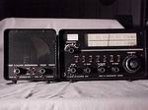For the next several years I was too busy time attending school, buying a couple of different homes and buying Delmar Mesa ranch. Raising a family seemed not more important set that time were about trying get equipment again and get active on ham radio.

San Diego didn’t have any local TV Stations at time, but there was condition where if you had a good antenna, you could get LA TV. The problem, with the TV weak signals in San Diego, the Amateur Radio Stations caused a lot of interference to neighboring TV sets. I solved the problem by putting up a TV antenna on top of tall poll and guying it with my 80 meter 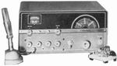dipole. And of course, I didn’t advertise that I was an Amateur Radio Operator.

I had just made Design Engineer and transferred from the Sycamore Static Test Sight. My new 2nd level Supervisor was Russ Casuitt and an Amateur Radio Licensee. He stressed the conversion to SSB, but the HT-37 could work with Am also, so that is the way it went. However, in just a short time I went from using AM to SSB only in just a few weeks.

I purchased a Hallicrafter HT-37 Transmitter, Drake 2A Receiver and a Drake 2A power supply and Speaker from Henry Radio for $717.43 ($150 down and $47.20/month). Single Side Band was becoming the new technology for Amateur Radio, but I liked the old AM. We called SSB “Solber Mouth” because how it sounded on my older Receivers. I was a dedicated “AM-er” but one I had a god receiver, I changed to using SSB z9Single Side Band).

My wife Gaye received her Amateur Radio License WA7QME, My oldest Son, Russ Jr. received his license WA7MLM, and youngest Son Randy received his license AC7DN.

I was called to be the advisor to a group of young LDS boys; I think that they were in the Teachers Quorum. They seeking something, but were not attending their meetings regularly. I decided to try Amateur Radio and it really clicked and they all got their Amateur Radio Licenses. Two went on to obtain Commercial Radio Licenses. They spent many hours helping me build the “State of Utah Emergency communications Center “which was located in the basement of the Utah National Guard Headquarters building.

I made a request for funds to build a basic Emergency communications center. The request went to the counsel of Defense for funding of this project. The funding problem was not the Council members, but our Department Director, General Thorstensen. The legislature had allocated a fund to be used for developing the department of Civil Defense (also called Department of Emergency Service)I think that the fund was about $160,000 . The director, General Thorstenson was extremely cautious spending any money out of this account. I don’t remember just how much he approved they gave us something to work with, I think around $2500.

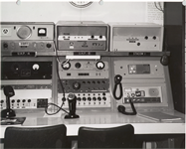

We requested equipment and radios from various state agencies.. We received mostly radios that were changed out and replaced with newer models. We did purchase a new Citizen Band Radio and an HF Stoner SSB Crystal control 100 W unit. As an active member in the MARS program, I was able to obtain cabinets and other material for the center. We were able to obtain a few things from the Utah State Surplus. We were able to obtain a lot of coaxial cable the Hill Field MARS program.

The Aaronic priesthood boys found a real interest in the program and felt it was an exciting project. There was very little expense to the State of Utah. We worked on the project after school and I spent after working hours working on the project.

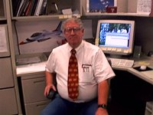

We were able to get cabinets, wire, other surplus material that help us with our project. Bill aff5ut Utah State mars director

For many years, Amateur radio utilized AM (Amplitude Modulation) on most amateur Radio Bands. I experienced problems in exception SSB (Single Side Band) and it took a little time to realize the advantaged of SSB. A lot of this was due to the Receiver that were commonly used in the Amateur Radio Service. SSB was called “SloberMouth” as the way it sounded over the air on our older radios. In about the late 1950, we were making good money and felt that we could afford to purchase a commercial built Radio and Transmitter.

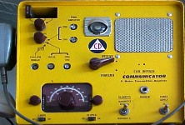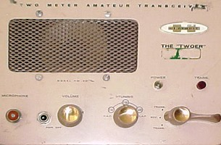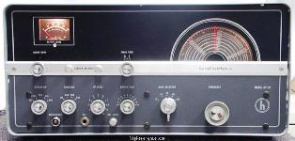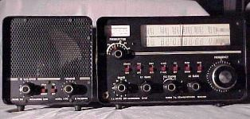In my research as what to buy, I talked with my Convair Bosses Boss. He encouraged me to purchase SSB type equipment. He recommended the Drake 2B receiver and the Hallacrafters HT-37 Transmitter. I was disappointed as I didn’t to join the “Slobermouth generation” In reading the specification’s on the equipment; I found that they could also be set for AM. With the new equipment I started operating the HF ( High Frequencies 80 to 10 meters.) using the AM capabilities of the new equipment, but it didn’t take long for me see the value of the new SSB and is a short time I was using 100% SSB except for communicating with several of my old friends who refused to convert.

The new thing when we moved back to Utah, was the new VHS ( Very High Frequencies) in the AM two meter bands. To begin with, it was built your own. Heath kit made an inexpensive kit available with all the parts and directions to build the “2er” transceiver and it was popular to call it the “Lunch Box”. Then were crystal controlled on the transmitter and variable tuned on the receiver section.

For those who had the money and didn’t want to build, the Gonset Communication was very popular. You could install four crystals , selectable with a switch. These were available in the 6 meter band (50 MHz) and the 2 meter (145 MHz band). I owed a “2ER) and later a Conset 2 meter when they were obsolete and a couple were given to me.

**First Amateur Radio FM transmissions in the State of Utah.**

About this same time, Amateur radio 2 meter FM was being authorized. The new FCC Amateur Repeater Regulations were adopted by the FCC. The first 2 meter FM was between Jerry Warner (Weber Communications) and Pat Buller. Jerry was in Ogden and Pat was in Providence, Utah.

In the early 1960, The first known FM Transmissions *were between* Jerry Werner W7?'.7.2 *(Weber* Communications) and Pat Buller W7RQT Provendence (Logan) Utah. Equipment they used *were* a combination Motorola *and* Home built. First Amateurs on FM in Utah *were:*

Jerry Werner W7GPN??? Ogden



Pat Buller W7RQT Providence/Salt Lake City

Mike

*Gorden* Smith W7HSW? Salt Lake City

Craig Jenson K7AWY Salt Lake City

Mike Mladejosky i WA7ARK

At the encouragement of several members of a group which later became the Utah VHF Society, I obtain a military repeater from Federal Surplus,

There were only two repeater pairs used throughout the United States and were called “The repeater Standard. The two Standard Amateur Repeater pairs were 146.34 / 146.94 and 146.16 / 146.76. The standard repeater pairs were published by the Amateur Radio Relay League and in many other Amateur Radio publications. The 600 KC spacing had been criticized by many people over that past many years. They don’t realize that the technology at that time was radio only 1 MHz capability. This was true in 1970 when the top of the line was the Motorola Motrack.

One of the members was Craig Jensen K7AWY, Radio Engineer for, Mountain Fuel Supply who suggested that I put in a request on my official State Stationary and requests the donation of a Motorola repeater that Mountain Fuel was phasing out.  They had tried to get the unit, but the company wouldn't release it to them.  It worked, and we were issued the repeater, including the duplexer.   Then, we had the big problem of licensing an Amateur Radio Repeater.  The work was done by Pat Buller, W7RQT, a registered Professional Engineer working for Utah Power and light, said that it was harder than his licensing a commercial repeater.  The submission was about 27 pages and was approved by the FCC at the first try.

The licensing was done mostly by Pat Buller, W7RQT, registered Consultant Electronic Engineer at Utah Power and Light, and Mike Mladejossky WA7ARK a PHD at the University of Utah. I was asked to be the trustee by the group as I had done a lot of the organizing. I could have never accomplished writing the 18 page license submission.

Craig Jensen K7AWY, was able to obtain an old Motorola tube type base station that we rebuilt in to our first repeater. This was then the first successful 2 meter repeater in Utah. After our WA7KZO license was issued, they added an “R” as the 2nd letter in the call sign. Licensing was an 18 page submission of all kinds’ graphs and charts. The licensing at that was the same requirements as in a commercial and required a license for a minim of two control stations on some other frequency. I was licensed as the Trustee

Two sets of frequency were established. The two sets of frequencies were 146.16/146.76 and 146.o4/146,640. .

Jerry Warner (Weber com-Ogden) had crystals for one of the National Stand pair (04/64) The FRC has solder in tubes and fail during the check out.

Utah Valley Relay club for all amateurs in Utah and announced that any one desiring to use a repeater would have to join their Club and pay a monthly fee for the use of the repeater. I can’t remember, but I think that the fee was initial $20 and $10 a month. They were using a combination of the two standard repeaters so that one repeater could be used in the area. Their club would then issue a black box with a button that activated the repeater.

The Utah VHF Society was very upset for two reasons. 1, their attempt to charge for use of the repeater and 2, their blocking any other computer to operate in the area as the Free VHF society was be constructed at by Jerry Warner.

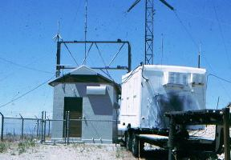

! wrote Bob Bricky a letter asking him to reconsider their frequency so that we wouldn’t have interference between the two repeaters. I told him the status of where we were and where the repeater was going to be located.

We moved ahead with the newly acquired Motorola repeater at Pat Bullers home. He noted that he had an interfering signal that he couldn’t identify. They moved the repeater to another location and the blocking signal disappeared.

I had acquired a equipment trailer body and with the help of the National Guard, we mounted it on a trailer that I had also acquired from surplus. The unit was moved to Ensign Peak at a State of Utah after receiving an approval letter from Salt Lake City. The repeater and antenna was installed and the repeater was on the air.

I had to attend something out of state and was gone a few days. As soon as I got home, I had a telephone call telling me that someone cut the paddle lock off the repeater building and shorted out all the transformers. The instruction manual and notes for the repeater was also missing. They said that they formed a working party and replaced the transformers in just a few hours and had the repeater back on the air.

I wrote a report to Salt Lake City Police about the incident. Sergeant Patrick of the Salt Lake Police contacted me and went over the report. He told me to relay on to the group that should anything like that happen again, to contact him elegantly and not to destroy any possible evidence.

The repeater was back on the air and working great and in only a short time, a large number of members obtain FM radios and had crystals on the repeater frequency. After the repeater was back on the air for a couple of weeks, the interfering signal came back. Several of the group try to trouble shoot the problem by moving the antenna to different places. I received a call from one of the members noting that they had found something that I needed to look at, at the repeater site.

Gordon Smith upset the Utah valley radio club when he duplicated a devise that would Sending out the same tones as the $50 black box accessing the Utah Valley repeater. Gordon Smith was an Engineering Student of the University of Utah and it was a challenge for him.

I called Sgt Patrick and he said me to meet him on a Police frequency that we both had in our cars. We used the radio for me to tell him how to find the site. That was a big mistake as by time we got up to the gate, there was about 20 newspaper reporters there. We spent about 20 minutes with some heated discussions between Sgt Patrick and the reports. The reports agreed not to release anything until Sgt Patrick approved it. So we all drove up the hill to the repeater site where were several of the group waiting for us. They showed us a small wire coming out of the ground attach to one of the legs of the Radio Tower. They told Sgt Patrick that they didn’t want to dig down to see what was there until he could wittiness it.

By then there a large crowd there watches us dig up the two water tight containers. One contained a electronic device that would take the output of the repeater and feed it back into the input causing the repeater to transmit a squeal to all the mobile units. The devise had a sito random timer that would turn the device on and off.

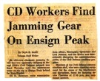It didn’t take long for the reporters to break their word about not releasing the news.

C**D WORKERS FIND JAMMING GEAR ON ENSIGN PEAK**

By Doyle E. Smith-Tribune Staff Writer.

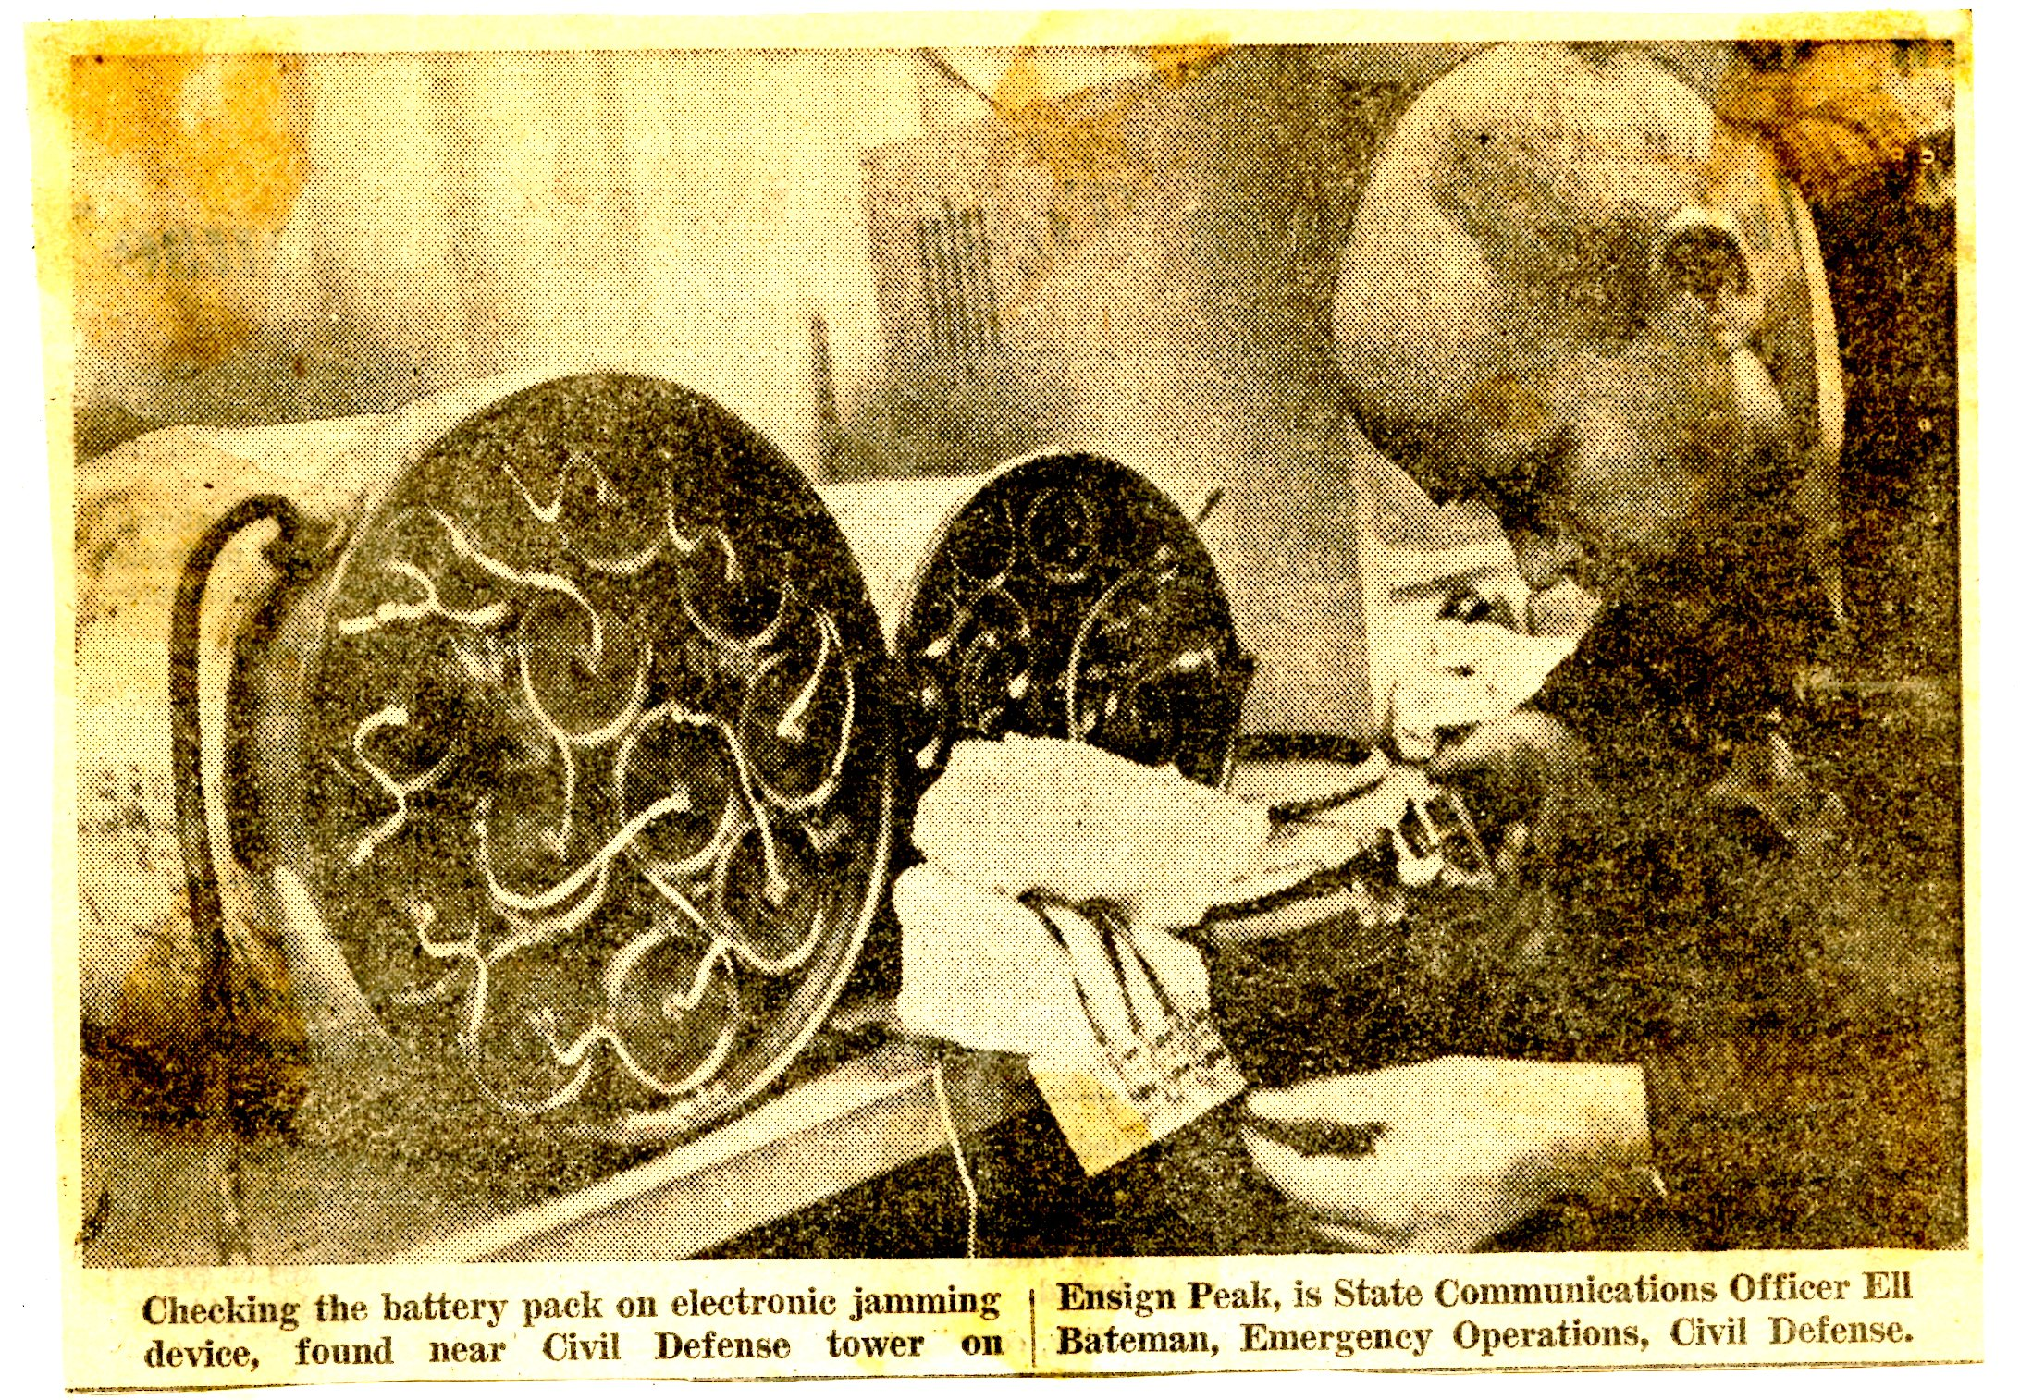

*An elaborate electronic jamming device that was apparently designed to disrupt Utah civil defense network was found Thursday near the microwave tower on top of engine peak behind the state capital.*

*Ell R Bateman state communication officer, emergency operations in civil defense, said the device was intermittently disrupting the communications ability of the civil defense auxiliary program.*

*Members of the civil defense communication staff, who were checking equipment for the cause of the interference and disruptions, found a jamming device Thursday at 12:45 PM and Summit Lawman*

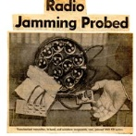*There was no more locking up the VHF Society repeater, but shortly after that there was a grinding sound that would periodically turn on, The next cd exercise, Sgt Patrick SLPD and Tom Uland a member of our a*mateur Radio and a Certified Highway Patrol officer waited at Brickey’s work place in an unmarked City Police car. Not long after he left work the grinding sound started and sgt Patrick pulled him over. Tom Uland keyed Rickey’s mobile radio and the grinding sound was transmitted. Also the Manual and notes that were taken from the repeater building were found in his trunk.

The next repeater was license by Bob Williams, W7MUG. The call sign was WR7AAA (first Amateur Repeater Licensed under the new repeater Call Sign program. Utah was ahead of the Amateur Radio technology in setting up Amateur Repeaters.

**My Amateur Radio Call signs that I have been issued by the FCC:**

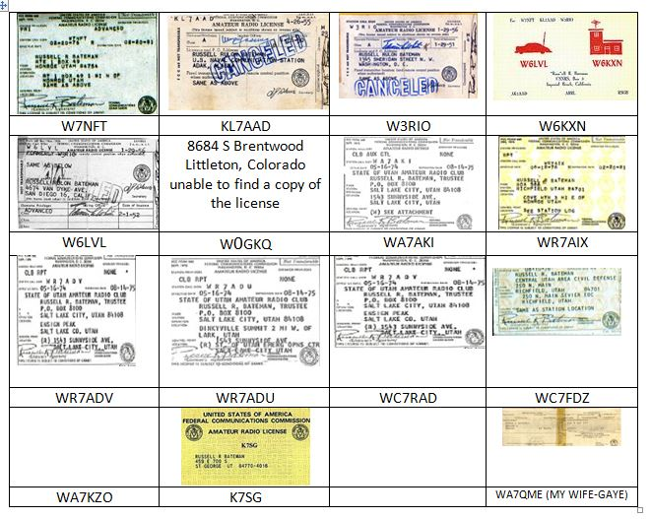

**My Military Amateur Radio Service Call Signs**

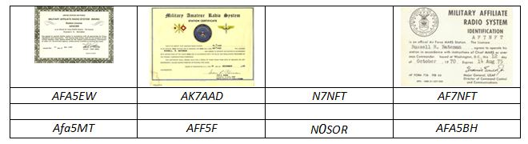

Licensing later became a lot more simplified to where you did not need to have a special license for a Repeater. I have had two or three repeaters in operation from the first successful repeater until 2009 when I had to give up being a trustee due to age. I was made an honorary Life time member of the Dixie Amateur Radio Club.

While living in Rose Park, I rejoined the Utah Civil Air Patrol as an effort to get a good activity for my two sons. The Civil Air Patrol was trying to establish a State Wide Radio Network and obtain several surplus Navy TBK-12 Transmitters similar to some that I used in Adak. These units were large a bulky. They had 110 Volt DC motors to power up the Transmitter causing the program not to be successful due to the DC requirement and the cost of the $400 diode to convert the available 115 AC to DC. We only got a couple of the units working. We heard of some Hallicrafter Military BC610 surplus units (similar to the one that we used in the Ham Station at Adak Alaska) available at the Yermo Logistic Marine Base near Barstow California. Mac Perterson and I drove to the Base to make a request for about a dozen of these surplus units. We made the request, and heard that our request was accepted, but I don’t know of any of the units being received. I wasn’t excited in that they were Amplitude Modulation only.

Heath Kit produced their HW-18 SSB Transceiver especially for CAP 4 MHz SSB usage (4450-4650 kHz). This put an end to the trying to fix up old surplus transmitter. The problem was that they were Kits and had to be put together. The Amateur Radio Community joined in to help put the HW-18 units together. Most of the CAP Radio people were also Amateur Radio also.

One time in the late 1960’s the Utah Nation Guard asks for participation of the CAP in one of their State wide exercised. The CAP seniors and Cadets installed antenna at a number of the National Guard Armories around the State and manned the stations with 12 to 15 year old CAP cadets. The National Guard communications failed and the CAP cadets did an outstanding performance. It was Very embarrassing to the National Guard.

The Civil Air Patrol was authorized several VHF frequencies., The Colorado wing set up experimental repeater on transmitting on 148.15 Mhz and receiving on 143.9 Mhz, but was unable to get CAP national to authorize the repeater operation. The members of the National Civil Air Patrol Radio Committee were from the Eastern States. I made a trip to the National CAP Conference help in Washington D. C. My discussion with the board was that they felt a repeater was not needed and would cause too much interference. I explained the type terrain that we had in the western states and requested special permission to license a CAP repeater in Utah. It still required a lot of personal contacts, but finally, we received permission to license the first CAP Repeater in the United States. There are now thousands of CAP repeaters now in the United States. Air Force General Richard N Ellis awarded me an “THE EXCEPTIONAL Service ward” and “THE MERITORIOUS SERVICE AWARD” for the development of the Civil Air Patrol Repeater project,

The National Robert Johnson field inspectors really liked what I had done and gave a lot of support. The funds were used in the Six County area, placing new radios base stations in all the Sheriff Offices, pagers for the EMT and a Single number emergency telephone number for emergencies ( similar to 911). At lease on of the RWJ inspectors was an Amateur Radio Licensee and was really a good supporter. I was able to get several Motorola Micor repeaters for several key amateur locations and a Civil Patrol repeater for the Salt Lake Area with these private funds.

Some way, Box Elder County picked up surplus new 10 Fiberglass Station Master 20 ft Antennas that was designed to include the 148 MHz Amateur Rand. They didn’t know what to do with them and offered them to me in a letter. I distributed them around the state for the Key Amateur Radio repeaters and a couple of CAP Repeaters.

Around 1983 before moving to St. George, I provided and installed an RCA ML1000 RCA repeater on the Red hill called the 94 repeater. This was the first 2 meter repeater in St. George and I was the owner and trustee unti2009 when I donated the repeater to the Dixie Amateur Radio Club. I also had a 146.45 and a 147.28 repeater.

I was involved in developing the number of mountaintop radio sides. Some of the sites I develop by myself and others I participated with groups. One of the sites that I contributed a large amount of parts and labor was blowhard which is located near Cedar breaks. To become a member owner each person at that time was required to donate or contribute value of equivalent to $600. At this site I installed I think six towers and about 30 foot of cable ducting. The towers and cable that were installed by the unit of the Utah air National Guard as part of their summer one-week training.

Some of the other Amateur Radio repeater mountain top sites that I participated in were the Blackrock, Frisco Peak repeater site Red hill, scrub peak Segmiller, Snowbird and Utah Hill.

Devere Swensen an Engineer hired by Robert Wood Johnson and I put in a number of non-Amateur Radio repeater’s in a number of sites around the State of Utah. I was installing a Emergency Medical repeater above Bear Lake when I broke an Axial on my F150 Ford Pickup. I gave a call on the SAR Frequency (155.160 MHz) and a Farmer answered, came up and load me his pickup to go into Montpelier, Idaho. After purchasing a new Axial, he went up with me and helped me replace the Axial.

After leaving the State of Utah, I made application for employment with Bonneville International-KSL. With my history in Amateur Radio, holding a Radio Telephone First Class FCC certification help for my selection, but I have to give the Lord’s blessing the main credit.

I used the Amateur repeater above Manti (one of the repeaters receiving the surplus new Base Master antennas) to talk to Gaye in Monroe. I set up Touchtone decoding, but had some complaints from several not liking to hear the touch tones.

One of the Salt Lake City repeaters was located in the building at Farnsworth peak, but I didn’t have much to do with it other than make some equipment check when requested by one of the owners.

Moving to St. George and commuting to Farnsworth Peak (West of Salt Lake City) it was rumored that they were making a personnel reduction in our department. In that I was last hired, I felt that I would be the first to be fired.

We started Dixie Communications and Dixie Paging. My work schedule was 8 days on and 13 days off. We set up a store front selling AT&T Telephones and doing Two-way radio sales and service. A friend that I served in the High Council with in Monroe, went in to business with us, his part was appliance repair.

I purchased a Mobile telephone VHF system (frequencies just above the 2 Amateur Radio Band)I set it up in one of my shed which I located it up on the Black Hill, just above the “D”.

I think that this system could handle about ten customers. Business was booming so we purchased a second system. Then the lunch box telephone system came out and took most of the business away from us in just a short time and customers dropped to just two customers, one was the Washington County Sheriff as they could use their Public Safety radio to access the system, and other customer was the Care taker at the Arizona Cedar Pockets RV park as it was the only system they could access.

We turned the mobile telephone business over to our Nephew I put my attention into the Mobile Radio Business selling to the Mesquite Police and Fire Department and several other business accounts. I could not try for the local St. George area accounts due to my job in Salt Lake and I could provide the 24 hour service required.

We moved in to paging and were the largest paging business in Southern Utah with the main base paging station at my sight South East of St. George. With the help of our son, Randy, we expanded our paging coverage with a Transmitter in Mesquite and Cedar City.

Then, the Cell Phone came that destroyed the paging business. We were fortunate to be able to see our paging business to American Paging. With the sale of Dixie Paging, we had enough money to get out of debt.

We had other setbacks with the owner of the black hill property requiring us to move and the access road cut on the Rocky Point paging sight. We lost all of our rental customers. American Paging bankrupt and out of business, only leaving the Amateur Radio 64 repeater in the building at Rocky Point. I also let Old West Paging stay in the building as they had two or three customers still in the St. George area. But there wasn’t any revenue in it for us.

The good news was I was one of the three that was kept out of the eight members of our department at KSL

I was contacted by Ubiquitel looking for a site for A Sprint Cell site. Along with the ubiquitel people we conducted a management business study the feasibility of placing the cell site there and future business. The study looked feasible and we moved ahead for the construction of the sell side at Rocky point. I came up with about $60,000 in cash and Ubiquitel came up with similar. The Ubiquitel people provided many hours during the construction that was not charged to the project. A long-term contract was drawn up with Sprint with favorable Rent based on the participation of Ubiquitel.

The business study indicated additional customer’s potential was very good. Except for digits Internet Company no additional business came.

With only two tenant, and digits made indications of leaving, I was concerned that the cell site expensed exceeded required both revenue’s to stay in the black. When we received an offer, we felt we should accept it.

Weather spotter [Utah.spotter@noaa.gob](mailto:Utah.spotter@noaa.gob)

WA7AKI 32