THE BEST YEARSTO BE ALIVE IN THE HISTORY OF THE WORLD

Russell Rulon Bateman History

**Chapter 12 APCO**



APCO International is the world’s oldest and largest organization of public safety communications professionals and supports the largest U.S. membership base of any public safety association. It serves the needs of public safety communications practitioners worldwide - and the welfare of the general public as a whole – by providing complete expertise, professional development, technical assistance, advocacy and outreach. APCO was established in 1935 at Daytona Beach, Florida Alexandria, Virginia

**Mission**

The Association of Public-Safety Communications Officials (APCO) is an international leader committed to providing complete public safety communications expertise, professional development, technical assistance, advocacy and outreach to benefit our members and the public.

**Vision**

APCO International commits to strengthen our communities by empowering and educating public safety communications professionals.

The Association of Public-Safety Communications Officials International (APCO) is a member driven association of communications professionals that provides leadership; influences public safety communications decisions of government and industry; promotes professional development; and, fosters the development and use of technology for the benefit of the public.

At one of the Federal Seminars that I attend, we were recommended to be active in APCO. APCO International is the world’s oldest and largest organization of public safety communications professionals and supports the largest U.S. membership base of any public safety association. It serves the needs of public safety communications practitioners worldwide - and the welfare of the general public as a whole – by providing complete expertise, professional development, technical assistance, advocacy and outreach.

**Mission**

The Association of Public-Safety Communications Officials (APCO) is an international leader committed to providing complete public safety communications expertise, professional development, technical assistance, advocacy and outreach to benefit our members and the public.

**Vision**

APCO International commits to strengthen our communities by empowering and educating public safety communications professionals.

I was active for a number of years on the National level serving on several committees.

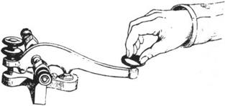My participation in APCO was initially funded by the State of Utah. I serviced on the "CW", Activity and Membership Committee and Chaired the Civil Defense Radio Committee.

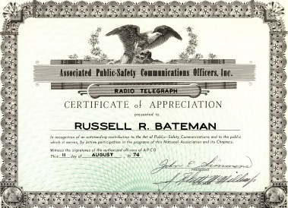In joining APCO, my resume showed that I had experience on a Navy High Speed CW net covering a wide area in the pacific (Several times I was net control for the Pacific direction finding correlation net). Most of the APCO members had various FCC Radio Telephone and Amateur Radio Licenses, but I guess that I was one of the few that also had the FCC Radio Telegraph License which was required for Ship to Shore maritime service. So it was understandable that I be assigned to the “CW Committee”. During WWII and shortly after, there a very seldom publicized net of a High Speed CW Radio network for Police and FBI across the United States. Our Committee was assigned to develop standardized procedure for public safety CW nets.

The beginning of Police Radio Communications

A most significant development in early State Police history began to unfold in 1929.  This was the department's establishment of the first state-owned and state-operated police radio in the world, Station WRDS.

Prompted by the successes noted by the pioneer Detroit city police radio, Station KOP, the department leadership foresaw the benefits of radio for directing law enforcement efforts on a statewide scale.  The Michigan Legislature liked the idea and not only appropriated $25,000 for initial equipment, but sent Governor Fred W. Green, Attorney General Wilber M. Brucker and a State Police delegation to Washington to obtain a Federal Communications Commission license.

The delegation was eventually successful, but not until after an argument during which Governor Green threatened to build the station whether licensed or not, the FCC yielded.  A 5,000-watt transmitter was set up at East Lansing and testing began in September of 1930.

Though WRDS was in operation only the last three months of that year, there were 745 messages broadcast.  The station in that same period had an important role in guiding the successful police search for the bank robber killers of Tpr. John S. Burke, the first intense manhunt ever directed by radio in a statewide scale

The first Police radio operation was just above the AM Commercial Broadcast band. This was primary used by police during WWII. Experiments have begun in the radiotelephone or wireless telephone for broadcasting of the criminal identification and information.

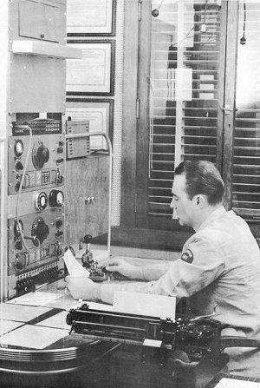In 1937 radiotelegraph commonly referred to as CW caught the interest of police agencies in many parts of the country and MSP was not to be left behind.  Construction of a CW network for point to point was begun and finished by years end.  The system was placed into service early 1938 which connected too interstate and other states.

In 1937 radiotelegraph commonly referred to as CW caught the interest of police agencies in many parts of the country and MSP was not to be left behind.  Construction of a CW network for point to point was begun and finished by years end.  The system was placed into service early 1938 which connected not only Michigan State Police (MSP) districts but also other states.

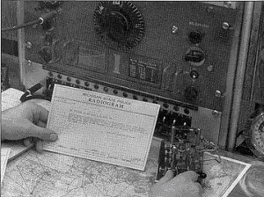The transmitter shown here was a Western Electric ten channel CW and AM unit placed in service at East Lansing Headquarters in Jan of 1938.  The tenth channel was used as standby in case the 5000 Watt AM transmitter failed.  It was capable of transmitting on the AM channel and [CW](http://msprg.com/MSPRG/Radio%20History/Triv%20from%20JY.htm) at the same time. Most of was in the form of a Radiogram.

In 1942, Michigan police and sheriff departments began to avail themselves of FM radio for two-way communications with their mobile units.  Additionally, it became mandatory that police organizations be able to have fast and reliable communications with each other.  To provide such a service a radio system or network called the "Indiana Plan" was developed.  Each department installed radio equipment on a common frequency for a designated area.  Districts were set up to coincide insofar as possible with the State Police Districts who provided relay service to other areas in the State.  Thus, all law enforcement agencies were coordinated into an effective communications network with the capability of exchanging police information with each other agency in the State**.**  
In accordance with Federal Communication Commission revision in 1949 of its station identification system, all four-letter radio station designations in police services were changed to letter and number combinations.  WRDS, widely known as the headquarters station of the first State Police owned and operated radio system in the world, lost this well-known identity with itspast when it became KQA258.

In 1946, The State of Utah began to replace their old police cars. I remember riding with Bud Bowman 18 (see Chapter 16) in his new 1947 Studebaker Land Curser. The Land cruiser was the top of the line in the Studebaker line. It was fast and a luxury car. The state of Utah purchased 1946 Fords for their Utah Highway Patrol replacement cars.

We were driving between St. George and Cedar City on highway 91 and at a speed that was over the speed limit. UHP trouper Blonde Porter (who lived a short distance from where I lived) took out after us. Bud said to me, don’t worry, those fords and not very fact and it didn’t take very long before we couldn’t see him behind us. The point is that there was very little hope for the UHP to catch a speeder and with no radio, they were helpless. Bud Bowman later became a UHP trouper and later served un the Utah House and made important laws that benefited Public Safety.   
The Use of CW (Continuous Wave) was the earliest form of long distance communications, using the International Morse code. CW nets used by most countries used Q-Codes. Q-codes were assigned meanings by the International Telecommunications Union in 1959, but the idea of Q-Codes was first noted at the Berlin International Radiotelegraph Conference of 1906.  A formal list of Q-Codes was instituted at the London Radiotelegraph Convention of 1912.   
I learned and use Q-codes in 1948 while attending the Naval Radio Operators School at San Diego. I leaned to commit to memory, many of the codes when operating on Navy CW nets. Many of these Q-codes were used on the Amateur Radio frequencies. Most, but not all, of the codes can be used either as a statement or a question, depending on the context of their use.

A sample of the Q-codes:

**QRA**    What is the name of your station  
**QRB**    How far, approximately, are you from my station  
**QRC**    What authority/administration settles the accounts of your station  
**QRD**    Where are you bound and where are you from  
**QRE**    What is your estimated time of arrival at ...(place)  
**QRF**    Are you returning to ...(place)  
**QRG**    Will you tell me my exact frequency or that of ...(callsign)  
**QRH**    Does my frequency vary  
**QRI**    How is the tone of my transmission  
**QRJ**    How many radio telephone calls have you to book. (See notes at the end of this list for possible alternative meanings).  
**QRK**    What is the intelligibility of my signals or those of ...(callsign)  
**QRL**    Are you busy  
In the early days of Police Communications K-codes were also used to indicate the results of a job.

|  |  |
| --- | --- |
| **Code** | **Meaning** |
| K1 | No further police action required |
| K3 | No offence disclosed (for incident initially reported as offences) |
| K6 | Reported |
| K9 | Arrest made. |

The following codes are now obsolete but may still be heard on the radio:

|  |  |
| --- | --- |
| **Code** | **Meaning** |
| K2 | Event held until later (replaced by the term "pre-empt") |
| K4 | Warning given (now included in K6) |
| K5 | Police form 258 or 101 submitted (now included in K6) |
| K7 | Job left for expert |
| K8 | Job left for prime unit. Note this code is still heard on the radio often. There is some debate as to whether it’s obsolete.  In the one committee meeting that I attended, it was decided that there were only several limited CW nets and they were only used as back up. So the committee was dissolved. |

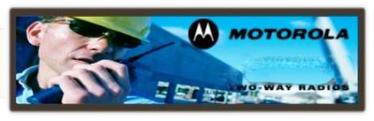This is where I got acquainted with Gene Goebel, who said that he previously worked for Motorola, He was the State communications Officer for the State of Illinois, and similar to the position I had for Utah. But he didn’t say that he was the former President of Motorola. He gave me a lot of guidance in my Communications Planning we spend a number of hours together at several seminars. (see my chapter 10 & 11 Emergency Medical and State of Utah Employment)

The FCC appointed Gene Gobles to be chairman of the SIAC (State Industrial Advisory Committee) to develop the regulations for the new 27 MHz Citizen Band Radio Services. I was honored that Gene asks me to be a member of that committee.

Who was this Gene Goebel? I don’t remember just how I met him, but it was short time after I join. I was asking a lot of questions from many members of APCO. Gene Goebel took a liking to me and spends many hours answering my questions, and you may say Training me.

Motorola started in [Chicago, Illinois](http://en.m.wikipedia.org/wiki/Chicago,_Illinois) as **Galvin Manufacturing Corporation** (at 847 West Harrison Street)[[12]](http://en.m.wikipedia.org/wiki/Motorola#cite_note-12) in 1928, when catholic brothers Paul V. and Joseph E. Galvin[[13]](http://en.m.wikipedia.org/wiki/Motorola#cite_note-13)[[14]](http://en.m.wikipedia.org/wiki/Motorola#cite_note-14)purchased the bankrupt Stewart Battery Company's battery-eliminator plans and manufacturing equipment at auction for $750. Galvin Manufacturing Corporation set up shop in a small section of a rented building. The company had $565 in working capital and five employees. The first week's payroll was $63.

The company's first products were [battery-eliminators](http://en.m.wikipedia.org/wiki/Battery_eliminator), devices that enabled battery-powered radios to operate on household electricity. Due to advances in radio technology, battery-eliminators soon became obsolete. Paul Galvin learned that some radio technicians were installing sets in cars, and challenged his engineers to design an inexpensive car radio that could be installed in most vehicles. His team was successful, and Galvin was able to demonstrate a working model of the radio at the June 1930 Radio Manufacturers Association convention in Atlantic City, New Jersey. He brought home enough orders to keep the company in business.

Paul Galvin wanted a brand name for Galvin Manufacturing Corporation's new car radio, and created the name “Motorola” by linking "motor" (for motorcar) with "ola" (it was a popular ending for many companies at the time, e.g. [Moviola](http://en.m.wikipedia.org/wiki/Moviola" \o "Moviola), [Crayola](http://en.m.wikipedia.org/wiki/Crayola).).[[15]](http://en.m.wikipedia.org/wiki/Motorola#cite_note-15)The company sold its first Motorola branded radio on June 23, 1930 to H.C. Wall of Fort Wayne, Indiana for $30. The Motorola brand name became so well-known that Galvin Manufacturing Corporation later changed its name to Motorola, Inc.

Galvin Manufacturing Corporation began selling Motorola car radio receivers to police departments and municipalities in November 1930. The company's first public safety customers (all in the U.S. state of Illinois) included the Village of River Forest; Village of Bellwood Police Department; City of Evanston Police; Illinois State Highway Police; and Cook County (Chicago area) Police.

Many of Motorola's products have been radio-related, starting with a [battery eliminator](http://en.m.wikipedia.org/wiki/Battery_eliminator) for radios, through the first hand-held [walkie-talkie](http://en.m.wikipedia.org/wiki/Walkie-talkie) in the world in 1940, and during the War, every things was Military related

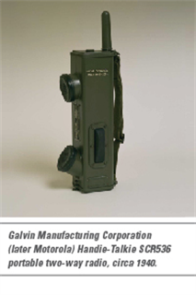 Cellular  infrastructure equipment, and mobile phone manufacturing. In the same year, the company built its research and development program with [Dan Noble](http://en.m.wikipedia.org/wiki/Daniel_E._Noble), a pioneer in [FM](http://en.m.wikipedia.org/wiki/Frequency_modulation) radio and semiconductor technologies, who joined the company as director of research. The company produced the hand-held [AM SCR-536](http://en.m.wikipedia.org/wiki/SCR-536) radio during [World War II](http://en.m.wikipedia.org/wiki/World_War_II) ( only new if it as the BC 611) , which was vital to [Allied](http://en.m.wikipedia.org/wiki/Allies_of_World_War_II) communication. Motorola ranked 94th among United States corporations in the value of World War II military production contracts. In 1943, Motorola went public and in 1947 became Motorola, Inc. At this time, Motorola's main business was producing and selling televisions and radios.

So getting back to “Who was Gene Goebel” In my many sessions with Gene, he only told me that he had worked for Motorola. Another tine, said that he was a Motorola Salesman. Michigan State Police Communication’s History gives him credit of designing Michigan State Communications System and referring to Galvin MFG.

Searching the Internet, there are a number of Gene Goebel so it has to be defined the Motorola Gene Goebel

TheInstitute of Electrical and Electronics Engineers

- *Motorola* Inc., Chicago, Illinois (1) .... The Committee on Arrangements under the Chairmanship of *Gene Goebel* is to be complimented.

I find it hard to find a picture of the Motorola Gene Goebel. I find one that referred to Motorola Vice Precedent Gene Goebel.

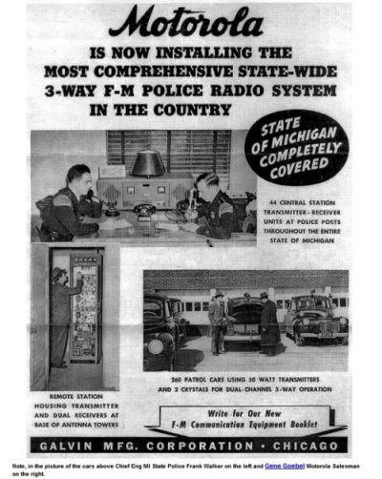In the advertisement, it notes that Frank Walker, MI State Police in one the Left and Gene Goebel in on the right. I find that 7 November 1950 Gene Goebel was the speaker at the CPRA/APCO annual meeting in Anaheim, ca, 26 April 1946 he was the speaker at the graduation LA Police Academy and other meeting 15 October 1984.

On the Internet, Dave Held said on 2/13/2009 *“Gene Goebel was the Motorola salesman that sold the original system to state*.(Michigan) *He later became a Motorola VP and  for most of his life kept a radio in his car on the MSP system.  He used to show up at Travers City where I and later Jack Hengartner used to check frequency for him.  For many years each and every transmitter frequency had to be checked and recorded, (FCC Requirement).  Gene had a home on Crystal Lake near Beulah, MI and flew his own airplane, (Beach Bonanza) on business trips, he once crashed landed in a cornfield in Illinois.*

So there is not a lot on the internet about Gene Goebel other than he was a Vice President of Motorola and a Motorola Salesman. So then, **how could Gene Goebel call William (Bill) J. Weisz, President of Motorola and ask him as a favor to fly from Schaumburg, Illinois to St. George Utah to meet with a NO_BODY Russ Bateman?**

***CHICAGO, Dec. 20—****William J. Weisz, a former chairman and chief executive of Motorola Inc., who played a leading role in the electronics company's rapid growth during the 1970's and 1980's, died on Wednesday at his home outside Phoenix. He was 70.*

*Mr. Weisz apparently died of a heart attack, the company said in a statement from its headquarters in the Chicago suburb of Schaumburg.*

*Mr. Weisz spent his entire career at Motorola, arriving immediately after graduating with a degree in electrical engineering from the Massachusetts Institute of Technology in 1948. He was especially influential in Motorola's drive to apply electronics technology to pagers, portable telephones and two-way radios, all products in which the company has become a world leader.*

*''Bill had a remarkable knowledge and understanding of technology, combined with an ability to communicate the possibilities of that technology to customers and decision-makers throughout the world,'' said Gary Tooker, Motorola's current chairman. ''His efforts to improve the use of the radio frequency spectrum helped to set the stage for global wireless communications.''*

*Mr. Weisz was the manager of a project developing a new portable radio by the mid-1950's when he first caught the eye of Paul Galvin, the company's founder.*

*''My father and I were at a technology review with the communications group, and after Bill talked, my father nudged me with his elbow and said, 'Watch that kid -- he's going someplace,' '' recalled Mr. Galvin's son, Robert, who later became chairman and chief executive and promoted Mr. Weisz into senior management.*

*Robert Galvin also said that Mr. Weisz had combined his technical expertise and intelligence with a personality ''as easygoing as the proverbial old shoe.'' As a result, Motorola workers felt comfortable having technical disputes with him or in his presence, Mr. Galvin said. That helped create Motorola's corporate culture, widely known for encouraging internal debate and reconsidering technologies it initially rejected.*

*Mr. Weisz could be found in the company cafeteria for lunch every day with fellow senior executives, their shirt-sleeves rolled up and pagers strapped to their hips.*

In chapter 11, I talked about the Robert Wood Johnson funding a project that installed radios in 41 Hospitals and 50 Ambulances. The Utah State progressive group wanted to make the project fail and with their influence of the Local and Idaho Motorola Salesmen block my purchase of the equipment. There was a dead line for the funds and if it could be delayed, the project would fail. They felt that the funds then would come back to them to Administer in developing one hospital.

It seems that there was nothing that I could do. On a Monday afternoon, I gave Gene Goebel a telephone call and explained the purchase problem. The next day, I received a Telephone call from Motorola ask for an appointment the following day. I though, just another runaround.

Wednesday, the Motorola man walked in and introduces himself as William J. Weisz, President of Motorola. He could see that I was somewhat confused. We went on to explain that he the company airplane flew west just to see and help me as a small token of appreciation to Gene Goebel. He told me that Gene had done so much for Motorola and help him personally that this was something that he could to for him. He told me that the locate Salesmen (that had gave me so much 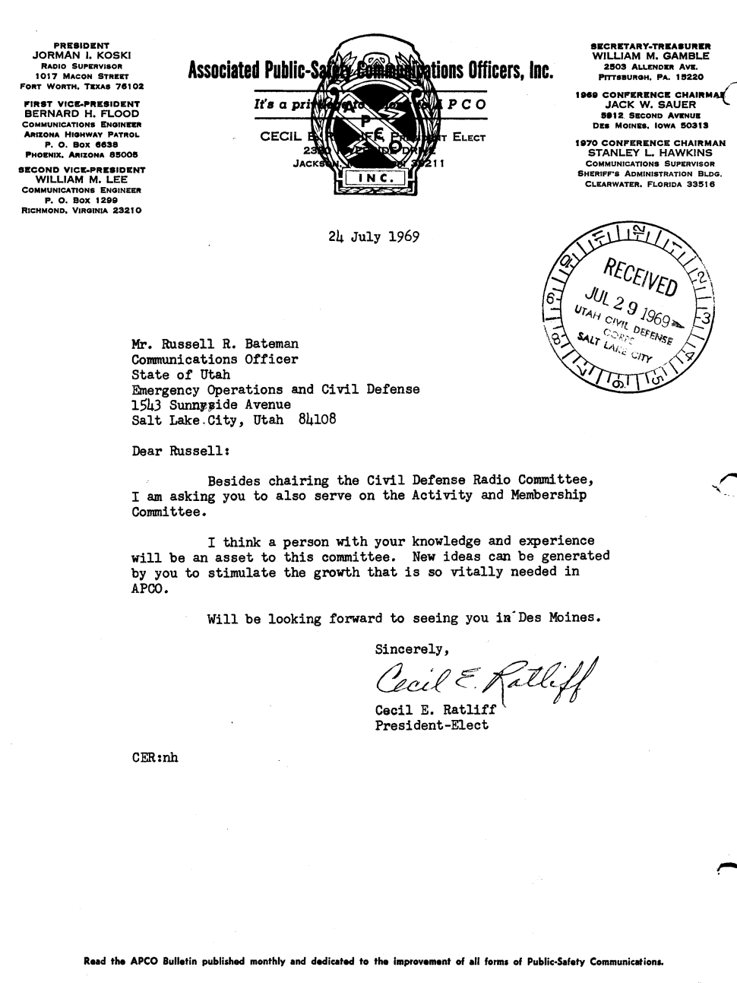problems) were outside “shaken in their boots”.

I gave him a list of the 41 Motrac Base Stations and 50 Mobile units, Antennas and other miscellaneous equipment. He told me that I would have it in two weeks as he would give the order top priority above any other order. In two weeks, the equipment was delivered to the University of Utah IRMP project.

This was another time the loard stepped in helped me.

APCO had other committees for standardization of public safety Communications accosts the United States. One of the major basic problems they had was the standardization of Public Safety radio procedures. As seen in the popular TV series “Adam 12” the procedure was to say your station call sign first and then who you were calling. “One Adam twelve to one L ninety go”. The APCO standard would change that to: “one L Ninety, One Adam twelve”.

One of the APCO meetings was in Los Angles, California. In the late 1950’s and 1960’s Los Angeles Police Communications were far superior to any other others found anywhere in the World. The TV Show Adam 12, included videos taken in at the various locations of the LA Police communications facilities. APCO members were guest of the LA Police and taken on tours of the main dispatch center and the main mountain top communications center where there was a lot of State of the Art equipment installed. This influenced my vision of what I felt that the State of Utah needed.

I was asked to Chair the National Civil Defense Radio Committee and serve on the Activity and Membership Committee,  
  
I was able to organize a Utah Chapter of APCO. After we received our charter, the next step was to vote in a Chapter President. Craig Jorgenson, Communications Director for the Utah Department of Highways. He was a member of the States Progressive Group that wanted the State to control radio and telecommunications in Utah. He was a good politician and had worked up to being the head of the State of Utah Telecommunications.

Somehow, I was no longer permitted to participate national with APCO. The new Chapter President convinced that the president of the Chapter should be the only one participate in the APCO.

Later, He was fired the first day of Governor Bangerter Term of office and some way talked his way of heading APCO’s project 25. I don’t know what the project was, but it caused a lot of problems and Jorgenson was eventually fired by APCO.

I indicated the Utah APCO chapter. It was opposed by the Utah Progressive Group, but it didn’t take long for them to take over the chapter and force me out when I was transferred to Southern Utah.

I really missed my association with APCO.