THE BEST YEARSTO BE ALIVE IN THE HISTORY OF THE WORLD

Russell Rulon Bateman History

**Chapter 11- Emergency Medical Communications**

In the classes that I took at some of my required federal Emergency Management training, one area was Emergency Medical and the importance of the Single Number Entry system. I had co-authored the Utah Government radio Communications portion of the 1970 UTAH TELECOMMUNICATIONS PLANNING STUDY and Dail Ogden did the Utah Education part. The plan was approved by the Governor’s Office and an Executive Ordered for the implementation of the planning. (See chapter 10)

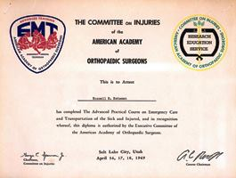In my investigation into Emergency Medical Communications requirements, I started researching information on the requirements of Emergency Medical Communications. I was referred to the American Academy of Orthopedic Surgeons and told that there was a training class being held in Salt Lake City and was invited to attend. The class was training for Ambulance drivers, “The advanced Practical Course on Emergency Care and Transportation of the Sick and Injured”, held on April 16, 17, and 18 of 1969. Completing this course, I was authorized to operate an ambulance.

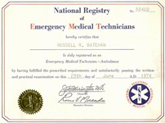In 1969, and majority of ambulances in rural Utah were Hearses run by Morticians who some felt that they had a conflict of interest. The standard procedure was to load the person into a vehicle and get them to a hospital as soon are you could. The operators had not more training than basic first aid training. There was pressure to upgrade the Utah Emergency Medical Communications program. The new Emergency Medical Technician-Ambulance Service program was being developed.

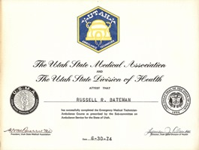My wife and I took the EMT training course as members of the Civil Air Patrol Emergency Medical Squadron. Our eight Squadron member’s instructors were Medical Doctors, including a couple of Emergency room doctors. They were all IFR Rated Pilots and had their own aircraft. The requirement was that all members of the squadron had to be MD, registered Nurses or certified EMTs. Our goal was Air Ambulance Service as there was no air service in the State of Utah at this time. As part of this Training, we flew to Luke AFB, Arizona for the High Altitude Chamber certification. This was made possible as a couple of our instructors were reserve Air Force Officers. I think that was certified at 18,000 ft elevation.

I obtained my State of Utah Certification number 581and the National Registry which my number was 33420. I guess that meant that I was the 581 to be licensed in the State and 33,420 in the nation. My wife also took the training and was one of the first women in Utah to certify as an Emergency Medical Technician. The EMT program would replace the ambulance drivers with skilled medical personnel.

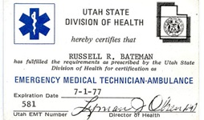

The Robert Wood Johnson Foundation allocated funding to the implement improved Emergency Medical facilities including EMS communications. I was invited to attend some of the Robert Wood Johnson discussions. **The major problem was defined was that Ambulances were arriving at the hospital and the Hospitals was not able to do any preparations for the arrival of the sick of injured patient.**  In many cases, there were no doctors in the hospital when the Ambulance arrived.

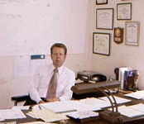Lionel Dradge was the director of the Intermountain Regional Medical Program (IRMP) which covered all of Utah, and Part of Nevada and Arizona. He asks me for suggestions, noting that I had State of Utah responsibility to for recommending the developing EMS Communications in the State of Utah.

Utah Communications, a Motorola franchised private Salt Lake Based Communication business submitted proposals. Their submission was for developing one metropolitan hospital to have the most modern EMS Communications facilities available. I was asked for evaluation and suggestions.

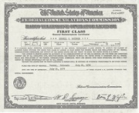Utah Communications ask for the Total Utah allotted funds to develop a one Hospital (I think the University of Utah Hospital) in to a show case of modern communications. I reported that I didn’t feel that this submission landed any credence to the intent of the Robert Wood Funding. My input was the funds would be better used by giving the funds to a State wide project benefiting all Hospitals and Ambulances. MacKay Dee Hospital in Ogden, University Hospital and the LDS hospital in Salt Lake, and the Utah Valley all had some radio Communications with their Ambulances. I stated that I could put a basic radio in the remaining 41 Hospitals and 50 Ambulances with the same funds. The Robert Wood Johnson Officials didn’t know how I could do it, but gave me the go ahead as they had confidence in me.

The major hospitals in the Ogden, Salt Lake City and Provo had some kind of Radio communications. I felt that the rural Hospitals had the greatest communications needs.   
There were 41 rural hospitals in Utah and I could identify 50 vehicles, Hearses or Ambulances serving these hospitals. I felt that the available funds would cover the 41 Base stations and 50 mobile radios, including antennas but not the installations. The Hospitals and ambulances were throughout the state of Utah including a lot of rural areas. I suggested that the installation could be done by three Air National Guard Electronic Installation Teams and that I could make arrangement for this project to be Active Duty and it would be good experience and their costs would be covered by the Air Guard. The FCC required at that time that the radios had to be checked out and certified by a person hold at least a FCC Radio Telephone 2nd class. I told that that I would take vacation from the State and coordinate the project and would only need IRMP to cover the cost of the fuel for my service truck and that I would not require any other compensation.

A number of the members of the (Intermountain Regional Medical Program) IRMP program were septal, but the Director, Lional Drage supported that I could do it. The funding would be covered by the Robert Wood Johnson Foundation. However, a major problem came up in getting the order for the purchase the equipment. I first contacted the Utah Motorola Sales officer and submitted our order for the 41 Motrac base stations and 50 Motrac mobile radios and antennas.

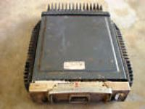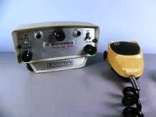I didn’t get any feedback and contacted them again. They told me that I had to go through a salesman in Idaho. I tried to contact him, but he was never available. I finally realized that I was getting the runabout. I suspected that Utah Communications and the “State progressive group” were behind it and if they could stall long enough, we would lose the Robert Wood Johnson (RWJ) funding.

I called my friend Gene Goebel (see APCO Chapter 12) and told him my story and ask for suggestions. He said he could check on a couple of things and get back to me. The next day, I received a call from Motorola asking for an appointment. I thought more runaround. The next day, the Motorola man came to my office. He 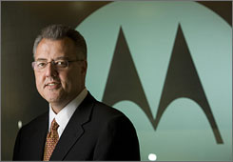Identified himself as Willian J. Weisz, President of Motorola. He told me that he had flown out west just to see me. He told me that the Motorola salesmen waiting outside were “shaking in their boots”. He said that he owed Gene Goebel for his start and success in the company and wanted to repay him something. It took me some time to realize just who he really was. Also, Who was Gene Goebel that was important enough to ask a favor of the President of Motorola, with over 36,000 employees, net Sales of $800,000.000 to fly from Schaumburg, Ill to meet a no-body in St. George, Utah. I cover more about these special men in the history of Moble Communications in Chapter 12.

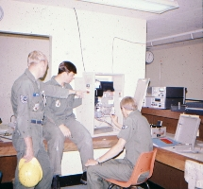We went through the details and the order. He promised me that he would expedite the order and get the equipment to me (University of Utah) in time to meet the schedule. I was told that our order was given top priority and moved to the head of the all the other Motorola orders that were being processed. The total order was delivered two weeks later.

I contacted the Air National Guard 130th commander and got the active duty paper work done and Three Teams of three men assigned to me. I was previously certified as a Team Chief and a member of the Squadron. The Squadron Commander had served under me before he graduated from college and going to OCS to get his commission. He felt that it was a great training and public service project.

I took four weeks’ vacation time from my State of Utah, and got three Air National Guard teams from my 103th Air National Guard unit and we installed the equipment in the 41 Hospitals and the 50 Ambulances. Our National Guard Teams installed the equipment and I had the required FCC license to get them operating and legally checked out.

Utah was the first State in the Nation to have a State Wide Emergency Medical Communications system with compatible Communications between all hospitals and Ambulances. I received a nice plaque from the University of Utah

The project was organized and hospitals and ambulances on the schedule for each team. After the installation was completed, I would do the finial check out and signoff the FCC requirements. 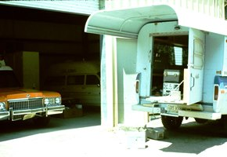My pickup had the service monitor, tools and other test equipment. It was also a place for me to sleep, but many times I would sleep on one of the Hospital beds and the hospitals would provide me with food, they were excited about the radios. The Air Guard members were on active duty training and had funding. See Appendix 1 for Emergency Medical Service (EMS) radio implementation.

The project had a lot of good publicity all over the state. An example, 12 July 1973 – Sun

***Sun Advocate – Price Utah***

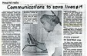***Hospital Radio Communications to save lives***

***Communication facilities between hospital emergency rooms and ambulances will help stop needless deaths in rural areas of Utah in­cluding Carbon and Emery County.***

***"Utahns in rural areas have had a four times greater chance of dying from accident or illness than those in urban areas," stated Lionel L. Drage, Utah Emergency Medical Service (EMS) Coordinator.***

***A base station radio was recently installed in the Carbon Hospital emergency room to help solve the communications problem in southeast Utah. The radio will operate on a single radio frequency (155.340) which every ambulance and Hospital in the state of Utah will be able to use.***

***This will enable ambulance per­sonnel to communicate with hospital emergency physicians and other medical personnel for instructions on patient care. Hospital personnel will be able to plan treatment for accident and illness victims while the patient is still reroute to the hospital.***

***Ambulance attendants will also be able to call for help while they are out of their normal operating area. Patients who develop unexpected medical problems while being transferred from rural areas to hospitals such as the University Of Utah Medical Center for special treatment will be treated by am­bulance personnel who receive their instructions by radio until the nearest hospital can be reached.***

***The two-way radio system will be installed in each of Utah's 41 hospitals by mid-July. Before June only nine hospitals, all located bet­ween Ogden and Point-of-the­ Mountain had radio communication. The equipment, purchased through the Utah EMS federal grant, was installed by members of the 130th Electronic Installation Squadron, Utah Air National Guard, under the direction of Russell Bateman, Utah Civil Defense Communications of­ficer. (But I had to take vacation time from the state to do the assignment)***

***Carbon Hospital's radio unit has already been used in an emergency situation. Both ambulance crews and emergency room personnel have found it to be helpful in their treat­ment of patients***

***Carbon Hospital's radio unit has already been used in an emergency situation. Both ambulance crews and emergency room personnel have found it to be helpful in their treat­ment of patients. See Appendix 2 for newspaper articles.***

I received no remuneration project, but saved a lot of problems. Utah Communications wrote a letter to Utah, Governor Rampton complained that the state was doing services that should be done by private companies and they intended to sue the State. The governor ordered an investigation which found that there were no State Funds in the project and it was all paid by the Robert Wood Johnson – private money and my services were on my vacation time. I received no RWJ or other finantial compensation.

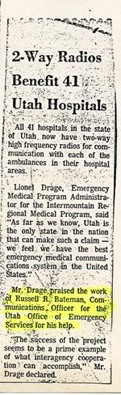***2- way radios benefit 41 Utah hospitals***

***All 41 hospitals in the state of Utah now have two-way high-frequency radios for communications with each of the eminences in the hospital areas.***

***Lionel Drage, emergency medical program administrator for the Intermountain regional medical program, said as far as we know, Utah is the only state in the nation that can make such a claim – we feel that we have the best emergency medical communications in the United States***

***. Mr. Drudge praised the work of Russell R Bateman, communications officer for the Utah office emergency services for his help.***

***“The success of the project seems to be a prime example of what interagency cooperation can be accomplished” Mr. Drage declared.***

Robert Wood Johnson Foundation and the University of Utah presented me with an award for my services:

*“****P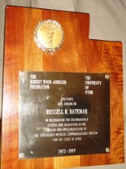RESENTS THIS AWARD Russell R. Bateman IN RECOGNITION FOR DISTINGUISHED SERVICE AND DEDICATION IN THE DESIGN AND IMPLEMENTATION OF THE EMERGENCY MEDICAL COMMUNICATIONS SYSTEM FOR THE STATE OF UTAH 1973-1977****”*

I continued working with Hospital Administrators in developing "Single Number Entry" and EMT paging systems. Utah was the first State in the Nation to have a common frequency (144.340 MHz)for all Hospitals and Ambulances. Some said that Utah EMS communications was the best organized system in the Nation.

We licensed the radio frequencies to the Hospitals and Ambulance owners to insure the control are to the owners and not to the State of Utah. This was upsetting to the Progressive group who wanted to control all EMS and other communications in the State.

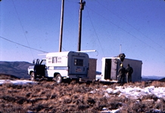We added other repeaters to extend the range for the ambulances. The Air Guard 130th Electronic Installation Squadron was always looking for projects for training, and I seem have many of these projects for them. We installed a number of using the Air Guard. The Air Guard teams enjoyed these projects as they felt that they were doing something what was a serve to the communities.

My pickup was on many mountain tops carrying equipment for the installations. I received no compensation for the use of my pickup.

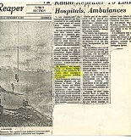

***1974-12-12 radio repeaters to link hospitals, ambulances. Richfield reaper***

***a new medical – radio communication network has been completed in southern central Utah region which will enable direct contact between hospitals and eminences.. Through installation of a high band radio repeater station located on a mountain peak Northwest of Marysville, hospitals and ambulance, as well as other non-law-enforcement emergency units will have radio communications***

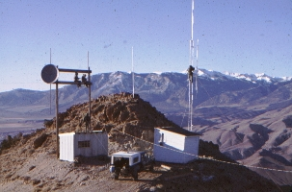

***The system was expanded to funding from the Intermountain regional medical program through an allocation of some $25,000 according to Russ Bateman, emergency services coordinator for the six County commissioners organization.***

***Bateman who recently moved to the Austin, Sevier County, is also the coordinator for several other emergency service programs including civil defense with the repeater station now operating, hospitals and ambulance in Sevier. Piute, Wayne, Sanpete and Millard County have direct communications. County which is also in the six County organizations is tied in with the Utah County system because of the train which does not allow direct medications with the other counties.***

***Another part of the system which will replace into operation soon, allows direct short range communications between eminences and hospitals without the usage of the other two frequencies through the repeater system.***

***The system was installed by members of the 130 insulation squadron from the Utah air National Guard under the direction of Lt. Col. Roy Stapp headquarters in Salt Lake City.***

***They installation was part of the units annual training and was carried out over the past two years, with the final installation just completed.***

***The transmitter is located on the same site as the Marysville television translator equipment, and include and includes a receiver -transmitter inside a box with the 60 foot steel radio tower.***

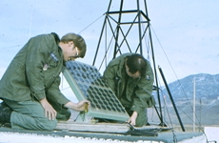

***Initial use of the system will be medical, it is planned that several other organizations we use the facilities including administration of the six County organization, coordination and search and rescue missions and civil defense.***

***Presently the Piute County Sheriff’s Department is using the system as part of civil defense. The Six County set up is one of several in the state and all can be linked together***.

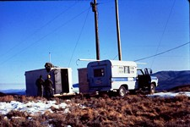

The IRMP ask me to be communications consultant. I told that I would accept, but I would have to serve without pay so that there couldn’t be an “Conflict of interest” Devier Swenson was hire by IRMP to work under me work where there were communications problem and to install new equipment as set up by IRMP. That included a number of repeaters on mountain tops to increase the rage of the ambulance.

The IRMP area of the grant covered the Navaho Nation and we few down to Window Rock to meet with the Navaho council. They had many entities where one would purchase one kind of equipment, another would fall prey to Radio Salesman. As results, they had a lot of equipment stored throughout the Navaho Nation had no function. They offered me a high salary to work under the Navaho Council and organize their radio communications systems. During one of the breaks in the meetings, a full blooded Native American (Indian) by the name of Wilson warned me that the council would hire a Caucasian get things working and then replace them with an Indian as soon as they could find or train someone. He told me that the Council sent him to college and as soon as he finished school, they hired him to replace the Caucasian, who was doing an excellent work in develop of the Tribe computer System. Even though the pay was about double that I was at that time receiving, but the idea had interest to me.

My recommendation to the IRMP was that there was too many “Chiefs” that were unwilling to work with each other and not enough Indians to do the work.

We had better luck out in Indian Reservation- Battle Mountain, Nevada. We lay out a suggested plan and with some IRMP funding, everything worked out successful.

I was transferred to Richfield under pressure from the State Progressive (Democrat) Group, I was still called back to participate in EMS programs

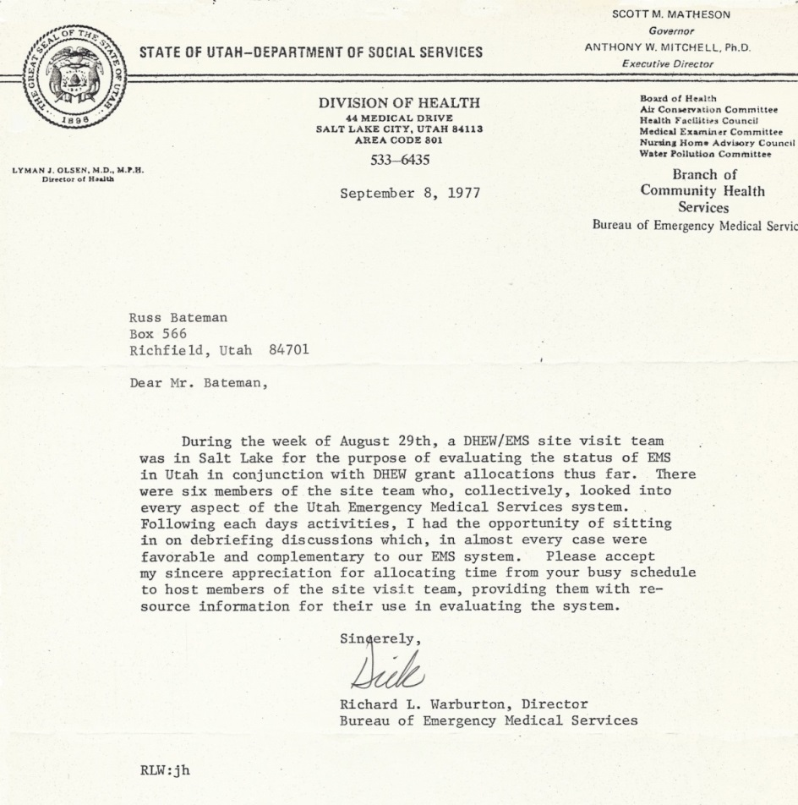

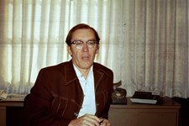

Before I was transferred to Richfield, I was heavy involved with Emergency Medical Planning with several different Organizations. I was asked to help host the DHEW team during their Utah evaluation visit and explain and answer questions that the team had.

Being that my wife and I were licensed EMT’s we were asked to help on the Monroe Ambulance. We would volunteer to take the duty one day a week being on call 24 hours. My wife was my partner and we would keep the ambulance with us where ever we went during those 24 hours. I served this volunteer assignment for 4 years and Gaye lasted 10 years. Our ambulance was the one of the left in the Picture.

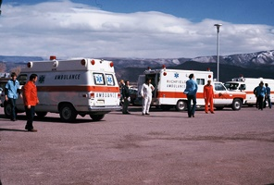

With my relocation, the State Progressive group was able to limit my activity in these programs. Once Governor Levitt was elected, they were able to force me to leave the State Employment.

(See chapter 10)