THE BEST YEARSTO BE ALIVE IN THE HISTORY OF THE WORLD

Russell Rulon Bateman History

**Chapter 10 Utah Office Emergency Services**

A study by the Federal DOD-Civil Defense identified that the State of Utah had a major deficiency in their Emergency Communications Planning. The Utah State Office of Civil Defense (Emergency Services) was given my name in their search for someone to fill that Position. In that I was working for the Mountain State Telephone and Telegraph Company Engineering Department, I was reluctant to change Employment and offered work with them as a volunteer, however, I found the assignment very challenging and became an Employee of the State of Utah. My job description:

***UTAH STATE CLASS SPECIFICATION  
APPROVED BY THE STATE PERSONNEL OFFICE***

***Dept: Governor's Office Effective Date: December 1, 1966***

|  |  |
| --- | --- |
| ***Div: Civil Defense*** | ***Job No: 12*** |

***Title: Communications Officer***

***Job Summary***

***Under general direction from the Director, Civil Defense, performs the following types of duties: plans and effects a program designed to insure communications capability in an emergency; supervises the establishment and operation of warning and communications systems and net­works, and the coordination of local and State communications systems with established/National systems,. coordinates all State communications systems to insure their availability to State emergency operations in an emergency coordinates communications plans with military and amateur operators, RACES, MARS, CAP, and any other agencies, governmental or pri­vate, which possess communications capability that can be used in time of emergency directs the operation of the Utah Civil Defense Communica­tions Center• recommends and supervises the location, procurement, installa­tion, and maintenance of equipment procures and trains operators in conjunction with operations officer and on a regular basis, conducts drills and exercises to test the condition of equipment and the proficiency of operators performs other duties as assigned.***

***Factors***

***1. Mental Application - requires considerable mental concentration to develop emergency communications and warning plans utilizing existing capabilities and recommends additional requirements: plans and directs tests and exercises of communications system, and coordinates communi­cations efforts of numerous agencies and organizations towards utilization in the emergency period.***

***2. Supervision Exercised - directs and supervises the operation of the Civil Defense Communications Center to include message center personnel; supervises the communications plans and capabilities of all political jurisdictions within the State.***

***3. Responsibility for Contacts - involves heavy contacts with State, Federal, and local governmental agencies and officials, including the Federal Office of Civil Defense, as well as, non-government communica­tions agencies--amateur and industrial.***

***4. Physical Effort--Working Conditions - requires light physical effort: considerable travel is necessary to supervise communications plans of County and City Civil Defense organizations.***

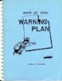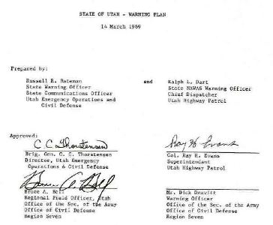Most of the time I was a Staff member of that Officer, we only had seven personnel and required us to wear many hats. One of my First Assignments was to write an Emergency Warning Plan, which included NAWAS - National Warning system. NAWAS was operated by the Utah Highway Patrol with a number of Entry Points around the State. The only thing that I found lacking was Emergency Power for each of the warning points.

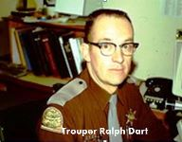Writing this Plan today would have been simple. It was written on a typewritten. Imaged and charts had to be drawn by hand manually. I received input, suggestions and worked with Ralph Dart and Ned Warensky, the Chief Utah Highway Patrol Dispatchers in writing the Utah Warning Plan. Warning points were located at Highway patrol dispatch centers throughout the state. My assignment as State Warning Officer required about ¼ of work load due to the inspections required. I had great support of Col. Ray Evans, Superintendent of the Utah Highway Patrol. He was a good friend and active LDS member. He made sure that I was invited to many meetings and activities that anything to do with the UHP operating of State Warning points, A complete digital copy of this original plan is contained on my data digital memory.

I made a request for funds to build a basic Emergency communications center. The request went to the counsel of Defense for funding of this project. The funding problem was not the Council members, but our Department Director, General Thorstensen. The legislature had allocated a fund to be used for developing the department of Civil Defense (also called Department of Emergency Service) I think that the fund was about $300,000. The director, General Thorstensen was extremely cautious spending any money out of this account. I don’t remember just how much he approved they gave us something to work with, I think around $2500.

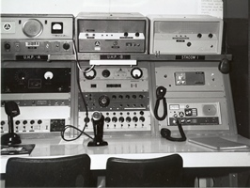Director Thorstensen, a retired National Guard General was over protective of using the funds to develop and equip the department. (He later eventually lost most of these funds to the State Progressive Group.)

We requested equipment and radios from various state agencies. We received mostly radios that were changed out and replaced with newer models. We did purchase a new Citizen Band Radio and an HF – Crystal control 100 W unit. As an active member in the MARS program, I was able to obtain cabinets and other material for the center. We were able to obtain a few things from the Utah State Surplus. We were able to obtain a lot of coaxial cable the Hill Field MARS program. (See Chapter 14 for the installation)

Our FEMA (Federal Emergency Management Administration) were impressed when they visited our state office. They felt that we accomplished a lot with no funding; they also made some very strong comments (Of the record) that there were Federal Matching Funds to match the State Funding and that it was cheap for the state officials not to build the center professional as most other states had done. The said that we did an excellent job with what we had to work with.

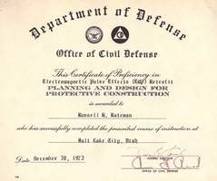Attended a EMP (Electromagnetic Pulse Effects retrofit) class that was presented by the Department of Defense. We were taught the effect of EMP and how to combat the effects. The instructor was a PHD Engineer out of the NEL(Naval Electronics’ Lavatory). After visiting our Communications center he asks if he could use the Utah center to conduct some EMP Protection tests.

Everything was ripped out of the Communications Room and a Copper screen room was installed filling the existing room. The communications cabinets and equipment was reinstalled and lines coming into the room were protected. They then tested the facility for EMP for a EMP strike. The had a large trailer that would create a EMP pulse that could be expected from an EMP Strike. He said the tests were successful and would help with their engineering to portect other communications facilities around the country.

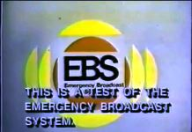My next project was the Utah Emergency Broadcast System - UEBS. We formed a Committee of management from various broadcast station and utility Companies. A member of the committee was Clint Barrack, an FCC Field Engineer out of the Santa Rosa, California Field Office. Rollow Kimball, Chief Engineer, KSL was chosen to be the committee chairman. This committee met monthly in Salt Lake City. My assignment was to be the errand boy and to set up and make notification of the meetings. I also acted as secretary, writhing the minets of the meetings.

As part of requirements for this program that there be Emergency Generator at each of the designated EBS Stations. I was assigned to coordinate this project of the installations. I was required to inspect each of these installations once a year to insure that they were operational.

Out State Cars were equipped with a Highway Patrol "low band" long whip antenna Radio. My Highway Patrol call was "880”. Low Band was 47 MHz like the Amateur Radio 6 meters. The can talk all over the world due to the skip. Low Band was a step from using the frequencies just above the AM Radio Station, but not well due to the skip. Meaning you could talk with some on 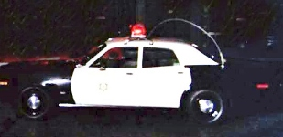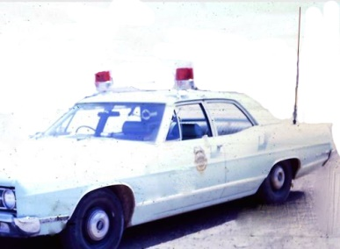in Texas, but not with your dispatcher just a few miles away. 90 % of the Utah Law Enforcement was on two Utah Highway Patrol low band frequencies. At times the "Skip" made the radios unusable. The long antennas would let you park in a garage and hit the trees unless you tied them over, but then they were not as effective. Low Band frequencies were far less usable that the high band frequencies where there were many frequencies available.

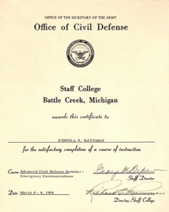As recommended by the Federal class instructors, the recommended that I join APCO. With the support of my office, I join APCO, an international organization of Public Safety communications Officer. (See chapter 12 for some of my activities in this organization.)

To be certified as State Emergency Service Professional, I was required to meet certain Education requirements. I took various training courses to work on my certification. I had the opportunity of being sent to the National Civil Defense Staff College in Battle Creek Michigan. The two week course was Titled "Emergency Communications” We covered various State and Local Communications System. I realized the facts that the State of Utah Public Safety Communication was very lacking. I began looking for answers as to what to recommend for the State of Utah.

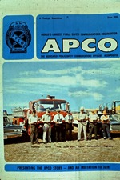

In the late 1960’s, I became active nationally with APCO (Associated Public-Safety Communications Officers, Inc.) and served on several National Committees.(see chapter 12) I became good friends with my Counterpart Gene Goebel from the State of Illinois. He didn’t tell me at that, but later I found out was previously the Vice President of Motorola Inc. and played a major part in the development to the VHF-Uhf technology and mobile Communication’s. He spent a considerable amount with me during the National APCO Conventions. He also asks me to serve on the NIAC (National Industrial advisory Council-1969) for the development of Citizen Band. We wrote the submission to the FCC for the development of the Citizen 27 MHz Bands). I disagreed with the designation of channel 9 being the emergency and suggested Channel 1, so I wes out voted.

I felt that he took a liking to me, as he really spent a large amount of time training me. He gave me advice and suggestions for things to be done in the State of Utah.

At the Civil Defense Communication School held at Battle Creek, we were encouraged to write or update our States Communication Plan. I submitted a request through channels to Ron Swenson, in the Governor’s Office for authorization of a preliminary Plan. Doing a Preliminary Report was approved by the Governor’s Office, but requested that we include the Education TV in the Study. Dail Ogden from the University of Utah had made some requests for a study of the Utah Educational TV.

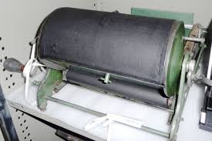This was back in the days of typewriters, Mimeograph, Hectographs were the tools of the day. Dail and I worked well together. We each developed the outline of our topic. Then Dail did the Prof Reading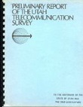 and editing and I drew up the images and grafts. The plenary report was published and turned over to the Governor’s Office. It was presented to the Legislature and an expanded study was authorized.



At that time, 90 percent of all the Utah State and local government radio traffic was on three 50 MHz (Low band) frequencies. In my part of the study, I recommended replacement of the States Low Band Radio System. The in a meeting with Utah Governor Calvin L. Rampton, he asks me which was right. Your study says one thing and others say different things. I suggested that I give him a list of a twenty State Communications Planners, and he select two men from those names to ask them to come to Utah and review the preliminary Plan and make their recommendations.

Eve Marriott, Governor’s Office, New Mexico and Dick Quinces, Washington State Police Communications was the two that he selected. The two men came to Utah (at the expense of their State) and reviewed the preliminary report and the conditions of public Safety communications in Utah. At the completion of their study another meeting was held with Governor Rampton and other agencies that had Government communication interests. Their report was, Utah’s communications were in a terrible state and fully supported the Preliminary Report. I was ask to join with Dail Ogden (University of Utah) and do a State of Utah Telecommunications Study and submit it to the Governor. Dail did the Education and State Microwave system and I did the Local and State and local Government VHF radio part. (Basically converting the Long Low Band Whip antennas to the 18” inch High Band antenna.)

Copies of the completed Utah 1070 telecommunications were sent to Eve Marriott and Dick Quinces for their review and they gave the report a very positive approval and suggested that we send a copy of the report to every state.

Department heads and Governor Rampton approved this plan; Dail Ogden and I were given approval to implement the plan. Politically, this was not easy. Dail moved to do his part and I did briefing to the State and Local entities of what the plan and costs were. The primary Radio available was the Motorola Motrac base and mobile units. The big limitation was that there was no Radio that could spread more than 1 MHz and that created major concerns of assignment of frequencies.

The Utah Division of Highways refused to accept the recommendation and kept their Low Band Radios. The group seeking control formed group that I call the Utah State Progressive committee, that include Vern Stevenson’s, no 3 in the Department of Highways, Greg Jorgenson Department of Highway Communications, Milt Davis, University of Utah KUED/KUER, Mac Helm, superintendent, Utah Highway patrol. They wanted control over all Police Frequencies and all government radio usage in the State of Utah. Col Mac Helm, superintendent, Utah Highway patrol was very power hungry with the objects was to create a State Police to handle all the Law Enforcement duties. He wanted the state to own all the radios and the frequencies and then rent them out to the local governments

Jack Aramacky, Utah Highway Patrol Radio supervisor rejected the high band conversion, but was soon to realize the advantage of it, even though, there was feeling about my part of the project.

***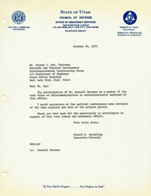*** We was able to block the State Police idea by licensing most of the County Sheriffs and City Police on their own licensed, but I sure developed some strong political Enemies that eventually were able to force me out of State Employment. Later, the State did get the assignment of the frequencies coordination, but was too late as most of the couhnties and larger cities have a frequency licensed to them. Following Gene suggestions, I was able to install some repeaters on Local Government and Natural Resources frequencies. Jack Birgance, Radio Tech for the Utah Forestry and Fire Control was a good supporter and we put in a number of Radio Repeaters that really improved their State Wide Communications.

In nineteen seventy three, the progressive group wanted to develop their own Telecommunications committee ask for the support of Blaine Kay, director of Highways. He insisted that I also was to be a member of this comitee.

***1973 10 26 Department of Highways STATE OF UTAH  
COUNCIL OF DEFENSE***

***OFFICE OF EMERGENCY SERVICES***

***1543 SUNNYSIDE AVENUE***

***P.O. BOX 8100, SALT LAKE CITY, UTAH 84108***

***TELEPHONE 328-5271***

***CALVIN L. RAMPTON GOVERNOR***

***DONALD R. SPRADLING EXECUTIVE DIRECTOR***

***October 26, 1973***

***Mr. Blaine J. Kay, Chairman***

***Economic and Physical Development***

***Interdepartmental Coordinating Group c/o Department of Highways State Office Building***

***Salt Lake City, Utah 84114***

***Dear Mr. Kay:***

***The participation of Mr. Russell Bateman as a member of the task force on Telecommunications is enthusiastically endorsed by this office.***

***I would appreciate at the earliest convenience some estimate of the time required and also of the project period.***

***Thank you very much for the opportunity to participate in support of this very timely and necessary effort.***

***Very truly yours***

***Donald R. Spradling Executive Director***

***DRS:djf***

***cc: Russell Bateman***

~~~~~~~~~~~~~~~~~~~~~~~~~~~~~~~~~~

1973 11 26 Department of highways, Blain J. Kay

|  |  |  |
| --- | --- | --- |
| DIRECTOR BLAINE J. KAY | _Pic2 | STATE HIGHWAY ENGINEER, C. V. ANDERSON |

***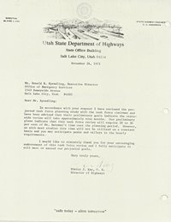Utah State Department of highways  
State Office Building***

***Salt Lake City, Utah 841 4***

***November 26, 1973***

***Mr. Donald R. Spradling, Executive Director Office of Emergency Services 1543 Sunnyside Avenue***

***Salt Lake City, Utah 84103***

***Dear Mr. Spralding:***

***In accordance with your request I have reviewed the pro­jected task force planning study with the task force chairman and have been advised that their preliminary goals indicate the state­wide review will take approximately nine months. Our preliminary plans indicate that this task force review will require 20 to 30 per cent of Mr. Bateman's time over the planning period. However, as with most studies this time will not be utilized on a constant basis and you may anticipate peaks and valleys in the hourly requirements.***

***I would like to sincerely thank you for your encouraging endorsement of this task force review and I fully anticipate it will meet or exceed our projected goals.***

***Very truly yours,***

***Blaine J. Kayi, P. E. Director of Highways***

***"safe today — alive tomorrow"***

The intent of this committee was to gain control of the State’s Telecommunications. I was active with this group, but much of the data and planning was withheld from me and every chance they could find to make me look bad. I was not notified of meetings and isolated from receiving plans, minutes and what was going on.

I was asked to serve as Communications advisor for the Robert Wood Johnson Foundation grants in the Utah, Northern Arizona and Eastern Nevada Emergency Medical program. I accepted on the bases that I would not receive any monetary compensation. (See chapter 11)

I also did some medical Consulting at Battle Creek Nevada and Window Rock Arizona. Window Rock is the headquarters for the Navaho Indian Nation. Various group fell to the Salesmen’s and purchased a lot of equipment that was not compatible between them. Talk about politics! They offered me a job to organize their radio Communications. A Caucasian named Halfman was hired to clean up their telephone, but had no one for their radio problems. I didn’t have any idea of accepting the job, but a full blooded Indian by the name of Wilson, a University Graduate and the Navaho Nation Computer specialist quietly got me aside and told me to be careful. “They hire a white man until they can get an Indian trained”. Then they fire the non-Indian. I would have never let myself get in the middle of all the Navaho groups political fighting.

~~~~~~~~~~~~~~~~~~~~~~~~~~~~~~~~~~~~~~~~~~~~~~~~~~~~~~~~~~~~~~~~~~~~~~~~~

I wrote a preliminary State of Utah Telecommunications public Safety study making suggest changes that would help the state of Utah. Dail Ogden was a great associate in this study. Drawings and sketches are an important part of any submission. Dail helped me with the wording of my part and I did the sketches as he directed for his part.

Dail Ogden was a great person to work with and we completed the 1970 Utah State Telecommunications Planning Report. The plan was sent to other state for their review and all replies were very positive.

Governor Rampton full supported the plan and ordered it to be developed as funding could be made available. Jack Aramakie was given the responsibility of the Conversion of the State owned radios. Dail Ogden was given the responsibility of the Higher Education. And I was given the responsibility of coordination with the Counties and Cities. Governor Rampton told me that I could keep in touch with his office. His administrative assist was to provide coordination.  
Salt Lake City, Ogden and Provo already had compatible Radio and frequencies.

***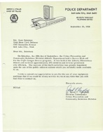***I turned my attention to Fire, Emergency Medical, and Natural Resources etc. I was contacted by Lionel Dradge Robert Wood Johnson Administrator, (JWJ) who invited me to an Emergency Medical Meeting. I was asking for suggestions. I was asked to be a consultant for RWJ. I accepted but told them that I could receive any pay as it would be a Conflict of Interest with my State job, but I would work with them on a Volunteer basis. (See Chapter 11)

I was involved with other agencies in the Salt Lake area,

***Police Department, Salt Lake City, UT 84111 Salt Lake City Utah. September 30, 1968***

***Mr. Russ Bateman, Utah State Civil Defense, 1543 Sunnyside Ave., Salt Lake City, UT***

***Dear Mr. Bateman***

***On Saturday the 28th day of September, our crime prevention and community relations division athletic department elder soccer kickoff for the Cop’s league soccer program. It was held at liberty elementary school and involved approximately 300 children and several prominent city officials. The success of the day’s activities was greatly dependent on the use of the public address system which you kindly made available to us. We wish to extend our appreciation to you for the use of your equipment and hope we can be used for any service to you at any time to please feel free to contact us. Sincerely***

***Lieut. David C Campbell   
Division Commander Crime Prevention and Community Relations Division***

I was invited to participate in the Salt Lake 911planning review committee. This was the first City in Utah to look at the 911 program. There were some high powered personalities, and I didn’t get a chance to say much.

A group of Amateurs contacted me complaining that Dee Roselle, (also an Amateur) the maintenance man in charge of the Salt Lake City Radio Communications, had put the Jeep Posse radios in the Amateur Radio 6 meter band. I tried to talk to Dee noting that it was probably illegal and ask him to reconsider his decision. He told me to get lost; he would do what he wanted. The next time that FCC Agent, Clint Barrack came to an EBS meeting, I ask him it is legal. All he said ok don’t worry about it.

The next thing that I heard was that an FCC inspector checks in on Salt Lake County Sheriff’s required records and found major violations. It was not my intent, but Dee was fired. I worked with the new County Radio maintenance Man and spent quite a bit of time getting jeep posse radios installed and on the new 155.160 SAR frequency. I was made an honorary member of the Salt Lake County Jeep Posse.

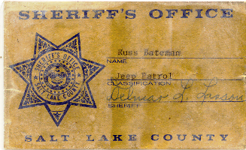I had been working with the Governs office through his administrative assist, Ron Swenson. However, one day, Ron contacted to tell me that I had to stop calling talk shows and bad-mouthing those who were opposed this new telecommunications program as it upset the Governor. I told Ron that I have never called a talk show in my life. Later Ron contacted my Director stating that I was still bad-mouthing that group on talk radio. I found that it was just a ploy to assonate my relations with the Governor Rampton. I was now bared from accessing the Governors Office.

Reprehensive Todd G Weston join the group. This group gain a strong position when Governor Levitt was elected. There were others that I didn’t know their names and positions. Their interest was stronger control over the State of Utah, Including the implantation of a State Police System. These were the primary leaders in the State of Utah Progressive Group (a socialist group wanting the State Government to have total control of Cities and Counties governments).

LDS President and former Secretary of Agriculture (Eisenhower Administration) Ezra Taff Benson wrote.

***It is a firm principle that the smallest or lowest level that can possibly undertake the task is the one that should do so. First, the community or city. If the city cannot handle it, then the county. Next, the state; and only if no smaller unit can possible do the job should the federal government be considered. This is merely the application to the field of politics of that wise and time-tested principle of never asking a larger gr a larger group to do that which can be done by a smaller group. And so far as government is concerned the smaller the unit and the closer it is to the people, the easier it is to guide it, to keep it solvent and to keep our freedom.***

In my communications training at the Civil Defense Staff College, we were taught that Emergency Management was best done at the low level possible. In communications, The City should control their own Communications. If a City is too small, that it should be the Country. So following this guide lines, Lionel Dradge and I licensed all the Radios to the owners of the equipment. Hospitals Radios were licensed to the owner of the Hospital, Ambulance Radio were licensed to the owners of the Ambulances.

This blocked the State taking over the Emergency Medical Communications Systems. Lionel Dradge and I followed with licensing more than half of the County Sheriff's and many Cities on their own frequencies. Example: I worked with Mac Kay Larson to license Washington County Sheriff and I licensed St. George City police on their own frequency. I worked with Chief Exell in setting up the Hurricane City Police communications. The RWJ provided funds to place a Base Station in every County Sheriff Office in the Six County area and later I worked with the five country Sheriffs, but couldn’t come up with RJW funding. This blocked the Utah Progressive group form taking full control of the Public Safely Communications.

At the time that the 1970 Utah state Telecommunications plan was written, only Ogden, Salt Lake City and Provo City Police had their own frequency. I had no problem with the UHP dispatching for the local communities as it did serve to have better coordination, especially in the rural areas. Ned Worensky and Ralph Dart, the two Utah Highway Patrol Chief Dispatchers work with writing the 1970 Telecommunications Plan,

At that time, the Motrack Mobile two way radios was considered the best mobile radio available in the United States You see these radios on the TV show“ADAM 12”.Prior to the Motrack, radios at most were 2 channel. The Motrack had four channels, packages in a   
  
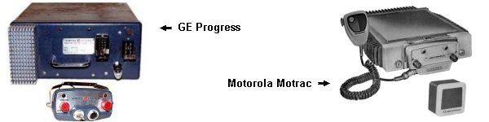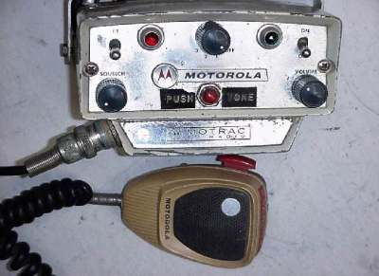 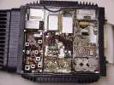  
convenient package for mobile installations. The only competition was the GE Progress line but they were not very popular. (later GE came out with their Master II which was superior to the Motrack and the Micor,

I join with Jack Brigance, radio person for Utah Natural Recourses (Forestry and Fire Control), fish and Game in setting up his department communications. The Utah Department of Highways refused to support the move to High Band and expanded their Low Band program. However later, when they realized the importance of the High Band repeater system, the adjacent states had taken all the Highway Department frequencies and with some politics, they took frequencies from of the Natural Recourses.

In attempt to limit me, I was transferred to Richfield to work with the Five County and the Six County groups. I was given my State Car to use, an Office and a Secretary and told to just sit there and do nothing unit I started to draw my retirement.

Robert Wood Johnson Foundation gave the Six County area $50,000 to Develop Emergency Communications. Later when their evaluation group came through, they were impressed with what I had done with the $50k. When they looked over that the State had done in the Salt Lake Area, the funding went into salaries and there was nothing to show for their funding. They took the remaining $160,000 away from them and brought it down to the Six County area and told me to continue the development that I had started.

With this funding, I tied the Six County Emergency Services, Sheriff, City Police, Fire Departments, Emergency Medical, Search and Rescue groups together, each county independent, but coordinated.

All though I didn’t have access to funding for the five county areas, I made suggestions of equipment and purchasing procedure with a goal of each county having a frequency of their own and a base station in their Offices.

Senator Thrope Waddingham was contacted fort this with a number of telephone calls. A copy of the reply: (

STATE OF UTAH

BUDGET COMMITTEE

Ace of the Legislative Fiscal analyst

419 STATE CAPITOL - SALT LAKE CITY 84114

LEO L. MEMMOTT

LEGISLATIVE ANALYST

SENATE MEMBERS

DIXIE LEAVITT, CHAIRMAN

Omar B. Bunnell

HOUSE MEMBERS

SIDNEY J. ATKIN CHARLES E. BENNETT

November 30, 1976

Senator Thorpe Waddingham 615 North 100 West

Delta, UT 84624

Dear Senator Waddingham

,

Regarding your request for additional information concerning the proposed regionalization of the Office of Emergency Services. It has been proposed by the Office of Emergency Services, and approved by the Council of Defense, that the Office of Emergency Services be realigned to conform with the existing multi-county planning districts. It was felt that this approach will insure maximum efficiency in the development of a statewide emergency response capability. The proposed regionalization of the Office of Emergency Services would be accomplished over a period of four years. This program would expand the staff of their office from its present staffing level of 9 to 14.

This proposal has been discussed by the legislative subcommittee on transportation and public safety over the last two years. Each year the subcommittee has unconditionally denied funding this concept. Subsequently in 1975 the communications officer was transferred to Richfield and is currently fulfilling the position of area coordinator to the eleven county area. The Office of Emergency Services intends to fill the vacancy created by the transfer of the communications officer by hiring a Deputy operations/Communication officer at grade 21.

The-office of emergency services has not followed the intent of the Legislature as set forth in the 1975 and 1976 legislative subcommittee hearings.. The Legislative, intent is quoted below.

"The Legislature denied a $34,800 workload increase. These funds were to be used to begin a regionalization program to provide emergency response capabilities along multi-county planning district lines. In denying the workload increase request the Legislature indicates its intent that state funds are not to be used in the development of emergency response capabilities at local levels of government. The Legislature recognizes that the state has an obligation to provide assistance to local units of government in developing emergency response capabilities, but maintains that local entities should bear the cost of such a program."

***As a follow-up on the intent statement expressed by the Legislature, I have been to many of the major cities in the eleven county areas served by Russel Bateman. One can only be impressed with his efforts to improve the emergency and medical communication capability in these outlying regions of the state. On the other hand, it was also noted that, he was actually performing many services to these cities and counties that they themselves should have been providing. For example, he would not only design an emergency communication network for a local community, he would also install and maintain the equipment in the hospital and the ambulance vehicles for them. As an emergency operations advisor to the eleven counties, he was not only assisting the counties in the design and development of emergency operational plans for these communities, he also wrote-up the plans and filled out the necessary government forms in behalf of the designated community civil defense coordinator. It was also noted that he concentrated his efforts in three or four principle cities in the 11 county areas while the needs of the more outlying areas were being neglected. On several occasions the civil defense coordinators in the more remote areas complained about not receiving the kind of help or direction that they felt entitled to from the state regional coordinator*.**

There are some very definite advantages and disadvantages to the regionalization program enitiated to the Office of Emergency Services. The Legislative Analyst recommended that the subcommittee again discuss the "Regionalization Concept" in depth with the agency then make a decision as to the implementation of this plan. Although the legislature has denied any state support in the past by not funding the program, they have not been opposed to the concept. But they feel that the cities and counties should finance the concept out of their own funds.

If there are any further questions, .please feel free to contact this office: thank you.

Sincerely,

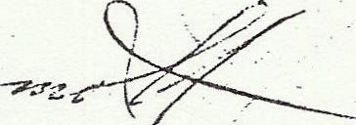

Leo L. Memmott

Legislative Fiscal Analyst

LLM:ag

Enclosures

STATE OF UTAH

BUDGET COMMITTEE

Ace of the Legislative Fiscal analyst

419 STATE CAPITOL - SALT LAKE CITY 84114

There was a campaign to protect my assignment and Office in Richfield. A number of letters, telephone calls and personal contact were made in my behalf. These letter show that I had contact and good relations with all the Counties and Cities in the five and Six County Areas

Robert Wood Johnson Foundation (RWJ) contributed a lot of private money to Utah to develop Emergency care and facilities. My hospital /ambulance received RWJ support and funding. (See my chapter 11) I applied for another $50,000 for use in the Six County area. The new money gave a new start for added radios in County Sheriff’s offices. After the funds were expended, a five man RWJ came to see the results of the funding. They were not hap[y with the funds given to the State in the Salt Lake area. As the funding was being use for Salaries and other projects what didn’t represent the intent of the program. RWJ pulled $160,000 of funds that hadn’t been spend and dedicated it to the six county projects. This was my death warrant as an employee of the State of Utah. I was also consulting with other state agencies.

Below are some of the letters written in my support? There were also telephone and personal contacts which I have no written copy of. The actual letter is shown as an icon with the test of the letter OCR for better readability.

***1976 01 17 Garfield County Sheriff***

***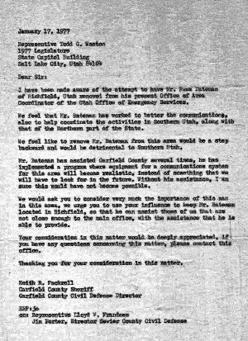Reprehensive Todd G. Weston  
1977 Legislature, State Capitol Building  
Salt Lake City, Utah***

***Dear Sir:***

***I have been made aware of the attempt to have Mr. Russ Bateman of Richfield, Utah removed from his present office of area coordinator of the state office of emergency services. We feel that Mr. Bateman has worked to better the communications, also to help coordinate the activities in southern Utah, along with that of the northern part of the state. We feel like to remove Mr. Bateman from this area would be a step backwards and would be detrimental to southern Utah***

***Mr. Bateman has assisted Garfield County several times, he is implemented a program where equipment for communication system for this area will become realistic, instead of something that will have to look for the future. Without his assistance, I’m sure this would not have been possible. We would ask you to consider the very much the importance of this man in our area, we urge you to use your influence to keep Mr. Bateman located in Richfield, so that he can assist those of us that are not close enough to the main office, with the assistance that he is able to provide.***

***Your consideration on this matter would be greatly appreciated, if you have any questions concerning this matter, please contact this office.***

***Keith R Fackrell, Garfield County Sheriff. Garfield County Civil Defense Director***

***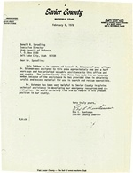***.~~~~~~~~~~~~~~~~~~~~~~

***1976 02 09 Sevier County Sheriff***

***Donald R. Spradling***

***Executive Director***

***Utah Council of Defense***

***P. 0. Box 8100***

***Salt Lake City, Utah 84108***

***Dear Mr. Spradling:***

***This letter is in support of Russell R. Bateman of your office. Mr. Bateman was assigned to this area approximately one and a half years ago and has provided valuable assistance to this office and our county. The Sevier County Jeep Posse has made him an honorary member because of the assistance he has provided them in obtaining surplus and excess material for use in search and rescue operations.***

***Mr. Bateman has been very helpful to Sevier County in giving technical assistance in developing our emergency resources and co­ordination. We would certainly like him to remain in his present position in our county.***

***Very truly yours,***

***Rex L. Huntsman***

***Sevier County Sheriff***

***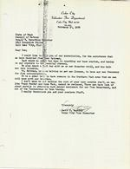1976 02 10 Cedar City volunteer Fire Department***

***State of Utah  
Council of Defense  
Donald R. Spradling Director***

***Dear Don,***

***I would like to tell you of our appreciation, food assistance that we have a receipt from Russ Bateman.   
Last week he spent two days in remodeling our base station, retuning the crystals to the hospital channel.  
He spent a full day with us on our disaster drill, and his help was very valuable  
Mr. Bateman is also helping us to get our license, to have our own frequency for fark communications. It’s great to have help from someone in southern Utah that we can call upon with her troubles  
I don’t mean not to mention the rest of the very capable staff, and men like Frank Reeder and Dana Peck, cannot be replaced. These men have been great in obtaining much-needed equipment for our fire department and all of the committees in our County,  
I really appreciate to near complete staff.***

***Sincerely  
David E Bentley, Cedar city fire inspector***

~~~~~~~~~~~~~~~~~

***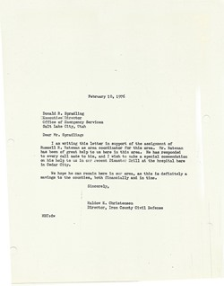1976 02 10 Iron County Civil Defense***

***February 10, 1976***

***Donald R. Spradling Doprectpr***

***Office of Emergency Services***

***Salt Lake City, Utah***

***Dear Mr. Spradling***

***I am writing this letter in support of the assignment of Russell R. Bateman as area coordinator for this area. Mr. Bateman has been of great help to us here in this area. He has responded to every call made to him, and I wish to make a special commendation on his help to us in our recent Disaster Drill at the hospital here in Cedar City.***

***We hope he can remain here in our area as this is definitely a savings to the counties, both financially and in time.***

***Sincerely,***

***Haldow E. Christensen***

***Director, Iron County Civil Defense***

***District Judge***

***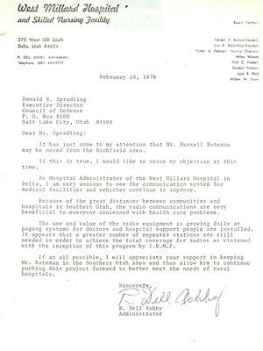1976 02 10 West Millard Hospital Delta***

***West Millard County Hospital***

***Donald R. Spradling***

***Executive Director***

***Council of Defense***

***P. 0. Box 8100***

***Salt Lake City, Utah 84108***

***Dear Mr. Spradling:***

***It has just come to my attention that Mr. Russell Bateman may be moved from the Richfield area.***

***If this is true, I would like to voice my objection at thistime.***

***As Hospital Administrator of the West Millard Hospital in Delta, I am very anxious to see the communication system for medical facilities and vehicles continue to improve.***

***Because of the great distances between communities and hospitals in Southern Utah, the radio communications are very beneficial to everyone concerned with health care problems.***

***The use and value of the radio equipment is growing daily as paging systems for doctors and hospital support people are installed. It appears that a greater number of repeater stations are still needed in order to achieve the total coverage for radios as versioned with the incepting of this program by I.R.M.P.***

***If at all possible, I will appreciate your support in keeping Mr. Bateman in the Southern Utah area and thus allow him to continue pushing this project forward to better meet the needs of rural hospitals.***

***Sincere***

***_Pic1***

***\,,***

***R. Dell Ashby  
Administrator***

***~~~~~~~~~~~~~~~~~~~~~~~~~~~~~~~~***

***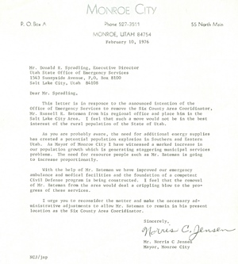1976 02 Monroe City***

***P. 0. Box A Phone 527-3511 55 North Main***

***MONROE, UTAH 84754***

***February 10, 1976***

***Mr. Donald R. Spradling, Executive Director Utah State Office of Emergency Services 1543 Sunnyside Avenue, P.O. Box 8100***

***Salt Lake City, Utah 84108***

***Dear Mr. Spradling,***

***This letter is in response to the announced intention of the Office of Emergency Services to remove the Six County Area Coordinator, Mr. Russell R. Bateman from his regional office and place him in the Salt Lake City Area. I feel that such a move would not be in the best interest of the rural population of the State of Utah.***

***As you are probably aware, the need for additional energy supplies has created a potential population explosion in Southern and Eastern Utah. As Mayor of Monroe City I have witnessed a marked increase in our population growth which is generating staggering municipal services problems. The need for resource people such as Mr. Bateman is going to increase proportionally.***

***With the help of Mr. Bateman we have improved our emergency ambulance and medical facilities and the foundation of a competent Civil Defense program is being constructed. I feel that the removal of Mr. Bateman from the area would deal a crippling blow to the pro­gress of these services.***

***I urge you to reconsider the matter and make the necessary ad­ministrative adjustments to allow Mr. Bateman to remain in his present location as the Six County Area Cooridinator.***

***Sincerely,***

***Mr. Norris C Jensen Mayor, Monroe City***

***NCJ/jnp***

~~~~~~~~~~~~~~~~~~~~~~~~~~~~~  
***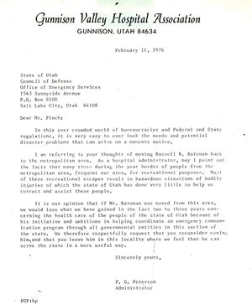1976 02 11 Gunnison Valley Hospital***

***Gunnison Valley Hospital Association***

***GUNNISON, UTAH 84634***

***February 11, 1976***

***State of Utah***

***Council of Defense***

***Office of Emergency Services***

***1543 Sunnyside Avenue***

***P.O. Box 8100***

***Salt Lake City, Utah 84108***

***Dear Mr. Finch:***

***In this over crowded world of bureaucracies and Federal and Stato regulations, it is very easy to over look the needs and potential disaster problems that can arise on a moments notice.***

***I am referring to your thoughts of moving Russell R. Bateman back to the metropolitan area. As a hospital administrator, may I point out the facts that many times during the year hordes of people from the metropolitan area, frequent our area, for recreational purposes. Most of these recreational escapes result in hazardous situations of bodily injuries of which the state of Utah has done very little to help us correct and assist these people.***

***It is our opinion that if Mr. Bateman was moved from this area, we would lose what we have gained in the last two to three years con­cerning the health care of the people of the state of Utah because of his initiative and ambitions in helping coordinate an emergency commun­ication program through all governmental entities in this section of the state. We therefore respectfully request that you reconsider moving him and that you leave him in this locality where we feel that he can serve the state in a more useful way.***

***Sincerely yours,***

***F. G. Peterson Administrator***

***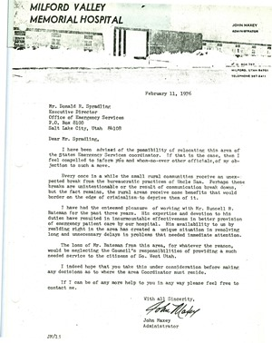1976 02 11 Milford Valley Hospital***

***MILFORD VALLEY MEMORIAL HOSPITAL***

***February 11, 1976***

***Mr. Donald R. Spradling Executive Director.***

***Office of Emergency Services P.O. Box 8100***

***Salt Lake City, Utah 84108***

***Dear Mr. Spradling,***

***I have been advised of the possibility of relocating this area of the States Emergency Services coordinator. If that is the case, then I feel compelled to inform you and whom-so-ever other officials, of my ob­jection to such a move.***

***Every once in a while the small rural communities receive an unex­pected break from the bureaucratic practices of Uncle Sam. Perhaps these breaks are unintentional or the result of communication break downs, but the fact remains, the rural areas receive some benefits that would border on the edge of criminalism, to deprive them of it.***

***I have had the esteemed pleasure of working with Mr. Russell R. Bateman for the past three years. His expertise and devotion to his duties have resulted in insurmountable effectiveness in better provision of emergency patient care by our hospital. His availability to us by residing right in the area has created a unique situation in resolving long and unnecessary delays in problems that needed immediate attention.***

***The loss of Mr. Bateman from this area, for whatever the reason, would be neglecting the Council's responsibilities of providing a much needed service to the citizens of So. West Utah.***

***I indeed hope that you take this under consideration before making any decisions as to where the area Coordinator must reside.***

***If I can be of any more help to you in any way please feel free to contact me.***

***With all Sincerity,***

***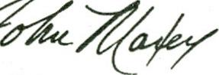***

***John Maxey Administrator***

***JM/li***

***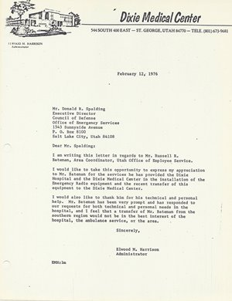1976 02 12 Dixie Medical Center***

*** Dixie Medical Center***

***February 12i 1976***

***Mr. Donald R. Spalding***

***Executive Director***

***Council of Defense***

***Office of Emergency Services***

***1543 Sunnyside Avenue***

***P. O. Box 8100***

***Salt Lake City, Utah 84108***

***Dear Mr. Spalding:***

***I am writing this letter in regards to Mr. Russell R. Bateman, Area Coordinator, Utah Office of Employee Service.***

***I would like to take this opportunity to express my appreciation to Mr. Bateman for the services he has provided the Dixie Hospital and the Dixie Medical Center in the installation of the Emergency Radio equipment and the recent transfer of this equipment to the Dixie Medical Center.***

***I would also like to thank him for his technical and personal help. Mr. Bateman has been very prompt and has responded to our requests for both technical and personal needs in the hospital, and I feel that a transfer of Mr. Bateman from the southern region would not be in the best interest of the***

***hospital, the ambulance service, or the area.***

***Sincerely,***

***Elwood M. Harrison Administrator***

***EMH: lm***

***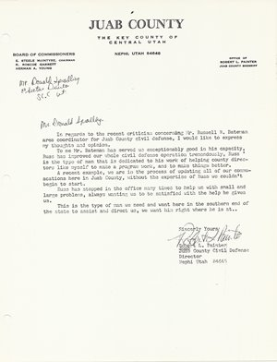1976 02-13 Juab County Sheriff & Civil Defense***

***In regards to the recent critics’ concerning Mr. Russell R. Bateman. Area coordinator for Juab County civil defense, I would like to express my thoughts and opinion.***

***To me Mr. Bateman- has served us exceptionably good in hit capacity, Russ -has improved our whole civil defense operation tremendously, Russ ' is the type of man that is dedicated to his work of helping county direc­tors like myself to make a program work, and to make things better.***

***A recent example, we are in the process of updating all of our communications here in Juab County, without the expertise of Russ we couldn't begin to start.***

***Russ has stopped in the office many times to help us with small and large problems, always wanting us to be satisfied with the help he gives us.***

***This is the type of man we need and want here in the southern end of the state to assist and direct us, we want him right where he is at..***

***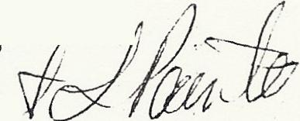  
Robert L Painter  
Juab County Sheriff and Civil Defense Director***

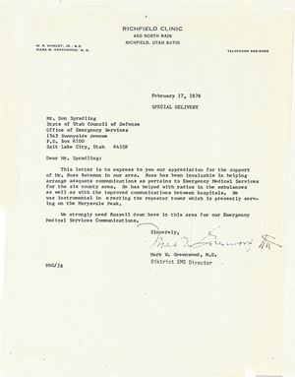1976 02 17 District EMS Director Mark Greenwood M, D,

RICHFIELD CLINIC

460 NORTH MAIN

RICHFIELD, UTAH 84701

W. R. WORLEY, JR., M.D.

MARK W. GREENWOOD, M. D. TELEPHONE 896.5496

February 17, 1976 SPECIAL DELIVERY

Mr. Don Spradling

State of Utah Council of Defense Office of Emergency Services 1543 Sunnyside Avenue

P.O. Box 8100

Salt Lake City, Utah 84108

Dear Mr. Spradling:

This letter is to express to you our appreciation for the support of Mr. Russ Bateman in our area. Russ has been invaluable in helping arrange adequate communications as pertains to Emergency Medical Services for the six county area. He has helped with radios in the ambulances as well as with the improved communications between hospitals. He was instrumental in erecting the repeater tower which is presently serv­ing on the Marysville Peak.

We strongly need Russell down here in this area for our Emergency Medical Services Communications.

Sincerely,

Mark W. Greenwood, M.D.

District EMS Director

1976 02 17 Six-County Commissioners Organization

|  |  |
| --- | --- |
| _Pic1 | 1976-02-6COUNTY05February 17, 1976 |

***SIX- COUNTY COMMISSIONERS ORGANIZATION***

***Donald Executive Director***

***State of Utah Council of Defense Office of Emergency Services 1543 Sunnyside Avenue***

***P. 0. Box-8100***

***Salt Lake City, Utah 84108***

***Dear Mr. Spralding:***

***It has come to our attention that some consideration is being given to eliminating the position of Emergency Services Coordinator, serving the Central Utah and Southern Utah Districts.***

***On behalf of the Six-County Commissioners Organization, we want to ex­press appreciation for the Emergency Services planned, developed, and implemented in the six counties of Central Utah through the efforts of Russell Bateman.***

***Decentralization of services has been the trend of state and federal programs for greater beneficial use by local government and for better service to the public.***

***As an organization representing the citizens of Central Utah in Millard, Juab, Sanpete, Sevier, Wayne, and Piute counties; we hope, and strongly urge, the administrators of the State Emergency Services to continue the activities of Russell Bateman in our behalf at the local level.***

***It is to our advantage and that of the state to maintain a position to carry out the activities of Emergency 'Services at the grass roots level of operation.***

***Again, we express our appreciation for the services rendered to this point in time and hope that these services may continue in the future.***

***truly yours,***

***Marve J Ogden, Executive Director***

***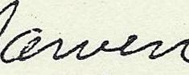***

***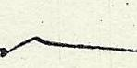***

***EXECUTIVE COMMITTEE***

***Keith Jorgensen, .Chairman Dean Nielsen, Vice:Chairman Steele McIntyre, Sec.-Treas. Basil Lay, Asst.Treasurer Harold Stewart***

***Kenneth Rees***

***~~~~~~~~~~~~~~~~~~~~~~~~~~~~~~~~~~~~~~~~~~~~~~***

***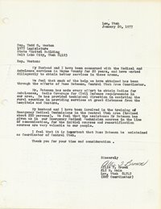1977 01 20 Loa EMT Coordinator***

***Loa\* Utah***

***January 20, 1977***

***Rep. Todd G. Weston***

***1977 Legislature***

***State Capitol Building***

***Salt Lake City, Utah 64103***

***Rep. Weston:***

***My Husband and I have been concerned with the Medical and Ambulance services in Wayne County for 20 years, and have worked diligently to obtain better services in these areas,***

***We feel that much of the help we have obtained has been through the efforts of Russ Bateman, Centro1. Utah Area Coordinator.***

***Mr. Bateman has made every effort to obtain Radios for Ambulances, Radio Coverage for Civil Defense requirements in our area, He has provided technical direction in assisting the rural counties in providing services at great distances from the hospitals and Doctors.***

***My husband and I have been involved in the training of Emergency Medical Technicians in the Central Utah Area (trained about 250 persons), We feel that the assistance Mr. Bateman has given us in our Emergency Medical Technician courses in the line of communication, for the initial courses and recertification courses are very valuable to our people.***

***I feel that it is important that Russ Bateman be maintained as Coordinator of Central Utah.***

***Thank you for your time and consideration***

***Sincerely***

***A Brown***

***215 N. Main***

***Loa\* Utah 84747 (EMT Coordinator)***

***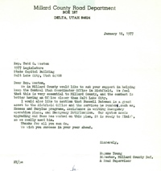1977 01 18 Millard County Road Department***

***Reprehensive Todd G Weston, 1977 legislature, state office building, Salt Lake City Utah***

***Dear Rep. Weston.***

***We in Millard County would like to ask your support and helping keep the central Utah coordinator office in Richfield. We feel that it is very central to Millard County, and the contact is better having an office closer than Salt Lake City.  
I would like also to mention that Russell Bateman is a great asset to the Richfield office and the services he renders us such as excess and surplus properties, assistance in writing emergency operation plans, and emergency not fire. Our system needs upgrading and Russ has worked on this plan, and it is ready to finish, so we really need him.  
Thanks for all you do.***

***We wish you success in your year ahead.***

***Sincerely,***

***Eugene Young, Director, Millard County road supervisor.***

***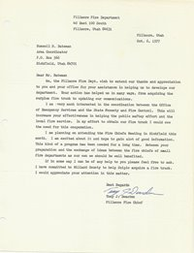1977 10 06 Fillmore Fire Department***

***40 East 100 South***

***Fillmore, Utah 84631***

***Fillmore, Utah***

***Oct. 6, 1977***

***Russell. R. Bateman***

***Area Coordinator***

***P.O. Box 566***

***Richfield, Utah 84701***

***Dear Mr. Bateman***

***We, the Fillmore Fire Dept. wish to extend our thanks and appreciation to you and your office for your assistance in helping us to develop our department. Your action has helped us in many ways, from acquiring the surplus fire truck to updating our communications.***

***I am very much interested in the coordination between the Office of Emergency Services and the State Forestry and Fire Control. This will increase your effectiveness in helping the public safety effort and the local fire service. In my effort to obtain our fire truck I could see the need for this cooperation.***

***I am planning on attending the Fire Chiefs Meeting in Richfield this month. I am excited about it and hope to gain a lot of good information. This kind of a program has been needed for a long time. Between your preparation and the exchange of ideas between the fire chiefs of small fire departments as our own we should be well benefited.***

***If in some way I can be of any help to you please feel free to ask. I have committed to Millard County to help Scipio acquire a fire truck. I would appreciate your attention in this matter.***

***Best Regards***

***Tony J. Dearden***

***Fillmore Fire Chief***

~~~~~~~~~~~~~~~~~~~~~~~~~~~~~~~~~~~~~~~~~~~~~~

1977-09 20 Sanpete County SAR

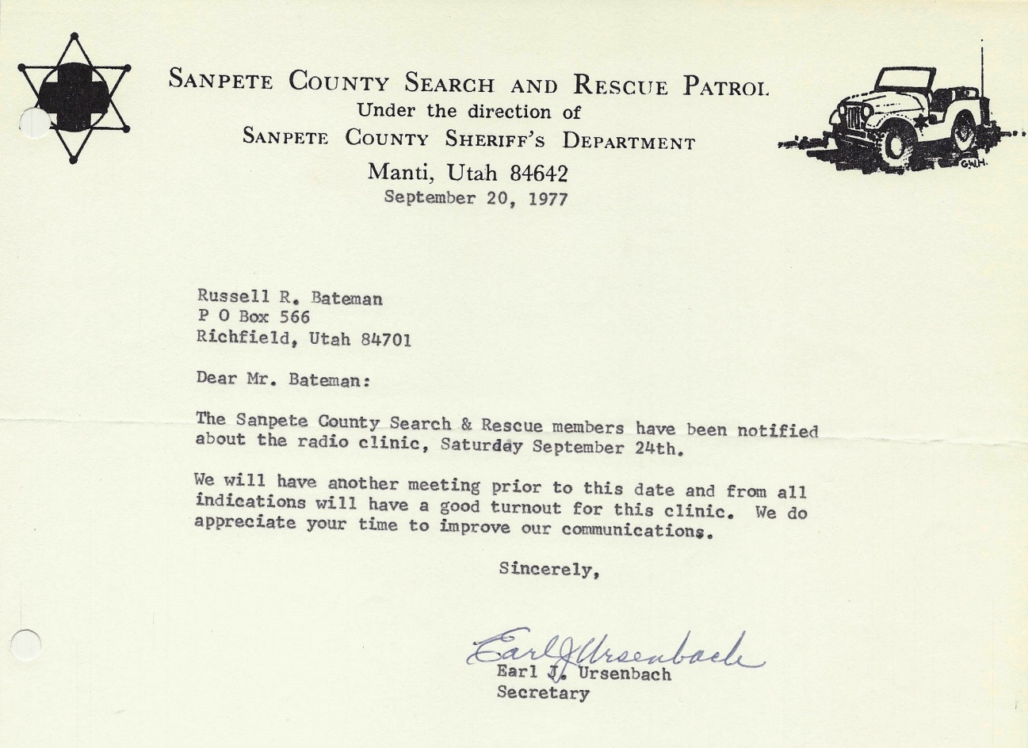

I was a salaried State Employee, I seen a need to help County Search and rescue units. At that time, public safety two- way radios were required check and set on frequency annually. A 2nd class FCC Radio Telephone license was required and I was properly licensed. I scheduled time with many of the County Jeep Posses to perform this requirement on my own time, with my own equipment and received no monetary reimbursement.

When I was transferred to Richfield and told by The Progressive Group that I could set at my desk and do nothing until I retired. I am not that kind of a person,

***1977 01 06 Governor Fires 3 Members of the Defense Council***

***Three members of the Utah State Counsel Defense who voted for against executive department wishes that director of the office of emergency services be fired, were fired themselves Wednesday by Gov. Scott Matheson.***

***The governor said he requested resignations – a governmental form of firing – from Council Chairman Robert R Finch, Salt Lake City; Joseph C. Empey, St. George; and Herbert Price,, Salt Lake City.***

***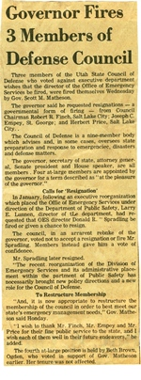The counsel defense is a nine-member body which advises and, in some cases, oversees the state preparation and response for emergencies, disaster and defense matters.***

***The governor, Secretary of State, Atty. Gen., Senate President and House Speaker, are all members. For at-large membership are appointed by the Governor for term described as at the pleasure of the governor.***

***Costs for “Resignation”***

***In January, following an executive reorganization which place the office of emergency services under the direction of the public safety, Larry E London, director of the department, had requested that OE S director Donald R Spralding be fired or given a chance to resign.***

***Council in an arrarent rebnke of the governor, voted not to accept the resignation or fire Mr. Spralding. Members of said gave him a vote of confidence.***

***Mr. Spralding later re-signed.***

*There is an organization of the division of emergency services and its administrative place within the Department of Public Safety has necessarily brought a new policy of directions and new role for the counsel defense.*

*To restructure membership*

*“And, it is now appropriate to restructure the membership of the counsel in order to best meet our states emergency management needs,” Gov. Matheson said Monday.*

*I wish to thank Mr. Finch, Mr. Empey and Mr. Price for the fine service to the state, and I wish each of them well in their future endeavors, he added.*

*The fourth at-large position is held by Beth Brown, of Ogden, who voted in support of Gov. Matheson earlier.*

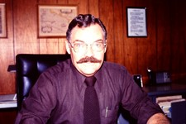

I feel deep remorse for the Firing of my Director, Don Spralding and members of the council of Defense. I feel that they were fired trying to protect me and my job.

Bob Finch was a high level Salt Lake Attorney. To be fired as the Chairman of the Council of Defense meant very little to his economic status, as he received no remuneration for the position. I met Bob Finch when he attended my Amateur Radio Class with his Son, Randy. (See chapter 14) I felt that Bob Finch may have pressured Don in the stand to protect my job.

For my director Don Spralding to lose his job was a major adjustment in his life. He like me, Dearly loved his job and was doing a great job.

They were republicans appointed by Democratic Governor Rampton. The only members of the council of Defense that were not fired were Democrats. I feel that the progressive Group was seeking control of Emergency Services Department for their access to Federal Funds.

The Department of Emergency services had less than ten members during the 15 years that I was an employee. In the next few months, the staff members grew to over 160 employees and last I heard, it was down to 70 members. They were given police powers as now they were part of the Utah Home Land Security.

Several years later, I talked with Larry Lunnen. He said that he was only a figure head and seemed to have no input to what was happening. I felt that he was saying that the State progressive group had taken over and were kind dictator form of government.

I really enjoyed my position as a staff member in the Department of Emergency Services. I was pressured out of my position, not for not doing my job, but doing too much. The Progressive Group now had the ear of Governor, new Governor Scott Matheson.