THE BEST YEARS TO BE ALIVE IN THE HISTORY OF THE WORLD

Russell Rulon Bateman History

**Chapter 09 CONVAIR VOLTEE AIRCRAFT 1954 - 1961**

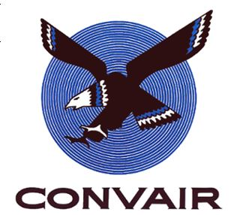I took leave, the last two months of my six years active duty in the Navy, got married (See chapter 02) went to work for Convair San Diego, California. Our plans were to find temporary work during the summer and then go to BYU on my GI Bill.

My Bishop Calvin Judd was a second level supervisor at Convair helped get me a special assignment in the CONVAIR TEST EQUIPMENT MODEL SHOP, starting 1 April 1954. The shop was primarily high skilled machinist with many years of background and experience. My first few months were very stressful as I gained the name of “SCREW-UP” because they felt that I ruined several items that were given to me to work on. I didn’t seem to fit in as I was unskilled working with extremely skilled people. “DON’T GIVE IT TO “SCREW-UP”, TO WORK ON AS HE WILL DISTROY IT”, was the common comment.

The assignment of the CONVAIR TEST EQUIPMENT MODEL SHOP to support the special equipment required for testing the CONVAIR Air Craft that was being developed. We fabricated the various brackets, special test gear, wiring harnesses, Etc,. This was a wide range of projects. The F102 “Delta Dart” jet and the CONVAIR LINER 240 were just completing and going in to production. The F106 Delta Dagger” design was the high priority project, getting the first test aircraft ready to fly.

The aircraft design and development support were for the projects as sown below.

|  |  |  |  |  |
| --- | --- | --- | --- | --- |
| H:\##@##RUSS HISTORY\Convair\Convair-340-1-150.jpg | H:\##@##RUSS HISTORY\Convair\convair580-44-150jpg.jpg | H:\##@##RUSS HISTORY\Convair\Convair880-150.gif | H:\##@##RUSS HISTORY\Convair\CONVAIR-R3Y-150.jpg | H:\##@##RUSS HISTORY\Convair\ConvairPogoStick-150.jpg |
| Convair 340 | Convair 580 | Convair 880 | Convair R3Y | Convair XFY-1 |

|  |  |  |  |
| --- | --- | --- | --- |
| H:\##@##RUSS HISTORY\Convair\Sea Dart-Convair-200.jpg | H:\##@##RUSS HISTORY\Convair\f102 Deltadagger1-150.jpg | H:\##@##RUSS HISTORY\Convair\f106-04-150.jpg | C:\Users\Dixieson\Desktop\My Dropbox\Russ\convair T-29.jpg |
| Convair Sea Dart | Convair F102 | Convair F106 | Convair T29 |

I really liked the work and put a lot of effort into my assignments. It took a few months, but then electronic technology entered the testing and became a major impact on the Model Shop. Those who gave me a hard time were now coming to me for help. I submitted a number of suggestions and received awards. One of them was pulsing - reversing the polarity of the plating machine which improved the plating and reduced the time required.

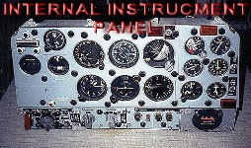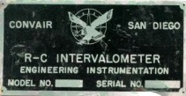 The main suggestion that I made was an R-C Intervalometer. The mechanical Intervalometer was a set of cams milled by the Machinist to pulse a 35 MM camera taking pictures of a duplicate instrument panel (same as the pilot were seeing) located in a remote area of the aircraft being tested. The fabrication of the Mechanical Intervalometer was a long process and they were way behind in the production and not meeting the demands for the flight testing requirements. I asked one of the Instrumentation Design Engineers if there was a precision timed pulse required. He said no, they needed to be able to select pulse speed for the camera to meet the requirement of the 35 MM camera. The timing was not critical. I submitted a suggestion of using an RC Intervalometer that would use a simple charging of a capacitor with a variable (pot) adjustable control to replace the Mechanical Intervalometer. It gave me a special feeling to see the production of a device made from my suggestion.

I was promoted to the night “Camera Bench”. I would check out the 35mm cameras, fabricate brackets etc., whatever was required for the cameras to be placed in the Aircraft that was being flight tested the next day. I was given the schedule of the test requirements and I had to have the cameras and mounting brackets ready.

[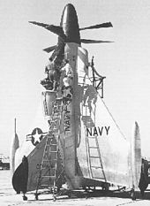](http://en.wikipedia.org/wiki/File:Convair_XYF-1_Pogo.jpg)One example of a test was the Pogo Stick. I had known of the flight test and had my part ready for a special flight that was scheduled for the ‘Pogo Stick”. The **Convair XFY Pogo** [tailsitter](http://en.wikipedia.org/wiki/Tailsitter) was an experiment in [vertical takeoff and landing](http://en.wikipedia.org/wiki/VTOL). The Pogo Stick had [delta wings](http://en.wikipedia.org/wiki/Delta_wing) and three-bladed [contra-rotating propellers](http://en.wikipedia.org/wiki/Contra-rotating_propellers). In May 1951, [Lockheed](http://en.wikipedia.org/wiki/Lockheed_Corporation) and [Convair](http://en.wikipedia.org/wiki/Convair) were awarded contracts in the attempt to design, construct, and test two experimental VTOL fighters that would be suitable for use by the Armed forces. The Navy wanted an aircraft that could take off vertically from a ship. On 19 April 1954, a Convair engineering test pilot and Marine reservist, Lieutenant Colonel [James F. "Skeets" Coleman](http://en.wikipedia.org/wiki/J._F._Coleman), made the first tethered flight in the Pogo. (Hovering Test of the air craft with safety constraints). 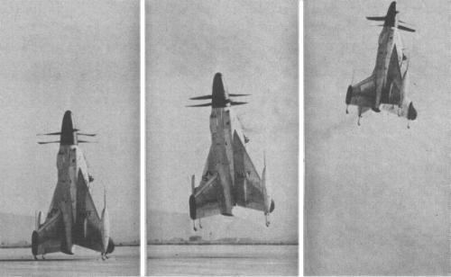This was a propeller type aircraft sit on it tail for taking off.

I knew about special the upcoming test flight as I had to get the camera ready. So the next day, I skipped going to school and took my wife to the secret place (The Naval Auxiliary Air Station in Brown Field , California near the Mexican Border South of San Diego) where the test was to be conducted. Why was it kept secret? If it failed, they didn’t want all the publicity. My wife and I were some of the few that witnessed the first successful Conversion Vertical takeoff and landing of a vertical Aircraft (VTOL) in the world on November 2, 1954 when it transitioned and flew horizontally for 21 minutes. Just two days later, the aircraft made its public debut.

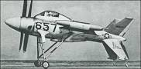The Navy awarded contracts to Convair and Lockheed to design, build, and fly experimental VTOL fighters in May 1951. Each company agreed to build two prototypes but in the end, they built only one Lockheed XFV-1 and one Convair XFY-1 Pogo. The Lockheed XFV-1 never made a vertical takeoff and landing, only taking off horizontally. The XFY-1 could not only takeoff and land vertically it could also transition to horizontal flight and back and did so many times.

It had been a great day for Convair, with the success of the Pogo flight, but only received minor publisity.

However, the disaster of the Convair XF2Y Sea Dart at about the same time on 4 November 1954 received publisity world wide.

Five SeaDart aircrafts were built and their were plans to build 22 for the Navy. The first four had two retractd water-skis and the last SeaDart only had single water-skis. The SeaDart had gone though a test period of water taxing and several water take offs and landings. The big public debut was the same day as the official debut of the Pogo, except there was a lot of interest to see the Navy Jet fighter take off on the water.

I was aware of the event, both from my camera bench scheduling and all the publisity on the Radio and news papers. I was unable to see it as I had to “punch in” at work about the same time as of the flight.

Convair test pilot Charles E. Richbourg made the initial flight tests of the number two SeaDart. On August 3, 1954, Richbourg took the Sea Dart through the sound barrier. This made the Sea Dart the first (and to date the only) seaplane to go supersonic.

Unfortunately, Richbourg was killed on November 4 of that year while demonstrating the number two SeaDart over San Diego Bay to Navy officers and press representatives. It seems that the aircraft had gotten pushed past its safety margin during a low-altitude, high-speed fly-past, and the plane disintegrated in midair as a result of pilot-induced pitch oscillations. Bits and pieces of flaming debris fell into the bay. I still remember the rather vivid photos of this 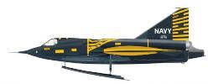accident that appeared in *Life* magazine and all the Newspapers. All SeaDart operations were suspended after the crash. There were some additional tests made, but no additional SeaDarts were built.

Three of the Surviving YF2Y-1 Sea Darts are with the San Diego Aerospace Museum at Balboa Park, San Diego. One of the Sea Darts is mounted at the enterance of the Museum.

I was promoted to an “RDT” and assigned to the RDT Lab. Research and Development Technician was called an RDT. This was like being the top ranked enlisted person, working with the Commissioned Officer. We were assigned out to help various design engineers with their projects. This was a real fun assignment

A full go-ahead for the Atlas design was ordered in January 1955 as Weapon System WS107A-l. At Convair the project was known as the Model 7. In September 1955, faced with intelligence reports of Russian progress on their ICBM, the Atlas received the highest national development priority. The project became one of the largest and most complex production, testing, and construction programs ever undertaken. The first propulsion system and component tests were conducted in June 1956; the first captive and flight-test missiles were completed later the same year.

*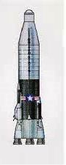“The* ***SM-65 Atlas*** *was the first* [*intercontinental ballistic missile*](http://en.wikipedia.org/wiki/Intercontinental_ballistic_missile) *(ICBM) developed and deployed by the* [*United States*](http://en.wikipedia.org/wiki/United_States)*. It was built for the* [*U.S. Air Force*](http://en.wikipedia.org/wiki/United_States_Air_Force) *by* [*Convair*](http://en.wikipedia.org/wiki/Convair) *Division of* [*General Dynamics*](http://en.wikipedia.org/wiki/General_Dynamics) *at the Kearny Mesa assembly plant north of* [*San Diego*](http://en.wikipedia.org/wiki/San_Diego)*,* [*California*](http://en.wikipedia.org/wiki/California)*. Atlas became operational as an ICBM in October 1959 and was used as a first stage for satellite launch vehicles for half a century. The Atlas missile's warhead was over 100 times more powerful than the* [*bomb dropped over Nagasaki*](http://en.wikipedia.org/wiki/Atomic_bombings_of_Hiroshima_and_Nagasaki) *in 1945.*

*An initial development contract was given to* [*Consolidated Vultee Aircraft*](http://en.wikipedia.org/wiki/Convair) *(Convair) on 16 January 1951 for what was then called MX-1593, but at a relatively low priority. The* [*1953 testing*](http://en.wikipedia.org/wiki/Joe_4) *of the first dry fuel* [*H-bomb*](http://en.wikipedia.org/wiki/Thermonuclear_weapon) *in the* [*Soviet Union*](http://en.wikipedia.org/wiki/Soviet_Union) *led to the project being dramatically accelerated. The initial design completed by Convair in 1953 was larger than the missile that eventually entered service. The Atlas program was formally given the highest national priority. Atlas development was tightly controlled by the Air Force's Western Development Division, WDD, later part of the Air Force Ballistic Missile Division. Contracts for warhead, guidance and propulsion were handled separately by WDD. The first successful flight of a highly instrumented Atlas missile to full range occurred 28 November 1958. Atlas ICBMs were deployed operationally from 31 October 1959 to 12 April 1965.”*

I was one of the first “RDT” selected to be assigned to the new Convair Atlas Missile project. The new company was called CONVAIR Astronomic and I was assigned to the Atlas telemetry group. The old method of instrumentation Aircraft was that the aircraft came back and you could access the recording devises. With a Missile, the Test data has to be “real time” radioed back. That process is called “Telemetry”. After being in that group for about a year, my evaluation showed that I was doing Engineer level work and was promoted to be a “Test Engineer”, and turn in my yellow badge and be issued what they called “ A candystrip” badge . That was like receiving a commission in the Military. I no longer had to punch a time clock and could leave the plant, come and go without having to request special permission.

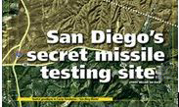At that time, when you received this type of promotion, in a way like receiving a commission in the Military, you were transferred out of the group and I were assigned as the night Blockhouse Engineer at the Sycamore Canyon Static Test Site. Sometimes called “San Diego’s secret missile testing site.”

**SYCAMORE CANYON TEST FACILITY   
THE SYCAMORE CANYON TEST FACILITY WAS LOCATED ON THE U.S. NAVY'S CAMP ELLIOTT, APPROXIMATELY 17 MILES NORTH OF DOWNTOWN SAN DIEGO.  THE SITE WAS ACTIVATED DURING SEPTEMBER 1956, PROVIDING CONVAIR ASTRONAUTICS WITH A STATIC FIRING TEST FACILITY IN THE VICINITY OF THE MANUFACTURING PLANT**

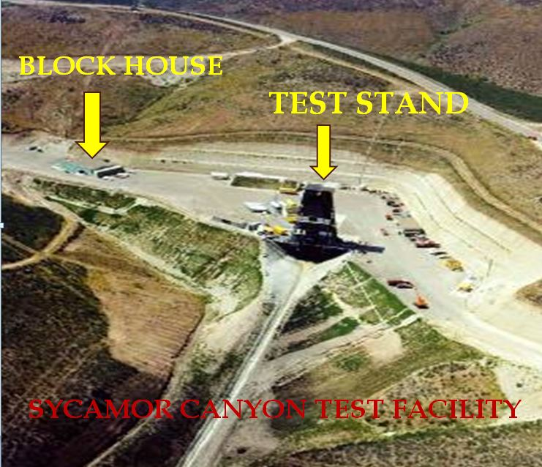

Ken Newton was the Chief Test Conductor for many years. The “Block House” was a special building near the missile launch Stand to protect the equipment and facility personnel from a possible explosion. This is where we would Static Test (do everything like we were launching the Atlas, but not let it go.) When they had “countdowns”, I had to be there 18 hours a day, sometimes running every day but Sunday trying to go through launch procedures and find the bugs for actual launching of the Atlas Missile. This procedure required about 20 Design Engineers from the main Plant to take their various equipment positions in the block house for the count down. The procedure would continue under “Green light” conditions, but would stop when a “Red Light” would appear meaning a malfunction. Sometimes it would take an hour to clear the red light and other times several l days. Everyone had to stay in place while the search for the problem was done. When the jet engines would start, the block house felt like an earth quake and the noise could be heard in San Diego. All the procedure were followed to launch the Alas Missile, but was held down on the test stand to simulate traveling into space. After a test, I would help collect the data to be taken back to the main plant for annuluses. On normal routine days, the Block house Engineers was the coordinator between Plant Engineers and the Site technical staff.

The Air Force wanted a documentation of the site, once everything was working. I was transferred from the Block House up to the Sycamore Canyon Site Engineering Administration building, saying that they needed me to run the site wiring documentation program. My major problem was that I could no longer take my college classes having to work days and the classes were not available at night.   
  
***“ADMINISTRATION BUILDING –Sycamore Canyon  
THE ADMINISTRATION BUILDING WAS USED BY THE AIR FORCE, CONVAIR ASTRONAUTICS AND ASSOCIATED CONTRACTOR LIAISON PERSONNEL.  IT PROVIDED A RECEPTION AND SECURITY CLEARANCE AREA AND AN OFFICE FOR ENGINEERING PERSONNEL.  IT ALSO CONTAINED A DISPENSARY, CAFETERIA, GARAGE AND AN INSTRUMENT CHECKOUT STATION.”***

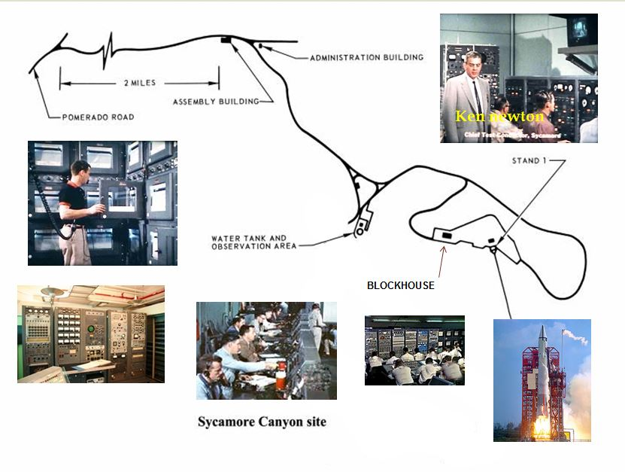

I designed a “Wire Tab” form that proved to be very successful. Convair Astronautics had one of the first computers but I was not allowed near it except for once I got a chance to see the racks and cabinets of tube type equipment.

A number of special Electrical Contractors were hired and went through every wire at the test stand and documented with the wire tabs. This project took months to document. I would have liked to have had my laptop computer then, but there were no computer available then and everything was paper.

With the completion of the Documentation assignment was completed, I wanted to get back to the main plant and I was transferred to the Telemetry Test Equipment Packaging Group

My Test Engineer Title was up graded to Design Engineer. I reported in to my new group with Bill Jungk as my Boss and Russ Cassutt was the upper level Supervisor. The name of our group was the Telemetry Test Equipment Packaging Group. The electronics group would design the circuitry for the equipment to meet the testing requirements of the telemetry systems. Our group would then design the layout of the parts on the chassis, packaging and equipment racks. A number of large enclosed trailers obtained to house the equipment.

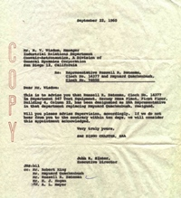I was taking an Industrial relationship class at San Diego State College and learning how great Unions were and what they did for our country.

*To: Convair Industrial Relations…..  
Re: Representative Russell R. Bateman, Clock No. 14377 and Maynard Quakenbgush Clock No 74858  
Dear Mr. Wisdom:  
This to advise you that Russell R. Bateman, Clock No. 14377 in Department 547 Test Equipment, Kerney Mesa Plant, First Floor, Building 4, Column 22, has been designated as EAA Representative in that department replacing Maynard Quackenbush, resigned.*

*Will you please advise Supervision, accordingly. If we do not hear from to the contrary within ten days, we will consider this appointment acknowledged. Very truly yours, San Diego Chapter EAA*

I fell for the Brain washing. At work, I was talked into being the Department Union Representative and given status of no layoff protection. At the first meeting of the Union I attended, I was on the front row ready to do all the good things I had learned in school. The first motion was entered by the union bosses to raise Union dues. I jumped up, with my great college learning, and said, no, let’s increase membership. I was told, “Shut up and sit down. It was the same for the next three or four monthly meetings. I lost all interest in the union when I found out the union was controlled by five guys who borrowed funds from the union membership dues at 1% and invested it at 4%. Only these five guys had that opportunity. I resigned from being Department Union Representative.

I had a little drafting in high School and I felt it was going to be more problems like I had when I first was employed with CONVAIR. The Equipment Packaging Group was fourteen Design Engineers taking the schematic designs from the Electronic Engineers and designing the equipment and cabinets as required fabricating the required test equipment. Half of our groups were college graduates and others had been trained in drafting schools. I ask myself, what am I doing here? I did drawings, but they didn’t in anyway compare with the others. So what did they do? They took the less qualified, the less skilled guy—me, and made me the group Supervisor.

I got along great with my boss and my Bosses, boss Russ Cassutt, who was an amateur Radio person.

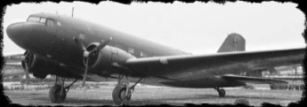The guys in my group were great and carried me and made me look good. I never had one problem with any of the members and it was one of the most enjoyable, stresses less times of my life. The other Supervisors were Senior Design Engineer. We had parties and social activities. My Boss took me with him to be “Venderized” meaning taken out to dinner by supplying vendors. When they started with the drinks, my boss Bill Jungk would say, bring Mr. Bateman a 7 up. When Gaye and I went to parties, we would be met at the door and given a 7 up. My section had the configuration control of the Telemetry Test Equipment Trailers located at several sites. We had trailers located at Vandenberg AFB, Edwards Rocket Base and four trailers at the Kennedy Space Center, Cape Canaveral. Convair had a “Goony Bird” Douglas C-47 that we used for transportation personnel between San Diego and Edwards AFB and I made the trip a number of times. I was not able to visit Cape Canaveral and had to work with a third party. (However, we did take a cadet group there a few years later.)

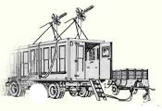The Telemetry Electronics group designed an update modification for 12 Trailers. This was a major project. I chose Boyd Spencley, A graduate Engineer in my group was chosen to be Convair’s Resident Engineer at the Hallamore Electronics Contractor’s plant near Disneyland. Hallamore Electronics was selected to make these modifications of the Telemetry Check-out Trailers. The trailers were transported from the various locations to the Hallamore Plant. At the completion of this program, Hallamore Electronics wrote this letter:

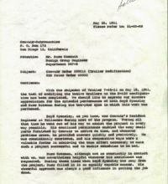*May 26, 1961 Hallamore Electronics*

*Convair astronautics  
P O box 172  
San Diego 12 California*

*Attention: Mr. Russ Cassutt  
 Design Group Engineer Department 547-4  
Subject: Convair Order S9901A (Trailer Modification) Red Sales Order 60002*

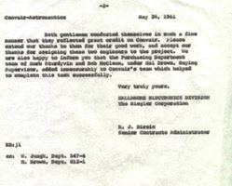*Gentlemen:*

*With the shipment of Trailer seven – 64 – 11 on May 19, 1961 the task of modifying the 12 Trailers to the D – AIG configuration has been complete we should like to express our sincere appreciation for the splendid performance of Both Boyd Spencley and Russ Bateman during the two-year span which this work was performed*

*Boyd Spencley. as you know was Convair’s Resident Engineer at Hallamore during most of the program. During all that time he went out of his way to assist the project in in every way possible. His continued persistence enabled the many small parts furnished by Convair to arrive on time and whatever problems arose, he provided answers quickly and positively. He was consistently courteous, and his cooperated ways were of valuable factor in achieving the team effort necessary to make such a project successful and to enable us to schedule to be met*

*Russ Bateman although not constantly in contact with us, was nevertheless helpful whenever his assistance was requested. During those times when Boyd specially was away from the project, Russ filled in in in equally capable mannered. His cheerful approach was always a good influence in getting the job done.*

*Both gentlemen conducted themselves in a fine matter that they reflected great credit on Convair. Please extend our thanks to them for the good work, and accept our thanks for signing these two engineers the project. Where also happy to inform you that the purchasing department team of Herb Sturdyvin and Bob McClean, under Mel Brown, Buying Supervisor, added immeasurably to Conair’s team which helped to complete this task successfully.*

*Very Truly Yours,*

*Hallamore Electronics Division  
The Siegler Corporation  
R. J Birsic, Senier Contracts Administrator  
CC w. Jungk, Dept. 547-4 -R Brown Dept. 812-1*

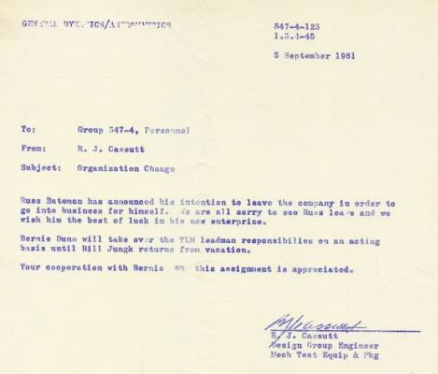Things were going great. The Atlas Missile project was very successful, meeting all the Air Force requirements and no failures. And the new Atlas Centaur project was just starting. We received startling news that the Atlas Chief engineer was discharged in that he didn’t have an Engineering Degree as required by the Air Force. The notice also stated that the Air Force required all Engineers to have degrees. I ask how that would affect me and was told that I would be reduced to the top grade Hourly Employee and that I could longer be a supervisor.

Due to my pride, I felt that I couldn’t do that so I looked for other avenues and left the company on 15 September 1961.

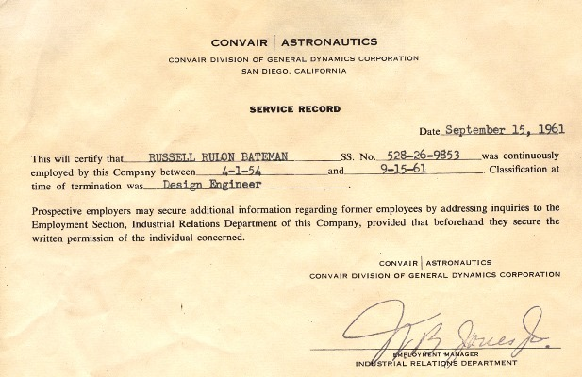A note of interest, after cleaning out the engineers (without degrees), and hiring the new College Degreed Engineers, the Atlas Centaur had many failures and the project was turned over to the Lockheed Martin which then controlled the “Atlas Rocked Family” and development of the Atlas V program for launches planned untilled 2020.

It was also interesting that Convair 880 Airliner was successful, but they cleaned out all the Non-degreed Engineers and with the newly hired Degreed Engineers, designed the new and improved 990 Airliner. To meet the competition, they went into full production without the normal testing. The 990 Airliner was a flop. It didn’t even meet the specifications of the 880. The San Diego Convair Aircraft Division was destroyed and no longer exists. I remember seeing many Convair 990’s sitting at San Diego Limburg field unable to be sold due to not meeting the required specifications and low performance ratings.