THE BEST YEARSTO BE ALIVE IN THE HISTORY OF THE WORLD

Russell Rulon Bateman History

**Chapter 08 - AIR FORCE AND CIVIL AIR PATROL –USAF AUXILLARY**

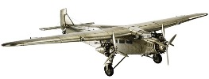In my early preschool childhood (1935) I listened to “Jack Armstrong The all American boy” on radio. There was something that they were giving a way TaylorCraft air plane. I think that it was sponsored by “Wheaties”. We didn’t have store bought foods, but some way I sent something is for the drawing, and was disappointed that I didn’t win the Air Plane.

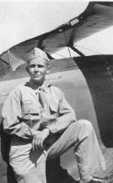My Mother took me out to the Idaho Falls Airport to see the Ford Tri-motor Airplane

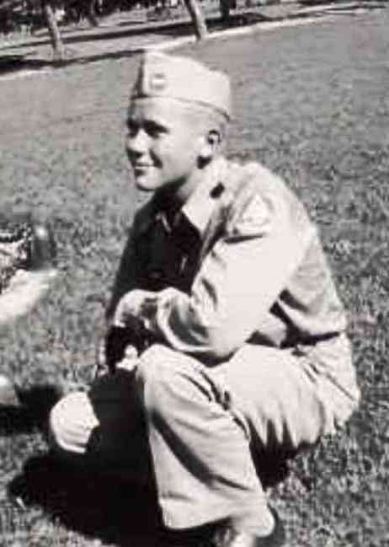I had been in the boy scouts and worked up to be a “First Class” Scout. Then I had changed to the LDS Air Scouts do to my interest in Air Planes. I don’t remember just how, some way I join the Civil Air Patrol and was able to get a ride. That was a real exciting moment for me. I have been in love with flying since then. We had a Aircraft gunner training at the Cedar City Airport and I enjoyed operating. We didn’t have all that automation games back them.

I enlisted in the Utah State Guard (see the Balloon War chapter) and I felt that was a more important calling, as we were in the World War. (See chapter07)

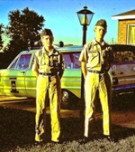  
We were living in the Salt Lake area in 1962, when my boys were at the age of the boy long hair area. I needed something to get them into a worthwhile activity and took them to a local CAP cadet meeting.

After the first meeting, they said that they wanted nothing to do with the cadet program as the cadets made negative comments about their hair, even though it was not that long. But the next week there were back and it wasn’t too many years that they were in leadership positions to correct the appearance of new cadets coming into the program.

They went on to be very active over the next two years, with my oldest being the 250 th cadet qualifying for the national Spaatz’ award. Well maybe in wasn’t the 250th cadet, but it was in the 200 or 300 area, now there are thousands who have receive that away that was named for General Carl A Spaatz. The elements of this award included, Leadership, Aerospace, Fitness and activities.

To support our boys, my wife Gaye and I also got active in the Civil Air Patrol program. We first spent our time in the local CAP Squadron, but shortly were ask to move up to the Utah State CAP Wing Headquarters activity.

I was promoted to the Civil Air Patrol position of Major and made Wing director of Communications due to having an Amateur Radio Class A licence and more important, I held current 2nd class radio Telephone and Radio Telegraph FCC Licenses

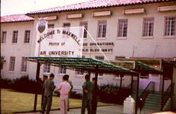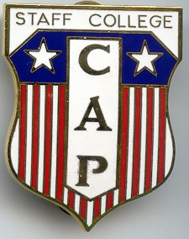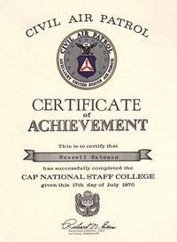June of 1970, I had the opportunity of attending the two week Civil Air Patrol Staff College at Maxwell Air force base in Alabama. They flew us out in an Air Force Convair T29 that had assigned to the Civil Air Patrol and piloted by reserve Air Force Officers.

This Newspaper article tells the 11 June 1970 Story.

**Searchers say pilot must have been killed instantly**

The search for a missing mail plane which was conducted strenuously for two weeks following its disappearance the morning of March 2, and which has been conducted intermittently since that time, was ended Saturday when wreckage of the plane was sighted at the .9600-foot level of the Patmos Peak east of Colum­bia.

The wreckage was sighted al 10:40 by Mrs. Bert (Louise) Morrison, Standard­ization officer and Russ Bateman, Wing director of communications, Utah Civil Air Patrol. Mrs. Morrison was piloting the search, plane with Mr. Bateman as observer.

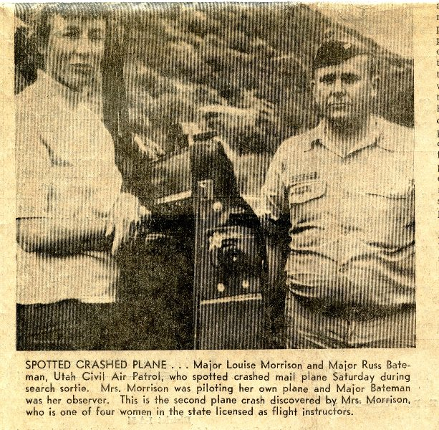  
This was Mrs. Morrison's second sortie of the day; she first was involved in the flight Saturday morning from Salt Lake City to the Carbon County Airport Wong the air mail route Roth Mrs. Morrison and Mr. Bateman bold the rank of major in the CAP.

The mail plane which made runs twice daily between Salt Lake City and Moab was piloted by Michael Ray (Mike) Smith, 22, d Dallas, Texas. It was carrying 26 pounds of first class and a smaller amount of third class mail.

Shortly after the wreckage was sighted from the air, ground searchers left Price by four-wheel drive vehicles to the crash area along the winding road to Bruin Point east of Sunnyside then south along the jagged mountain top 12 miles to the south where the road ,reeds. From there the searchers hiked toll the crash site which was about a mile further to the south and some 400 feet below the crest of the mountain.

The body of the pilot in a decomposed state was found still strapped to the seat. The plane had decomposed upon impact into the mountainside and the apparent injuries to the pilot led searchers to believe that he had been killed instantly. Some fire damage was noted on the left motor section of the twin-engine white and maroon Piper Aztec. The pilot's body and the seat to which it was attached were found in the immediate vicinity of the right engine section.

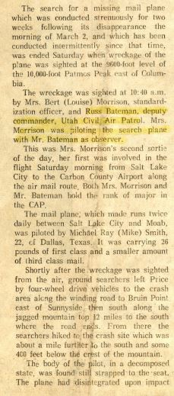

The searchers arrived at the crash site at about 4:40 and their inspection indicated the plane had crashed straight into the mountain. This also indicated that the pilot, during the snow storm that was prevalent the morning of the crash, was not aware that his elevation was not sufficient to clear the peak.

In the ground search team were Deputy Sheriff Ned McCourt, Mrs. Morrison and her husband, who is area director for the CAP; Mr. Bateman: members of the Carbon County Sheriff's Jeep Patrol, Price Postmaster Pete Bruno and representatives of the Sun-Advocate.

The three mail bags carried by the plane were found intact and by Monday morning the mail contained therein were dispatched to its destinations with the notation Stamped on each piece "Delayed in hand­ling in the postal service."

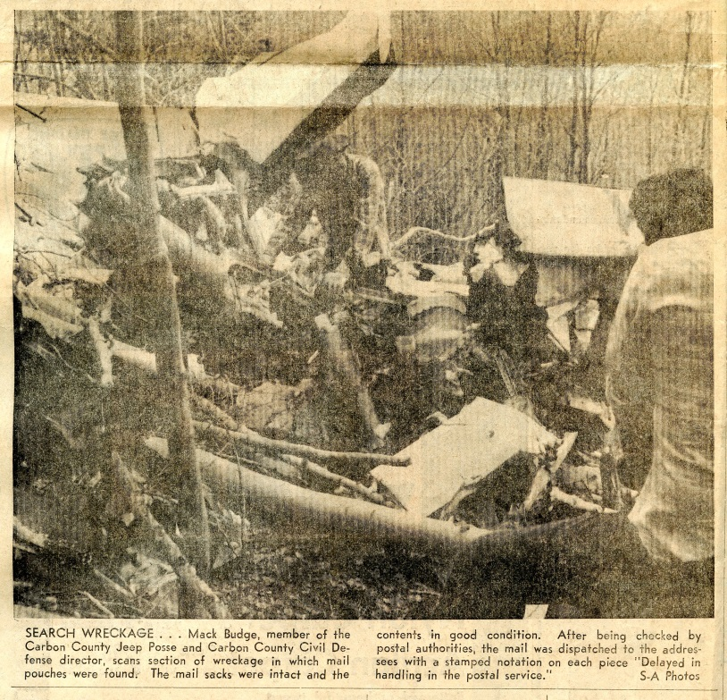Monday Sheriff Albert Passic accom­panied by representatives of the Federal Aeronautics Administration from Denver and Salt Lake City went to the crash site. They reported that plane instruments scat­tered up the mountainside for some 50 feet indicated the plane's altimeter reading was 9600 feet, the time showing on the plane's clock was 3:45 a.m. and air speed at the time of the crash was 160 miles per hour.

The plane had been due to arrive at the Carbon County airport at 3:45 a.m. March 2. It was last heard from at 3:39 a.m. when pilot radioed Salt Lake City for an

Altimeter reading, it was snowing that morning in this area.

Searches by jeep patrolmen were instituted and as weather permitted some 15 CAP planes and private craft scanned the area to no avail. At that time the air searches were concentrated in the East Carbon area because reports from workmen at Sunnyside were to the effect that they had heard a plane through the heavy overcast at about the time it was due. Subsequent discovery of the crashed plane and the time of the crash as indi­cated on the plane's clock bear out the fact that these men did hear the plane possibly a minute or two before it went down. Discovery at that time was made more difficult by the snow cover, new snows falling through the original search period and the white color of the plane.

The plane was found in a forest of aspen and it is surmised that had the plane not been found at this time the difficulties of searching would have been compounded by the trees as the spring and summer leaves became more abundant.

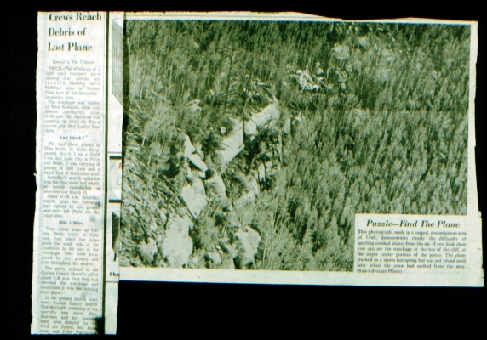Saturday's search effort was resumed by the CAP with seven planes which flew 15 sorties up to the time of the discovery. Major Donald E. Shockey and Colonel Ott Webb, Utah CAP, Salt Lake City, had re­turned to the Carbon County airport and were again directing search activities as they had immediately after the plane was reported missing.

Louise added another start to her find ribbon and I receive my first find Ribbon Find Ribbon.

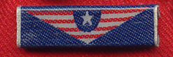I was able to get many hours in the air on searches and other activities. I wished that I could say that I was the pilot during these flights, but I was only working on my license taking lessons in a Cessna 150 with Louise Morrison as my instructor. I did get time at the controls however.

To my surprise and I am sure to some resentment, I, a non-pilot,

was promoted to deputy Wing Commander with the authority to launch search operations. I never felt any resentment due to this assignment.

*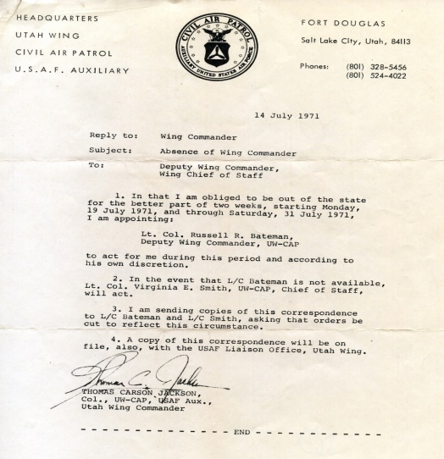14 July 1971*

*Subject: Absence of Wing Commander*

*To: Deputy Wing Commander  
 Wing Chief of Staff*

1. *In that I am obliged to be out of the state for the better of two weeks, Starting Monday 19 July 1971, and through Saturday, 31 July 1971, I am appointing:*

*Lt. Col. Russell R. Bateman, Deputy Wing Commander, UW-CAP*

*to act for me during this period and according to his own discretion.*

1. *In the event that L/C Bateman is not available, Lt. Col Virginia E. Smith, UW-CAP Chief of Staff, will act.*

*3. I am sending copies of this correspondence to L/C Bateman and L/C Smith,*

*asking that the orders be cut to reflect this circumstance.*

*4. A copy of this correspondence will be on file, also, with the USAF Liaison Office, Utah Wing.*

*Thomas Carson Jackson, Col., UW, USDAF Aux., Utah Wing Commander*

~~~~~~~~~~~~~~~~~~~~~~~  
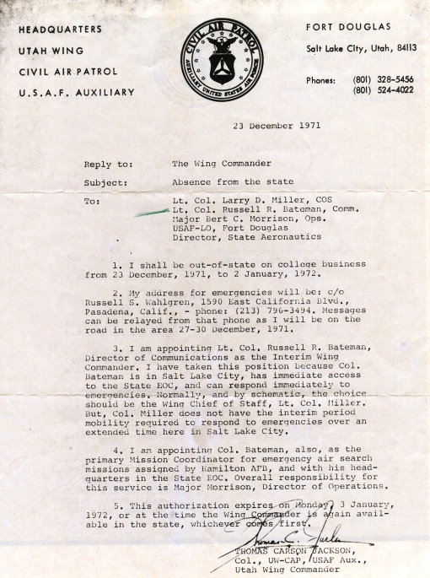

*23 December 1971*

*Reply to: The wind commander  
Subject: Absence from the state.*

*To: Lt. Col. Larry D. Miller, COS  
 Lt. Col. Russell R, Bateman Comm  
 Major Bert Morrison, Ops.  
 USAF-LO Fort Douglas  
 Director, State Aeronautics  
1. I shall be out of state on college business from 23 December, 1971, two to January 1972.*

*2. My address for emergencies will be; C/O Russell S Walgreen………..*

*3. I am appointing Lieut. Col. Russell R Bateman, director of communications as the interim Wing Commander. I have taken this petition because Col. Bateman is in the Salt Lake City area and has the immediate access to the state GOP, and can respond immediately to emergency. Normally, and by schematic, the chapters should be the winning team of staff, Lieut. Col. Miller but, Col. Miller does not have the interim. Most of the required respond to emergencies over an extended time in Salt Lake City.*

*4. I am appointing L/C Bateman, also, as the primary mission coordinator for emergency air search missions assigned by Hamilton Air Force Base, in which his headquarters in the state EOC. Overall responsibility for service is Major Morrison, Director of Operations.*

*5. This authorization expires on Monday, 3 January 1972 or at the time the Wing Commander is again available in the state, whichever comes first.*

*Thomas Carson Jackson, Col., UW-CAP, Utah wing commander*

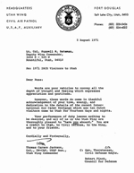I was also active in other areas of Civil Air Patrol. The international exchange program exchanged cadets between countries. Activity and I took my turn hosting foreign cadets as in the case of the Dutch visitors. It was my assignment to arrange tours, meals and all activities during the fourteen days that they were in Utah.

*5 August 1971*

*Lt. Col. Russell R. Bateman, Deputy Wing Commander,*

*3222 S - 525 W*

*Bountiful, Utah, 84010*

*Re: 1971 IACE Visitors to Utah*

*Dear Russ:*

*Words are poor vehicles to convey all the depth of thought and feeling which expresses appreciation and gratitude.*

*However, these words do come in thankful acknowledgement of your time, energy, and dedication to the details of the recent Inter­national Air Cadet Exchange which saw ten Dutch visitors come to Utah for fourteen days and nights.*

*Your performance of duty leaves nothing to be desired, and all of us in the Utah Wing are thoroughly pleased to "have you aboard." You are a credit to Utah, to Civil Defense, to the Wing, and to your friends.*

*Cordially and Fraternally,*

*Thomas Carson Jackson,*

*Col., UW-CAP, USAF Aux., Utah Wing Commander*

I was given the responsibility to write a number of exercises, coordinate them to the wing stall and submit them to the Air Force liaisons Officer for approval. One approved, the Wing Staff would organize and exercise and set the date.

***Newspaper: Utah Holds Practice Mission***

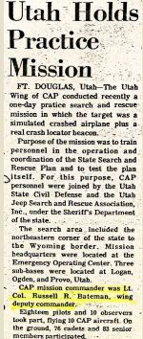

*FT. DOUGLAS, Utah—The Utah Wing of CAP conducted recently a one-day practice search and rescue mission in which the target was a simulated crashed airplane plus a real crash locator beacon.*

*Purpose of the mission was to train personnel in the operation and coordination of the State Search and Rescue Plan and to test the plan itself. For this purpose, CAP personnel were joined by the Utah State Civil Defense and the Utah Jeep Search and Rescue Association, Inc., under the Sheriff's Department of the state.*

*The search area included the northeastern corner of the state to the Wyoming border. Mission headquarters were located at the Emergency Operating Center. Three sub-bases were located at Logan, Ogden, and Provo, Utah.*

*CAP mission commander was Lt. Col. Russell R. Bateman, wing deputy commander.*

*Eighteen pilots and 10 observers -took part, flying 10 CAP aircraft. On the ground, 76 cadets and 83 senior members participated.*

The Civil Air Patrol is organized under the U. S. Air force and allotted several frequencies for use by the CAP in their Search assignments. At that time, the heathkit “Twoer” was popular. This was a low powered lunch box type radio. Some areas were moving from amplitude (AM) to Frequency Modulation (FM) and we were able to get several FM radios in the Utah Civil Air Patrol.

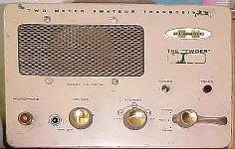

As the Utah Civil Air Patrol wing Communications director. I had been active in Repeaters for the State of Utah, and Utah Amateur Radio Operators, so I was wondering about Utah Civil Air Patrol repeaters. In asking questions, I heard that the Colorado Wind had been doing some experimenting with CAP FM repeaters, but was unable to get authorization.

The Air Force Liaison Officer was able to get me a flight to Washington D. C. where they were holding a CAP National Communications Committee in Washington D. C, board meeting. The board had rules that they didn’t need repeaters in the Civil Air Patrol program. I argued that the mountain terrain limited our range and some way was able to get the authorization for the first Civil Air Patrol Repeater in the United States. This sounded like a simple procedure, but it took weeks and months to accomplish this agreement and there was a lot of position.

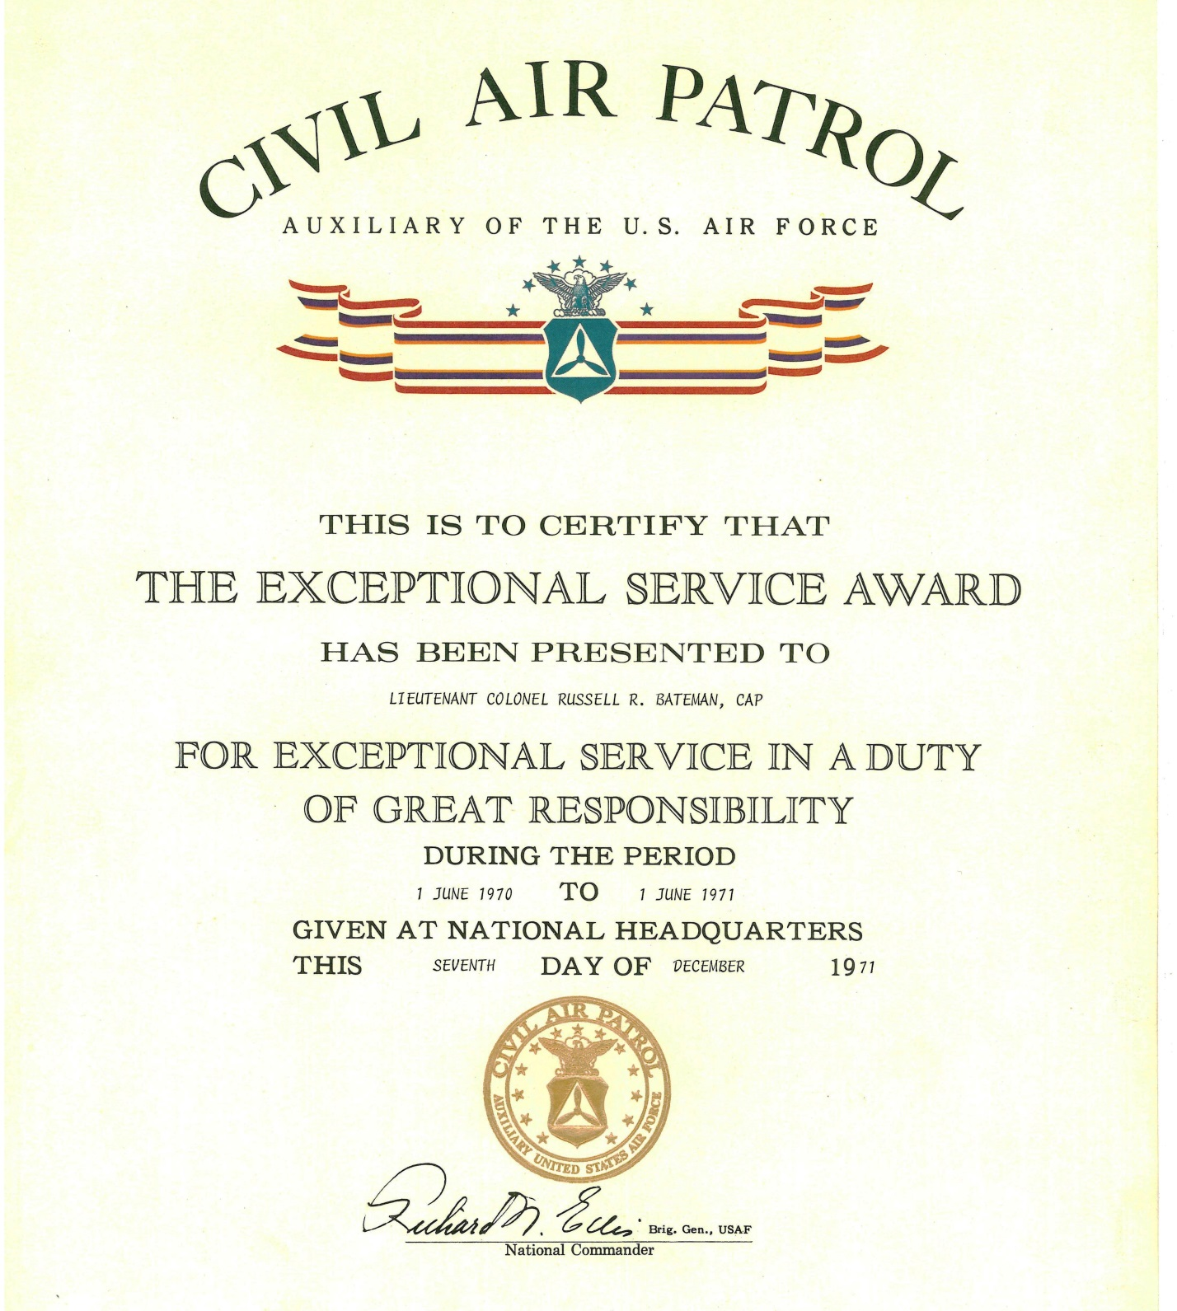

I appreciated getting national recognition for this project as this award what to go through the Air Force General at Maxwell Air Force Base, Alabama

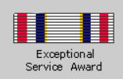

A month later I was surprised to receive another award that came through the Regional Commander. These awards include a ribbon to be worn on a uniform.

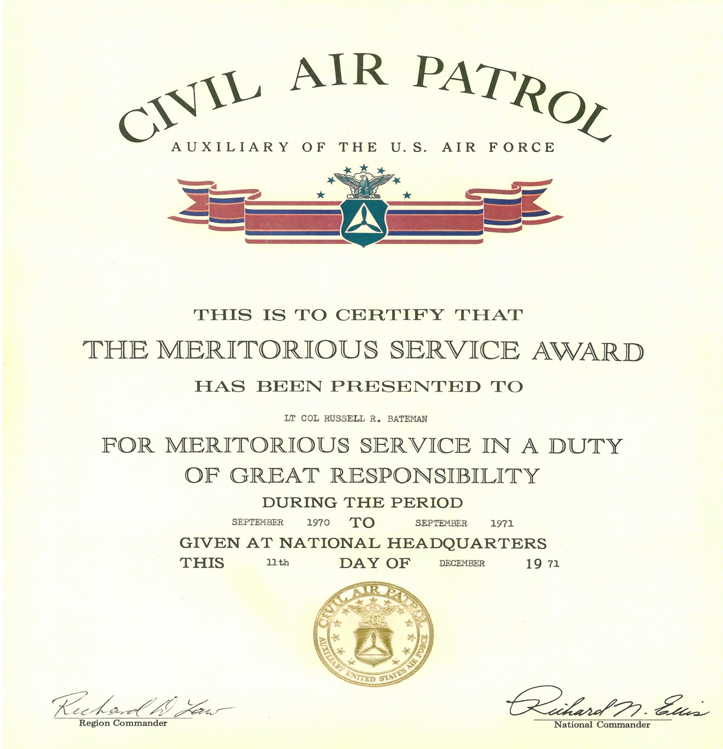

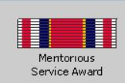

Active in the Civil Air Patrol and a Staff member of the Utah State Emergency services helped with many combine activities. These Newspaper releases tells a story:

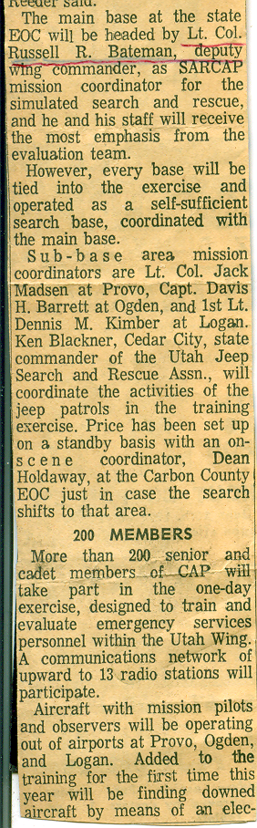*The main base at the state EOC will be headed by Lt. Col. Russell R. Bateman, deputy wing commander, as S & A mission coordinator for the simulated search and rescue, and he and his staff will receive the most emphasis from the evaluation team. However, every base will be tied into the exercise and operated as a self-sufficient search base, coordinated with the main base.*

*Sub-base area mission coordinators are Lt. Col. Jack Madsen at Provo, Capt. Davis H. Barrett at Ogden, and 1st Lt. Dennis M. Kimber at Logan. Ken Blackner, Cedar City, state commander of the Utah Jeep Search and Rescue Assn., will coordinate the activities of the jeep patrols in the training exercise. Price has been set up on a standby basis with an on-scene coordinator, Dean Holdaway, at the Carbon County EOC just in case the search shifts to that area.*

*200 MEMBERS*

*More than 200 senior and cadet members of CAP will take part in the one-day exercise, designed to train and evaluate emergency services personnel within the Utah Wing. A communications network of upward to 13 radio stations will participate.*

*Aircraft with mission pilots and observers will be operating out of airports at Provo, Ogden, and Logan. Added to the training for the first time this year will be finding downed aircraft by means of an Emergency Locator Transmitter.*

**Utah Holds Practice Mission**



FT. DOUGLAS, Utah—The Utah Wing of CAP conducted recently a one-day practice search and rescue mission in which the target was a simulated crashed airplane plus a real crash locator beacon.

Purpose of the mission was to train personnel in the operation and coordination of the State Search and Rescue Plan and to test the plan itself. For this purpose, CAP personnel were joined by the Utah State Civil Defense and the Utah Jeep Search and Rescue Association, Inc., under the Sheriff's Department of the state.

The search area included the northeastern corner of the state to the Wyoming border. Mission headquarters were located at the Emergency Operating Center. Three sub-bases were located at Logan, Ogden, and Provo, Utah.

CAP mission commander was Lt. Col. Russell R. Bateman, wing deputy commander.

**Ogden standard Examiner, Friday, June 25, 1971**

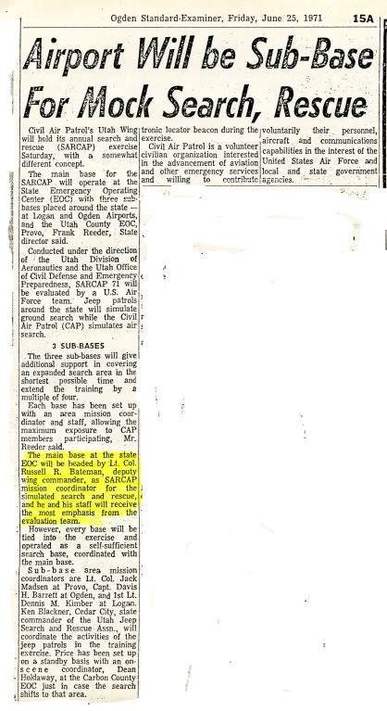**Airport will be Sub-Base for Mock Search, Rescue**

*Civil Air Patrol’s Utah Wing (SARCAP) exercise Saturday with somewhat different concept.*

*The main base for the SARCAP will operate at the State Emergency Operating Center (EOC) with three sub bases placed around the state - at Logan and Ogden airports, and the Utah County OC, Provo, Frank reader, state director said.*

*Conducting under the direction of the Utah division of Aeronautics and the Utah office of Civil Defense and Emergency Preparedness SARCAP 71 will be evaluated by a U.S. Air Force team. She patrolled around the state to assimilate and ground searches while the similar patrol (CAP) simulates air search.*

***3 SUB-BASES***

*The three sub bases will give additional support in covering an expanded search area in the shortest possible time and extended training by a multiple of four.*

*Each base has been set up with an area mission coordinator and staffing, allowing the maximum exposure to the CAP members participating, Mr. Reeder said.*

*The main base at the state emergency operating Center will be headed by Lt. Col. Russell R. Bateman deputy wing commander, as char Mission coordinator for the simulated search and rescue and he and his staff will receive most emphasis from the evaluation team.*

*However, every base will be tied into the exercise and operated as a self-sufficient search base, coordinated with the main base.*

*Sub-base area mission coordinators are Lieut. Col. Jack Madsen at Provo, Capt. Davis H. Barrett at Ogden, and first Lieut. Dennis M. Kimber at Logan. Ken Blackner, Cedar city, State Commander of the Utah Jeep Search and Rescue Assn., will coordinate the activities of the jeep patrols in the training exercise. Price has been set up on a standby basis with an on scene commander, Dean Holdaway at the carbon County emergency operating Center just in case the search shifts to that area.*

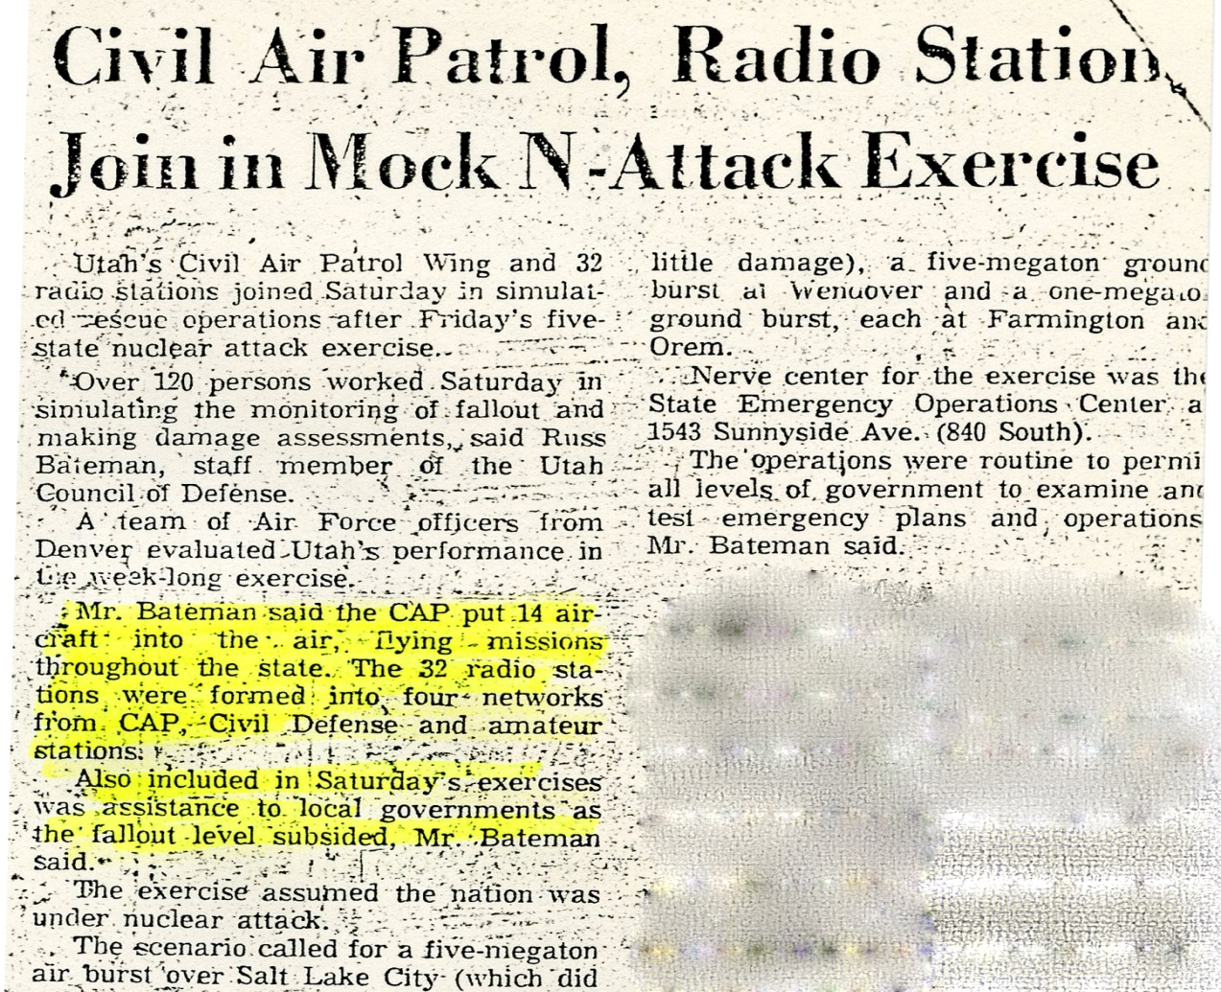

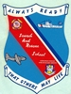**SEARCH AND RESCUE**

NATIONAL SEARCH AND RESCUE SCHOOL - GOVERNORS ISLAND, N. Y

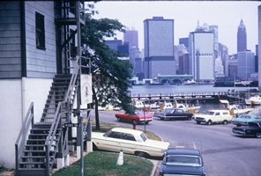

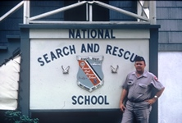In July of 1970, I had the opportunity of attending the National Search and Rescue school at the United States Cost Guard Base at Governors Island New York which is located in the bay not far from the Statue of Liberty and Manhattan. This school was sponsored by the Coast Guard and the U. S. Air Force and I was attending as a Search Coordinator for the State of Utah and the Utah Wing of the Civil Air Patrol. However, the state wouldn’t fund the activity and I had to go by CAP transpiration and take vacation to attend.

During the first few days of the school, I became acquainted with Blair Nilsson, from the Department of Emergency Services in Colorado. We struck up a close friendship which developed during the two week school.

**Two Mormon boys incited a worldwide SAR Coordination**

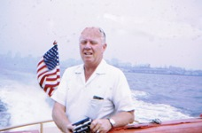One time he was wearing a shear shirt and I could see that he was wearing LDS Garments.

During the duration of the school, we talked of religion and other things that we had in common. The main topic was the need for coordination between all agencies in the National Search and Rescue effort. We both are serving on the State level dealing with search and rescue relating to many agencies. We formulated the 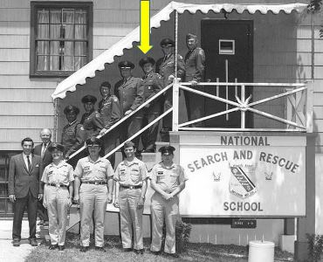idea of a National Search and Rescue organization which would provide that coordination requirement.

Asking our class for comments on attempting to standardize Search and Rescue suggestions, they felt that there should be some standardization with the Civil Air Patrol. This discussion was very successful and was a newspaper article written:

GOVERNORS ISLAND, N.Y. Sept 1970

*Twelve' Civil Air Patrol senior members, working with an Air Force adviser and a retired Air Force officer, have developed an outline for a proposed Standardized Search and Rescue Education for CAP members which would be presented at regional levels.*

*The proposed course would be based upon that presented by the Coast Guard here and would enable greater numbers of CAP personnel to learn SAR techniques which the Coast Guard has developed.*

*CAP region and wing officials and officials at National Headquarters have long recognized the need for such a course. The National Search and Rescue School here has room for only a few CAP members.*

*The group developed the proposal at a seminar In conjunction with their attendance at the National SAR school this past summer.*

*Benefits of the proposed course would include the use of standardized SAR techniques throughout the entire CAP organization; a more professional and efficient use of resources on hand; and better relations with other organizations involved in search and rescue efforts.*

**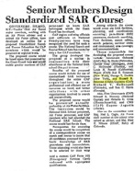***The proposed course would be presented annually preferably at Air Force -facilities The instructors would be National SAR School personnel, Air Force personnel, and CAP members who had attended the National SAR School. The course would last for six days.*

*Prerequisites for attending the course would be completion of a correspondence course on search and rescue to insure that all candidates possessed the same basic knowledge of SAR procedures and nomenclature. Those attending would also have to be selected by their wing, bold a current CAP Form 101 (Emergency Services Card) endorsed with appropriate qualifications.*

*Among subjects the course would cover are SAR facilities, planning, and coordination; scanning; parachute drift; pararescue; electronic searching. FAA facilities; search safety; search patterns; survivor stress and environment; area coverage; and communications.*

*Those responsible for developing the proposed course include: Lieutenant Colonel (CAP) Roy E. Stuhr (Nebraska), Chester Gray (Michigan), John C. McDonald (Florida), and Louis ft Powell (California)*

*Majors (CAP) Joel E. Sussman (New York), George T. Durkin (New York), and Russell R. Bateman (Utah)*

*Captains (CAP) Richard V. McDougall (Colorado), and Ben C. Harris (Georgia).*

*Also, First Lieutenants (CAP) Edward S. Munney (National Capital) and Melanlo 0. Ortiz (Massachusetts); and CWO (CAP) Eugene Augustin (Alaska).*

*Also on the committee were Maj. Ned L. Cagle, Air Force staff member at the school who served as adviser, and Maj. Blair E. Nilsson (USAF, Ret.) of Colorado State EMS.*

At the end of the course, we laid the ground work, object and constitution plain of the National Association of Search and Rescue coordinators. We ask Hall Foss, Search and Rescue Coordinator from the State of Washington was ask to be the President of the organization. He had shown great personal effort in the Search and Rescue program. Blair Nelsson was the Vice President and I would be the first Secretary and chairman of the first National Search and Rescue Seminar held in Salt Lake City.

I was assigned the title of Utah State Search and Rescue Coordinator (in addition to my other hats) so that the conformance would have the backing of the State of Utah. Our secretary did the mailing and correspondence and helped me have thing organized

Being the conference chairman of such a large undertaking was a challenge. I was able to get Governor Rampton to giving the initial address. President Hal Foss arranged for the speakers and I took care of the Housing and food requirements. Those attending included representatives from the Air Force, Coastguard, Navy, BLM Forest Service, CAP, and Search and Rescue coordinator from a number of states. There was about two hundred to two hundred fifty that attended and I was excited about the success.

The costs for membership were $1.00 for membership and $3.50 for the Seminar.

My excitement didn’t last long. Paul Koenig was a new member of our staff in the Utah State Office of Emergency Services. He was looking for something of interest and took a liking to the Search and Rescue program resulting his be assigned to be the new State SAR Coordinator. I thought that it was about the Politics, but I had more to do that I could handle. He probably did a better job than, as he put his full time in to it including a lot of traveling. I guess what bothered me, He didn’t have to take time off and his expenses were paid by the State.

I don’t know why Hal Foss resigned, but Blair Nelsson was certainly a good replacement

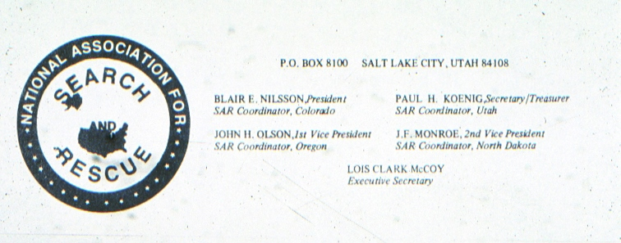

The organization has grown with full time personnel and an executive Director Lois Clark McCoy with the organization moving to La Jolla, California In 1980 NASAR was to go International with the name to be NASAR INTERNATIONAL ASSOCIATION FOR SEARCH AND RESCUE . Search and Rescue meeting now to be held in major countries around the world.

I found the following in the internet:

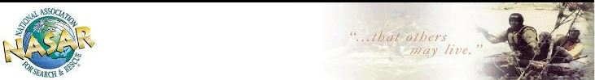

[***History of the National Association of Search and Rescue Coordinators (NASARC)***](http://www.ssarcc.com/uploadfiles/History%20of%20the%20National%20Association%20Search%20and%20Rescue%20Coordinators%20by%20Cole%20Brown%20May%202010.pdf)

[***By Cole Brown, Maryland May 2010***](http://www.ssarcc.com/uploadfiles/History%20of%20the%20National%20Association%20Search%20and%20Rescue%20Coordinators%20by%20Cole%20Brown%20May%202010.pdf)

The first meeting of the National Search and Rescue Council, an out growth from the National Association of Search and Rescue Coordinators (NASARC) took place in Boise, Idaho on April 19 and 20, 1974.  The National Association of Search and Rescue Coordinators (NASARC) was formed in 1970 at a meeting in Salt Lake, Utah and Hal Foss was the first President.   
  
I dedicate the History Section of the Website for the State Search and Rescue Coordinators Council to Hal Foss. Hal’s wisdom and insight has led us to where we are today. I would also like to dedicate the History Section to Dennis Kelley for his dedication to the documentation of these events as they happened in Search and Rescue Magazines.

Why was the meeting held in Salt Lake City? Because, I was the Secretary of NASARC and the Conference Chairman in 1970.

It all started by two Mormons who got together at the National Search and Rescue school in New York.

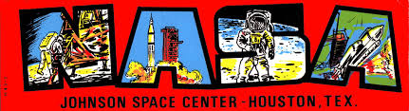Back to the Civil Air Patrol, Gaye and I were asked to be senior escort on two different Cadet Treks. Our youngest son also qualified for the trek. The Air Force provided the transportation. Our first trek was to the Johnson Space Center in Houston, Texas. I can’t find my documentation on the Texas, but I remember that the Air Force plan had problems and we had to land at some AFB for repairs and were only about a three hour delay.



I don’t remember the dates, but the trek to the Kennedy Space Center in Florida was very special for us. My younger son Randy and his Mother qualified to this Trek. I had worked for Convair and had the configuration responsibility on two Telemetry checkout test equipment trailers, but was never able to make the trip to the site. (See my Convair chapter)

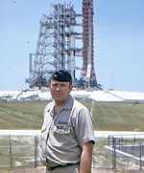

Lt. Col. Russ Bateman

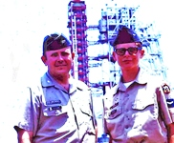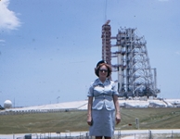

Captain Gaye Bateman

MMY SON, RANDY AND ME   
AT THE Florida Space Center

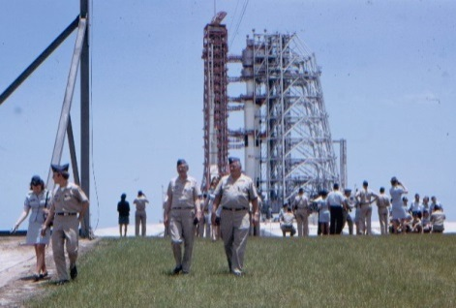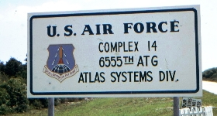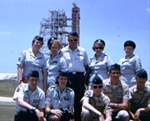

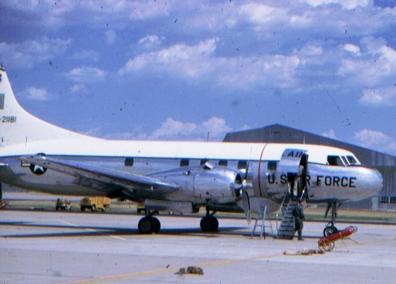

**Hill Field Air Force Base Annual CAP Cadet Encampment**

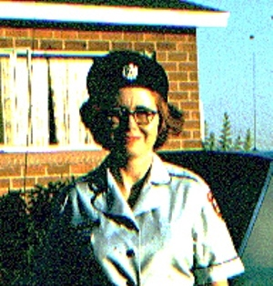

My Wife, Gaye qualified for the CAP Captain commission due her holding two degrees from Weber State College.

The made it possible to attend activities and several Treks together.

Gaye was asked to be the 1974 Annual Civil Air Patrol Cadet Encampment Commander at Hill Field Air Force Base. There were a couple a hundred attendees, both male and female.

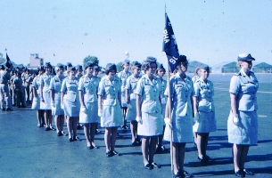

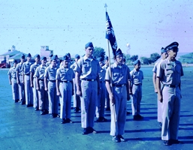

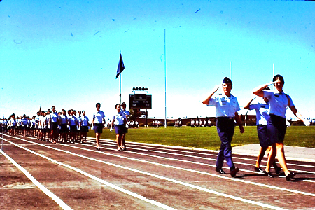

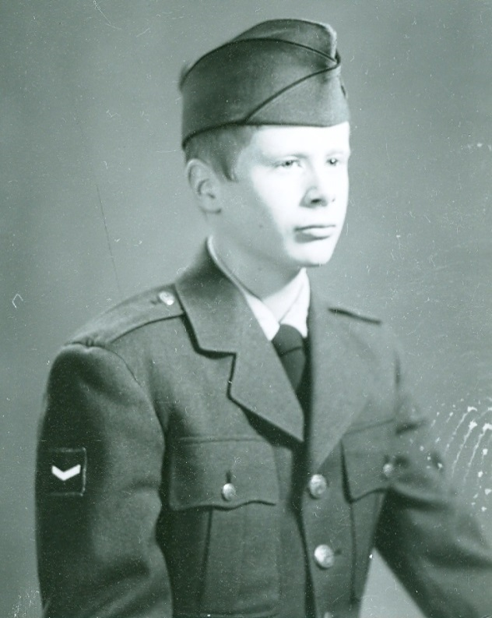

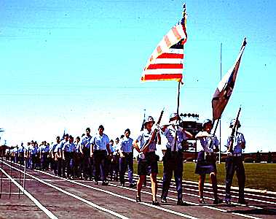

Gaye is shown in the picture on the parade reviewing stand with dozed (or so) Reserve Air Force Officers assigned to help her with the Annual hill AFB Cadet encampment. There is a lot of training at this encampment with cadets from all over the region. It is a great opportunity for the youth of our country.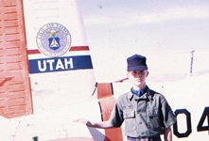

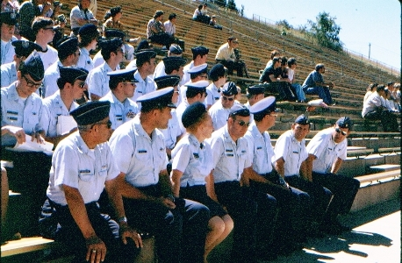

J:\$-@@@RUSS BATEMAN pictures MASTER folder\105-CAP-civilairpatrol\Draft folder\1974-hill field cadet encapment\BatemanRusscaprjr3.TIF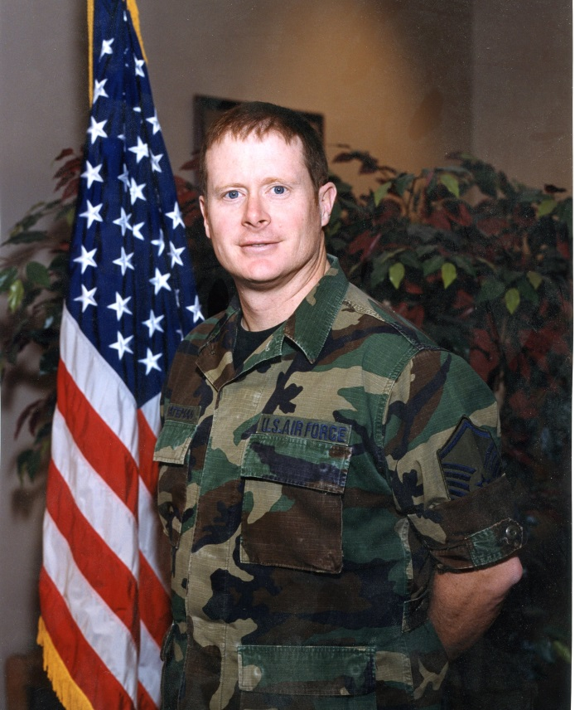

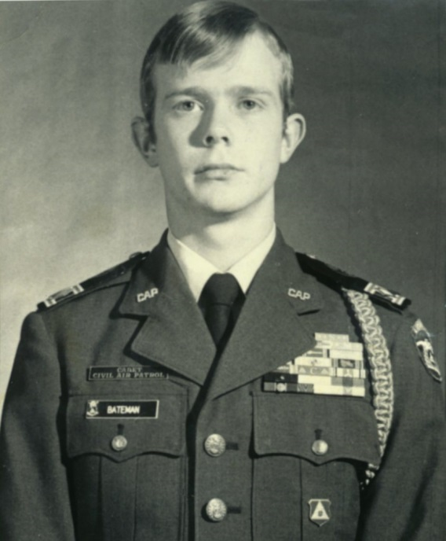

Our oldest son (Russ Jr) was the Wing Cadet Commander. He was the 350th in the Nation to pass the General Carl Spaatz Award.

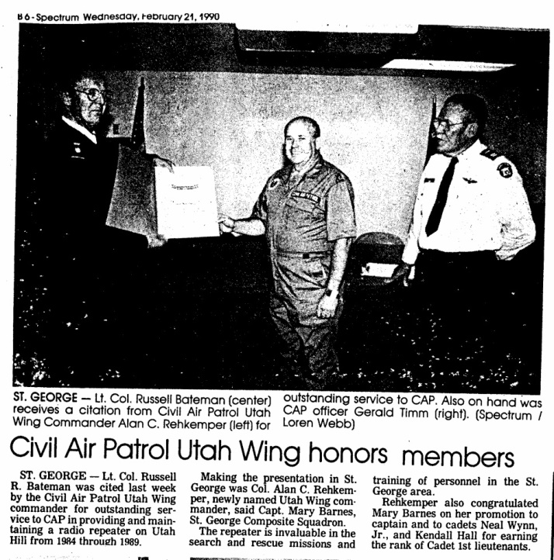

Our youngest son went one from a Cadet to retiring from the Air Force

