THE BEST YEARSTO BE ALIVE IN THE HISTORY OF THE WORLD

Russell Rulon Bateman History

07- U. S. Navy

I again was looking at the Military and listed to a Navy recruiter who promises me a complete education in Electronic maintenance. He called the School, “Radio Material School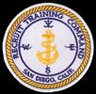” I was too Trusting and enlisted. I thought that this was the answer to me Education problems, would get out of not being at the National Guard Summer encampment and I could get the Education that I wanted. I was discharged from the National Guard (removal from the State) and the Naval Reserve (joining active duty in the Navy).

My Navy Basic Training was at Camp Decatur, in the U. S. Naval Training Center, San Diego. Basic training was very hard on me as I was not in the best of shape for all the physical demands. But I did make it though, completing all requirements.

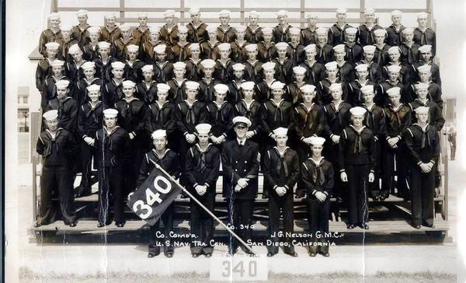

**Eleven weeks of hell**

Above the Mexican border,  
Boot Camp is the spot,   
Where we are doomed to serve or time,  
In the land that god forgot.

Through the pines with our M-1 rifles,  
In the place men feel blue,  
Right in the middle of now where,  
and a thousand miles from you.

To hell with the snakes and lizards,  
and digging in the ground with a pick,  
Doing the work of a slave,  
and just too damn lazy to kick.

We sweat, we freeze, we shudder,  
It is more than we can stand,  
We are not really convicts,  
We are defenders of our land.

We are sailors of the Navy,  
Earning our meager pay,  
Grinding the wall street millions,  
for two and a half a day.

Living with just our memories,  
Waiting to see our gals,  
Hoping that when we get home,  
They haven’t married our pals.

Nobody knows we are living,  
Nobody gives a damn,  
Back home we are soon forgotten,  
We have been loaned to Uncle Sam.

The term we serve in the Navy,  
Is part of our lives we missed,  
So if the draft don’t get you,  
For God’s sake don’t enlist.

And when our lives are over,  
We’ll go off to a place we know so well,  
Where Saint Peter will say “Come in Boys.”  
“You’ve served your time in hell.”

Author was a member of my Boot Camp Company 340

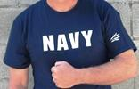I was assigned to the Naval Radio Operators School which was also located at the San Diego Naval Training Center. After the first week of school, I realized that this was not the School that I was promise. I went into the School office and ask them to look at the agreement the recruiter has promise me. They told me that I had to complete this School and then if I did well, I could put in for the Electronics School as that was the replacement for the Radio Material School, I completed the Radio Operators School with a good grade, even though I had the measles the last two weeks of school. Morse code and "CW" (carrier wave) telegraphy, which we had to send and receive at increasing speeds until we reached at least 12 words per minute. For many, learning telegraphy techniques and Morse code were the most difficult subjects, since "CW" was completely foreign to our life experiences. It was a combination of learning a new language plus then having to translate the sound impulses from ear to brain to hand to typewriter in micro seconds.

I was now "rated" as a Radioman seaman apprentice and could sew, on my jerseys above the two stripes designating rank, the lightning bolts announcing I was a Radioman, or "Sparks" as we would be called informally. "Sparks" was a rating nickname which I suspect originated from the sparks created by an operating telegraphic key. I graduated, the event occurring in the sixth week of school. Many others did not make it. As punishment for their failure to graduate they went directly to their next duty station without leave and, no doubt, with great embarrassment.

 After my graduation, I went back to the school office, telling I wanted to continue to the Electronics School. They told me that I would have to wait until I had a duty station assignment and make application there. My duty Station assignment was Adak Alaska and as soon as I arrived there I ask for the Electronics School assignment. They then said, “You have been through the Radio Operators School. The Electronics School is also a Basic School and you can’t attend two basic schools. I then realized that I had been had too! lied, lied to by the various Naval people, from the recruiter to the people at the Radio School.

**-ALEUTIAN ISLANDS, The land of 40 Volcanoes – and “A woman behind every tree”**

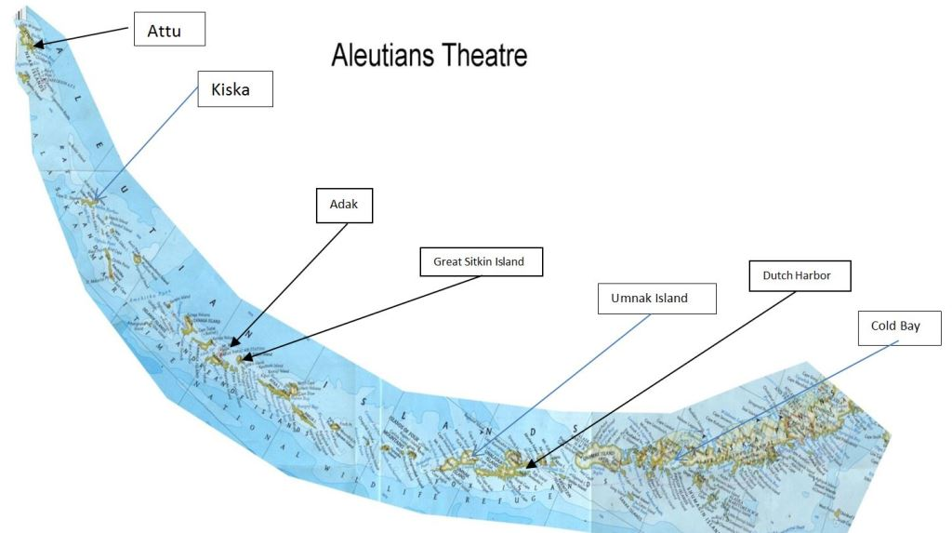

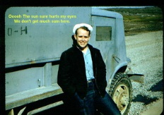

Kodiak Island

Cold Bay

I am devoting a time on The Aleutian Islands, as this area was a very important time at this stage of my life. It also makes it a little more understandable why in 1943, I was enlisted in to the military, put in uniform, issued a 30-06 Rifle, etc., at age 13. (See Utah State Guard Chapter)

My assignment to the Aleutian Islands was three years after the Hostilities of World War II ended. There were a number of key events in the Aleutians, including:

The Battle of Attu was the second most costly battle for the troops involved in the Pacific Theater for the United States during the war.

The Battle of Attu was the first amphibious island invasion by the U.S. Army in World War II.

The first invasion of U.S. soil since the War of 1812 happened in the Aleutian Islands in 1942.  
The first Japanese Zero captured intact in the war was on Atkun Island in July 1942.  
The Battle of the Komandorskis in March 1943 was the longest continuous gunnery battle in modern naval history.  
The first bombing of the Japanese homeland by land based Navy bombers was from the Aleutian Islands-in 1945.

After Navy Boot Camp and Radio School, we flew from Seattle, Washington in the Navy R5D, four engine passenger aircraft to Kodiak Alaska. We spent several days at Kodiak waiting for a flight out to Adak. I had a chance to visit some of my classmates from radio school and some that I was in boot camp with. One of those was Jim Benson from Parowan Utah. I also made a couple of trips to Kodiak Village to visit a family that I was ask to visit, but I don't remember the details. I also attended a dance, but the girls were Aleuts (Eskimo) and certainly were not very attractive.

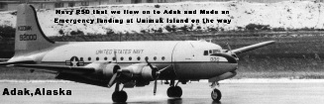We boarded a Navy R5D four engine cargo plane (C-54 Skymaster) on a routine flight to Adak Alaska. This area of the world is known for its terrible weather conditions, especially in the winter. There is an air current that comes up from Japan into the Arctic Circle and picks up a lot of moisture with it. This moisture laden air then sweeps down across the Aleutian Islands. The RF5D aircraft that I was flying in hit a severe weather Turbulence. This caused the aircraft to vibrate heavily with the R5D being tossed around like a toy and those of us in the rear of the plane flying around in the cargo area with the tremendous turbulence caused damage to the aircraft hydraulic control system. There was a period of panic trying to find something hold on too and trying to get back to our “bucket seats” and safety belts. Many aircraft have been lost under this condition

We made a forced landing on Umnak Island. We were told that finding airstrip so close by, saved our lives. We were told that it is impossible to land safely on the muddy Tundra. If you forced to ditch a plane in the ocean water is so cold that there's no chance of survival. Most of the casualties in the Aleutians during the Second World War were weather related.

With almost one million acres, Umnak Island extends west from the tip of the Alaska Peninsula. Only a relatively thin strip of sea separates Umnak from the Izembek National Wildlife Refuge. Approximately ninety three percent of Umnak Island has now been designated Wilderness.

**Umnak Island**

Most of the early settlements that developed up on Umnak were located along the streams. A major geologic event was the cutting of strand flats during the Hypsithermal period, about 3000 years ago, which led to a greater natural food supply on the island for the settlers.

The modern history of Umnak Island is linked to the defense bases established by the United States during World War II. The purpose of these forward air bases in the Aleutian Islands was not only to defend the Dutch Harbor but also launch attacks against the Japanese.

The US Navy considered this island as exclusive and as "their turf". They created a camouflage of establishing "Blair Fish Packing Co," to build airports, as forward bases, for use by the US Army Air Force during World War II. General Buckner after getting clearance from General DeWitt, built Secretly the airbases at Umnak and at Cold Bay. With this, the garrison at Umnak had strength of 4000, including engineering forces complemented by infantry and of field and antiaircraft artillery units, by the time the Japanese army enemy forces launched an attack two 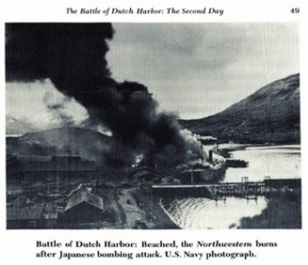months later in the summer of 1942. The Japanese had been planning to attack this island in June and capture the island with the intention of maintaining an aerial patrol of North Pacific waters. The island was planned to become an outpost in a new area of dominance that would later include the Samoan and Fiji Islands and New Caledonia. The Japanese were unaware of the covert preparations being made by the United States as they believed that the island was only protected by a few ships operating in Aleutian waters.

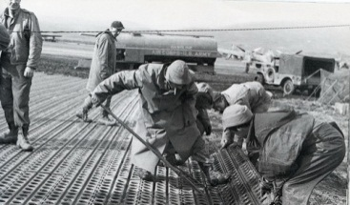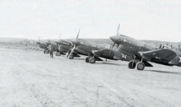A short time before the Bombing of Dutch Harbor, The Army built an Air Strip on top of the Umnak Trundra and stationed about 40, P-40 Fighters. This was one of Buckner’s "Secret" Bases. (Simon Bolivar Buckner, a four stars General, Commanded the defenses of Alaska. He was later killed during the last days of the Battle of Okinawa by enemy Artillery fire, making him the highest-ranking U. S. Officer killed by Enemy Fire during World War II, this occurred on 18 June 1945. **Thank you General Buckner for building a Landing strip and probably saving our lives**. Ninety Percent of the causalities in the Aleutians were Weather related not Enemy caused.

Dutch Harbor Naval Operating Base and Fort Mears are the two military installations built next to each other in [Dutch Harbor](http://en.wikipedia.org/wiki/Dutch_Harbor), [Alaska](http://en.wikipedia.org/wiki/Alaska). They were built by the [United States](http://en.wikipedia.org/wiki/United_States) in response to the growing war threat with [Japan](http://en.wikipedia.org/wiki/Japan). A 1938 Navy board recommended the construction which began in July 1940. The first army troops arrived in June 1941 and the Navy air base was finished in September 1941. At the time of the [attack on Pearl Harbor](http://en.wikipedia.org/wiki/Attack_on_Pearl_Harbor), these two bases were the only military installations in the Aleutian Islands.

From June 3rd to June 5th, 1942, The Japanese used Kate (Nakajima B5n) Bombers off from the Aircraft carriers Junyo and Ryujo. Due to the bad weather, only half of the planes found their targets. The causalities of this raid were 43 U. S. Navy personnel as the Aleutians were previously evacuated to camps in other areas.

Communications were primitive and Fort Glenn Army Base on Umnak and Ft Randall -Cold Bay were not contacted until the 4th of June. The Japanese believed that the Aleutian Chain of Islands had almost no defensive force and were shocked to see all the P40s from Umnak swarming to defend Dutch Harbor. The P40s from Cold Bay were also sent, but due to the distance, didn’t arrive in time to participate in the action.

The Japanese Invasion force then withdrew from the Dutch Harbor area and then Invaded Kiska on 6 June 1943 and Attu on 7 June. This was the first time that foreign power had invaded and occupied US Territory. There was no means of defense for these islands and they were occupied since the war of 1812. A few Aleut weather station personnel and an occasion school teacher. These were taken to the main land of Japan and interned. There were also plans to occupy Shemya and Adak as they would provide better terrain to construct Airfields. The United States developed a new base at Adak and was able to limited food and supplies to the Japanese garrisons. Japanese submarines seemed to be the only means to deliver the needed supplies. Japan was aware of the new B36 aircraft that were being develop and could bomb the main land of Japan from bases in the Aleutians.

**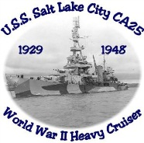**The movies say that the Aleutians invasion was a diversionary action. However, The Aleutians provided two important asset to Japan, First, it was a stepping stone for the invasion of the United States Pacific Coast and second, from there they would be able to provide the protection and control of the seas North of Japan.

**THE BATTLE OF THE KOMANDORSKIE –Salt Lake City**

During the War, there was one major sea battle and was called the Battle of Komandorski Island. The flag Ship under Rear Admiral Charles McMorris was the heavy cruiser Salt Lake City. This ship named by a Mormon Missionary, was put in Service in February 1930, the same Month that I was born. In January 1943 the new commander immediately went on the offensive. With every ship he could gather, he formed a blockade squadron to try to stop Japanese ships from resupplying the garrisons on Kiska and Atti. The ships patrolled far out into the sea opposite the Kuriel islands and managed to sink or turn back Japanese transports.

The transport that reached ATTU on 10 March was the last to run the blockade. The defenses on Attu were in serious trouble and without heavy construction equipment they could not complete the airfield from which land-based fighters and bombers could operate

So on 27 March 1943, the USS Salt Lake City was out of date for modern warfare. The Komandorski Island Battle was one of the most unusual engagements of World War II. It produced the longest continuous gunnery duel in modern naval history and was the last significant naval action in the Aleutian campaign. The American ships were old and had limited capabilities to stand up to the superior Japanese. However, neither fleet had air or submarine assistance. There was heavy damage on both sides. When the Japanese were posed for victory, Admiral Hosogaya, not realizing the heavy damage his Force had inflicted on the heavy cruiser Salt Lake City and fearing American Air Forces were in route, chose to retire without delivering the final knockout blow. Aircraft were actually launched from Adak but never arrived in the battle area in spite acceptability of rare good visibility of sea. The Japanese withdrawal led to a defeat of the Japanese because it ended their attempts to resupply their Aleutian garrisons by surface ships leaving only submarines for the resupply mission.

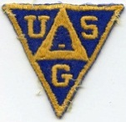Also, during this time period, The objective of Japanese Navy was to invade Midway Island for development of a major control point, Land based Air Strip and Naval Base. Naval Intelligence had broken the Japanese code and knew of their plans (More about the men who broke the codes will be covered later in this Chapter). The United State Navy gathered everything they had to repel this attack. Their main concerns were that this committed the total of their naval resources, leaving nothing to stop the Japanese from invading the West Coast of the United States. This information and the Balloon invasion is why the Utah State guard and other units were created. I became a member of the Utah State Guard in 1943 at the age of 13. There was a great concern for the protection of our West Coast from Japanese invasion. We were trained to protect the West Coast from an invading army. More about this is covered in another part of this history.

Military presence on Adak began during the early days of World War II. The Japanese had occupied Attu and Kiska Islands, and the United States was beginning preparations for an offensive campaign to dislodge them. The following is a quote from "The Thousand-Mile War…World War II in Alaska and the Aleutians", by Brian Garfield.

"In the heaving darkness of the night of August 28, 1942, fleet submarines Triton and Tuna surfaced a mile off the Adak coast. Without lights or sound, Colonel Lawrence Castner and the thirty-seven commandos slipped into rubber boats, pushed away from the pitching submarines, and rowed toward the dim coastline.

Crossing the reefs, they paddled into Kuluk Bay, dragged their rafts up on the beach, and fanned out inland. They covered ground thoroughly, taking all night to sweep the island. They found no Japanese; there were not even any ashes to indicate recent enemy presence on the island code-named Fireplace."   
  
Adak Navy Operation Base becomes the main operational base to launce attack Against the Japanese invaders. Un like Umnak and Unimak Island, Adak had a excellent harbor and air strip and could launch the PBY sea planes as well as the land based P40- Warhawk,, P38 - lightening, B17- Flying Fortress etc. On 7 May 1943, the main Attu invasion forces left Cold Bay. Most of the men did not have adequate clothing for Alaska. Amputations from frostbite proved to be a significant part of the high casualty rate encountered. The men had been train and clothed for a warm weather theatre of operation. It was 29 May when the last Japanese defender was dead. United States forces lost 600 killed and over 1200 wounded or put out of action by severe frostbite.

Okay, back to our Forced Landing on Umnak Island in February, 1949. The Base was still an active base. There has been no improvement of the Army Air Corps base since the end of the War except it was then, under the newly created U. S. Air Force. There was a small contingent 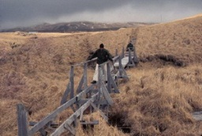of about 50 men as care taker personnel at the base. It was a filthy place, everything was dirty, the food was bad , no one seemed to be in charge and it seems that everyone was drunk. They were even drinking hair tonic.

Communications were made and a crew of Aircraft mechanics and parts were sent to repair our aircraft. I think that they came out of NAS-Kodiak. In a couple of days, the R5D was made operational. They didn't have a power unit to cycle the engines in preparation to starting them. We had to manually rotate the propeller blades to circulate the oil in the four engines. It was very cold and we were warned not to tough any metal blades as our hands would immediately freeze to the blades. After a major effort, the engines were started and we took off for Adak.

The weather was fair and we landed at Adak without any further problems. Adak, like most of the military facilities, was just as it was the day the World War II ended. The Air Force, Navy and Marines were still there, but reduced in numbers. Everything was Quonset Huts or old wood buildings. Food was terrible and there were no places to purchase snacks or other food, so we were dependent on the Chow Halls for anything to eat.

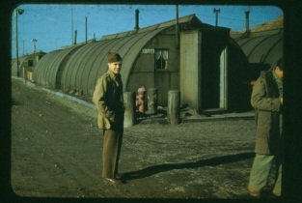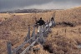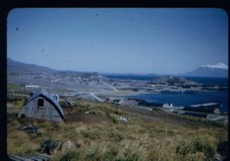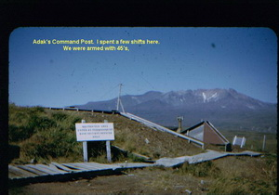The Korean War started after I arrive at Adak. My Island defense assignment was as BAR Team leader. I was assigned to stand Watches at the Base Command Post. Adak with considered to be in the War Zone and we received Island Defense Training from the Marine Corps

**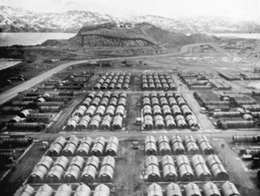**I was assigned to the Naval Transmitter site called Rocky Point. We had two large buildings, hous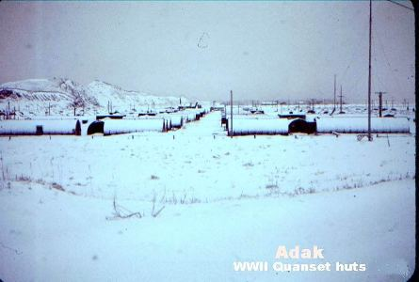ing many WWII transmitters. These Transmitters were all tube type units requiring considerable efforts to keep them on frequency and operational. Replacement parts were just about non-existent. As an example, the breaker (fuse) on the main MUX (Teletype) transmitter would routinely trip due the constant rain and heavy moisture in the air. The Breaker had tripped so many times, that it quit working. The fix was to take several strands of wire and wind them around the terminals on back of the defective breaker. One night in the early morning hours, the temporary fuse blew, so I grabbed my long nose pliers and the right number of wires and proceeded to install them on back of the defectives breaker. The pliers some way, dropped out of my hand, hitting the large bolts on back of the defective breaker and disappeared in a large flash. I had forgotten to turn the power off. I felt the Lords hand again in protecting me from death.

There was nothing to do when not on watch or working. No recreation was available, leaving only gambling and drinking. I didn't fit in with the group to well, so I studied and took classes from Capital Radio Correspondence course.

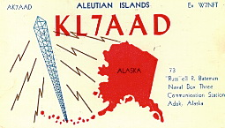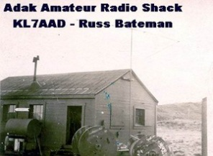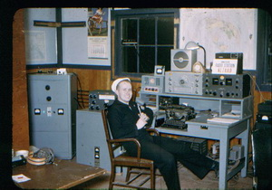Having passed my Amateur Radio Test in San Diego, I concentrated heavily in Amateur Radio Activities. Being only a "two striper Seaman", lowest rank in the active duty Navy, I was some way was able to become the Base MARS (Military Amateur Radio Service) Station master, obtain the use of a building and install underground power facilities to the Base Power Plant. This was an "off duty" project and was in addition to normal work assignments. Our working hours were heavy due to the shortage of personnel. Our MARS group of a dozen members, all having higher rating than I, took shifts of operating the station, providing local base personnel with the ability to talk with their family back in the States. If we couldn’t contact an Amateur Radio Operator near a town where the family was that we wanted to talk to, we would get as near as possible and then "Phone Patch" to contact them. In those days, there was no other means of voice communications back to the “States”. When I was not doing "Phone patching" for base personnel, I would just make contacts all over the world and exchange "QSL Contact confirmation Cards” I got two shoe boxes full of cards. The Station Call Sign was W7NFT/KL7 and then latter KL7AAD.

Near Adak was the Island of Great Sitkin. It had an active Volcano, with Fumaroles, hot springs, and bubbling hot mud. I didn't see any of the activity of the Volcano. This was a secret supply base and it that was hard to get any information about it even though it was only 25 miles from Adak. This base was storage for a lot of support supplies. The base had 50 caretaker personnel on the Island. The Story goes is that one night Navy security police observed a flashing coded light coming from out at sea, answered by a coded flashing light on the Island. At one time the Duty Officer ran out on the pier trying to identify the source of the flashing light and identified the object as a Submarine. He drew his 45 caliber pistol and fired at the object, which then departed. After a short investigation, all of the 50 personnel were replaced and I was the replacement radio operator. As only a "two Striper.” I had no training nor could I update the Communications documentation system, I was only there a month and I was relieved by a much more experienced, top rated radioman. I never heard anything more about the Island other than "Salvage Ships" came in and remove the entire supplies after which they closed the base.

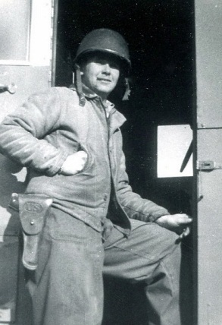I think that this secret base was first developed to support recovery of Attu and Kiska, and then later develop as support for the planned Invasion of the Main Land of Japan. There were many, many warehouses full of all kinds of War Suppliers, about everything that you could think of including jeeps and many types of weaponry, including large tanks containing different types of fuel. There was a very large amount of material. Up on leaving Great Sitkin Island, I was told that I was never to tell anyone about the base and what was there.

I had been working at the Transmitter Station and various other high level assignments such as paint the base of the antenna towers. Eventually, I was re-assigned to heart Lake Navy Receiver operation station. I was learning to be an operator communicator with Navy Aircraft, ships at sea and other stations. We had very little voice communications, operating with the WWII "dot-dash" American Morse Code. I was the operator on "ship to shore" duty one day when a Coast Guard Ship called and sent "int VERA". I didn't know what he was requesting so I ask for guidance from the Watch Supervisor. He opens a book that he had on his desk and wrote down on a scrap of paper "VERA - Dutch Harbor" which I sent to the Ship. Later, I was given a "Captain Mask" (type of a mini-court martial) noting that the information was classified. The Watch Supervisor by the name of Barfield claiming that he knew nothing about it, he didn't look up the information out of the classified book and said that he had a hard time supervising me. I said that that what he said was not true and that we had never had any personal Problems.

Well, guess who they believed. It was embarrassing to me for several reasons. I was LDS Serviceman’s Group Leader for the Island and group leaders' are supposed to not get in problems. My sentence was 3 months "Mess Cooking" ( KP) and I was sent to Radio City, a Navy Communications Intelligence Base on the other side of the Island. I was really depressed and felt that the Lord had not protected me.

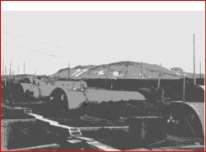I arrived at “Radio City” about the time the evening meal had been served and was assigned to clean up, especially all the pots and pans left by the approximately 100 enlisted men stationed at Radio City.

Monday morning I was up a 5 A. M. to help prepare for breakfast. I was called into the Office of the Mess Hall NCOIC. He said that they were assigning me to be the "CPO Mess Cook", meaning that I took care of the Chief Petty Officers (top rank for the enlisted rates) in their separate dining hall. There were 16 CPO and it was my assig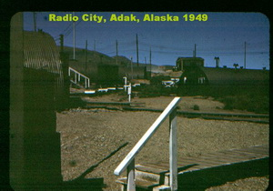nment to have their tables and dishes taken care of and ready for the next meal. Usually they would go out to the serving line and select what they desired or if they couldn't see anything that they wanted, I would fix them a toasted cheese sandwich or similar. 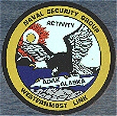

This was not a bad assignment giving me only a limit amount of working hours, not the 10 or 12 hour days that I had previous to this assignment. The environment was completely different. This was a high class people, very little bad language, no gambling or drinking. Hey, it was a neat group of people to be with. At the end of the month, one of the Chiefs handed me $50. I ask what that was for, and he said that we tip our mess cooks. As a lowly two stripper, my pay was about $110 a month, so nice increase in pay. I ask why there were no movies in the Movie theatre and was told there was no one who could operate the projection equipment. With my 5 years’ experience as projectionist in Cedar City and St. George theatres, I offered to run the equipment. I ended up running shows several afternoons and evenings, ordering the regular movie films from the Base theatre at the Island main base. At the end of the Month, I was handed another $50. Gee, may pay was doubled and no place to spend anything.

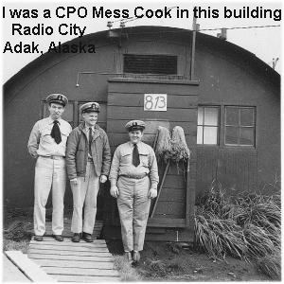At the end of my three month sentence, I requested an extension of three months. I was told they had never had a request from anyone extending their "Mess Cooking" assignment, but if I was that dumb, stay another three months they would approve.

At the end of the next three months, I again requested an extension for another three months. They refused my extension noting that there was something fishy about it and ordered me back to the main Navy Operating Base.

On my last day at radio city I found all 16 chiefs were waiting for me in the dining hall. This was unusual in that they were all on a shift type duty; I had never seen all of them at the same time before. They told me that with support of the 16 Chiefs, a request was sent through channels to have me transferred into the Naval Security Group and ask for my concurrence in. These same Chief Petty Officers played a major role in breaking the Japanese Secrete Codes just several years earlier.

I returned to my assignment at the regular naval operation base and found a number of changes from when I was there before. While the best thing was that the two commissioned officers that I had before, had been transferred. These two men were enlisted Navy personnel and captured by the Japanese during World War II. After their release they were given commissions to help compensate for their treatment as prisoners of war. They were the type that power gives them the opportunity to perform like little dictators. I felt that they were replaced, because they may have over stepped their authority, and it was a discipline problem.

The normal Tour of Duty for general naval personnel on Adak was one year, but due to the Korean War and being in what they considered the Korean War Zone, all rotation was cancelled. I had been on Adak about two years and was not happy to go back to my old communications group and environment.

Before I was given my new assignment, I was surprised to be called to the office of my new unit officer whom I had not previously met. He told me that he had high priority orders, transferring me immediately to Washington DC to report to the Navy Security Station for duty. This Navy Lieutenant, seem to be a very nice person, told me that he had requested transfer to the security Group several times but was always turned down. He asked me if I knew of anyway that he could get into the Security Unit. I suggested mess cooking at radio city.

Checking out and leaving Adak was no easy task. Since personnel were frozen due to being in the Korean War zone, there was no organized procedure. Waving my orders at a number of people, I was finally on a flight back to Kodiak Naval Air Station. While waiting for transportation to the lower “forty eight” had the opportunity of again attending the dance in Kodiak Village. I hadn't seen or talked to a girl in two years; it was surprising how much better the Aleut girls looked this time, than when I was there before.

Arriving in Seattle Washington I had the opportunity of attending some kind of social. I remember a couple girls coming up speaking to me and then thinking of me as some kind of a strange guy because I was speechless and couldn't seem to talk.

But, I was now a member of the United States Naval Security Group.

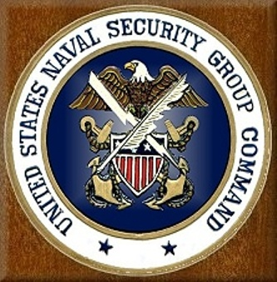.

**IN GOD WE TRUST -- ALL OTHERS WE MONITOR**

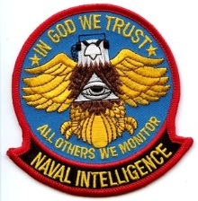**NAVAL INTELLIGENCE**

From Adak, after a 30 day leave at home, I flew into Washington D. C. and arrived at the Naval Transit Center for a day and then Transferred to the Naval Security Center in Washington D. C. From there I was taken to Cheltenham, MD Communications Station which was part of the Naval Security command and a classified monitoring Station with similar duties as Radio City on Adak.

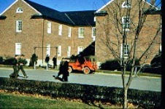 My assignment there was for SESP Training. It was intelligence gathering training for “Special Electronic Search Project”, a Top Secret activity at that time. The primary object was to locate and monitor Russian Guided Missile Telemetry Signals.

There were only about 12 students in training at the time I was there. About half of them had college degrees and had been selected from various naval programs

I requested duty with the Naval Intelligence flying unit that was stationed at U. S. Naval Air Station, Port Lyautey, Kenitra, Morocco. *The French military base at Port Lyautey was used by United States military forces during World War 2 and was expanded to a major US Naval Air Station in 1951. (The original airbase was captured by one American Destroyer (USS Dallas DD-199 and an Army Raider team in WW2.)*

*“PORT LYAUTEY, French Morocco - One of the silliest experiences any correspondent can have is to stand here in this French Moroccan town, and look, only yards away, smack at one of the most important tactical bases the United States armed forces have anywhere on the globe. The silly feeling arises because the joint is top-secret, hush-hush-hush, its existence officially denied by the U.S. Navy. The Port Lyautey Naval Air Facility is the aorta of supply to the U.S. Sixth Fleet air arm, the sharpest cutting blade of American strength in Europe, but Naval brass hats in the Pentagon still pretend no one knows about this key base "which does not exist" except in the knowledge of a few million Moroccans, Frenchmen, and sundry.*

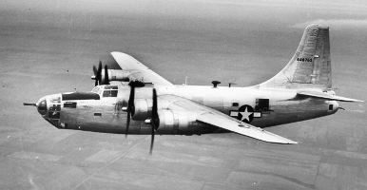They were flying a special aircraft called an YB34N that looked like a B24, but had a single tail. These aircraft were long range and equipment with special Naval Intelligence monitoring equipment. They had two or three of the Navy Aircrafts assigned to this project. The Air Craft would fly over Russia when there was a suspected Missile Launch, and fly back over the Mediterranean Sea before the Russian fighters could catch them. Later, I heard that The Russians didn’t stop of the Russian cost line, but followed the Navy Spy planes and shot them down over the Mediterranean Sea. Latter these air craft were replaced by Navy P2V2 fighter/Bombers that had two congenital propeller type engines, but had special “jet assist” that permitted the aircraft to energize the rocket engines when the Russian air craft caught up with them.

I was told that was an opening about the time I would finish my training-about six –nine months’. But to get the assignment, I would have to study hard and become vary efficient in each of the categories. My competition was several College degreed men.

I was excited about the assignment and put my efforts into my Training. There was lots of special equipment to study and I had to demonstrate usage and pass off each item. One special piece of equipment was a Radar Monitoring device that could finger-print radar equipment that with only one sweep of the radar signal, would I identify the signal with its differences from all other radars. This way we could identify a radar signal and record it and be able to identify it if we ever heard it again.

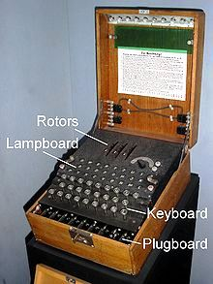one very interesting equipment at the school was the Famed German Enigma coding machine, The Enigma machine*.* The Enigma machine was an advanced electro-mechanical cipher machine developed in Germany after World War 1. The Enigma machine was used by all branches of the German military as their main device for secure wireless communications until the end of World War 2. Several types of the Enigma machine were developed before and during World War 2, each more complex and harder to code break than its predecessors. The most complex Enigma type was used by the German Navy. In addition to the complexity of the Enigma machine itself, its operating procedures became increasingly complex, as the German military wanted to make Enigma communications harder to code break.

Various intelligence evidence during World War 2 led the German military to make several investigations about the possibility that The Allies can read Enigma messages. The German intelligence and communications experts concluded that Enigma was still secure from allied code breakers. They were wrong.

In the age before digital electronics and computers, code breaking the ciphered messages produced by the Enigma machine was almost impossible even if the code breaker had a working copy of the Enigma machine, as long as he didn't know the right combination of initial electric and mechanical settings, which were also periodically changed. Additional security procedures such as double encryption and using codes in the original free text message made it even harder to code break an Enigma message, so no wonder the German experts were over confident about the security of the Enigma machine despite the suspicions raised during the war. In the age before digital electronics and computers, code breaking the ciphered messages produced by the Enigma machine was almost impossible even if the code breaker had a working copy of the Enigma machine, as long as he didn't know the right combination of initial electric and mechanical settings, which were also periodically changed. Additional security procedures such as double encryption and using codes in the original free text message made it even harder to code break an Enigma message, so no wonder the German experts were over confident about the security of the Enigma machine despite the suspicions raised during the war.

The operation of this machine was the first subject that was taught and was expanded onto the modern encoding of signals, specializing in Telemetry used for monitoring the operational functions of the Russian Missiles.

A lot of the training was one-on-one type. I was excited to complete training on one piece of equipment so that I could start on the next.

Early one morning as I was starting my training, one of the instructors came up to me and said, “Tomorrow, when you get in London, be sure you contact…….” I reminded him that I had another six months of training left and I was going to PORT LYAUTEY assignment. He was startled in that no one had talked to me. He told me that they had to replace one of the members of a team that been taken aboard a Submarine on a special mission and that I was his replacement on a top priory. Within two hours, I was on my way and the next day I was in London.

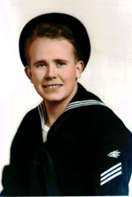

I asked “Why me, when I had only completed 1/3 of the training?’ What they said was, I was the only one they felt that had enough training to fill the assignment at the time. I was very disappointed. I really felt that I was only a “Seaman First (three striper)” and the others were petty officer rated and College Graduates, they got the choice of not being the replacement.

Order NM9/P16-3(2)/M U, S, Naval Receiving Station, Washington 25, D. C. Dated 20 Feb. 1951 (given to me on 21 February)  
To: Bateman, Russell Rulon 716 03 24 RMSN. Ref: BuPers ltr Pers-B211-ml-5 of 7 February 1951.

“You will proceed on 21 February 1951 and report to the U. S. Army Air Base, Westover Field, Mass. for further transfer on 25 February 1951 to Commander in Chief, Naval Forces, Easter Atlantic and Mediterranean London, England for duty with U. S. Naval Communication Unit No 32.”

My Priority 1 Travel provided me with a lot of attention. I bounced people from the Military Air flights. I think even a commissioned officer was bumped. We flew to Westover Field. And I transferred to a Navy R3y passenger air craft. We flew to the Azores for refueling and then on to an Air Field, just north of London.

It was dark when we landed at the Air Port near London. There were four of us Navy personnel that were loaded into a Navy personnel Van that was sent to pick us up and taken to London. As we were driving down a two lane road, we saw the lights of another vehicle heading towards us. But instead of passing us on our left, it passed us on the right and the four of us dove for the floor; think that it would be a head on collision. After the car had speed by us on our right, we got back up off the floor and sat quietly for a while, then started laughing as we were in England, where they drive on the wrong side of the road. 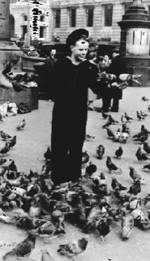

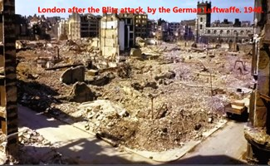The Van dropped us off at the “Park House” 97-99 Park Street, London, W.1. This was a Hotel rented by the military to house military personnel like me. I was issued a membership card reported in to the U. S. Naval Forces Office in London on the 23rd of February 1951. I was told that I needed to report to the U.S.S. Harold J. Ellison DD-864, on the 6th of March, at Portland, England. (Until then-get lost). That gave me ten days sight-seeing and attending church Etc.

London LDS Mission Home on knightengale Lane

There were still many areas that were still bombed out and a lot of piles of Brick. I spent a lot of time touring various areas of London. I found where the LDS mission Home was located and visited there. The while sign on the side of the fence said “War Damage repaired by….” I was told about the Gold and Green Balls that were scheduled and attended the one in London.

J:\@@@RUSS BATEMAN pictures MASTER folder\209-LDS\navy-GoldandGreenBall-London-150.tif

I met Margret Singer at Church, an LDS girl who showed me around London. I also met her Mother and Brother. They were LDS members and very good people. Her Mother was caught up needing Medical treatment that was delayed or refused by the government health care system.

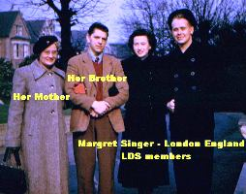March 6, 1951, I rode the Train from London to Plymouth England. With my Sea Bag over my shoulder, I walked down the plank, saluted the Ship and Saluted the deck officer and requested permission to come aboard.



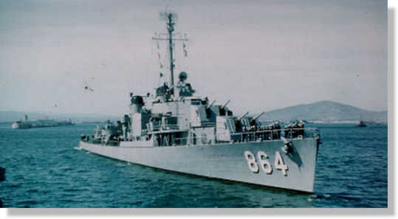

Ellison Commission 23 June 1945. De commissioned a August 1983 and given to Pakistan

“On 10 January 1951, the ELLISON departed Norfolk on her fourth trip to European-Mediterranean waters. Following two months of renewing old acquaintances in the Mediterranean, the ship accompanied the U.S.S. PERRY (DD-844) on a tour of various ports in England, Scotland and Germany”

Comm Unt 32 Naval Intelligence Teams comprise of a five man team plus one commissioned officer. My Officer was Mr. Soland, a Chief Warrant IV with 35 years of service. Mr Soland was called to meet me and take me to my quarters. The other members were chief Petty Officers and three other rated men. All the enlisted men were “Radiomen” with the logo of “Sparks”. 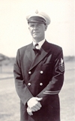J:\@@@RUSS BATEMAN pictures MASTER folder\109-Navy\navy-rating-radioman.JPG

Again, I was only a three stripped Seaman, the lowest rated member of the team.

Mr Soland had birthing in the Officers’ quarters, our CPO in the CPO quarters and the rest of us were assigned to a special CPO quarters. A special room (called the Spook Room) and antenna facilities were pre-install before the ship left the United States.

We left Portland the evening of 12 March, spending the 13th at Sea and arriving at Glasgow Scotland on the 14th of March. Glasgow still had a lot of War Damage and a lot of debris yet to be cleaned up. The area of damage was spotty and in spots all over the City. Some areas that were high class and better homes, we now just rubble. 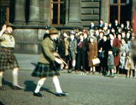 I watch some type of Scout parade and activity in Glasgow while were there. Men and boys were wearing their “Kilts.” The **kilt** is a knee-length garment with pleats at the rear, originating in the traditional dress of men and boys in the Scottish Highlands of the 16th century. Since the 19th century it has become associated with the wider culture of Scotland in general, or with Celtic (and more specifically Gaelic) heritage even more broadly. It is most often made of woolen cloth in a tartan pattern.J:\@@@RUSS BATEMAN pictures MASTER folder\209-LDS\Navy-GoldandGreenBall-Scottish150.tif Although the kilt is most often worn on formal occasions and at Highland games and sports events, it has also been adapted as an item of fashionable informal male clothing in recent years, re The kilt first appeared as the *great kilt*, the beacon or belted plaid, during the 16th century and is Highland Gaelic in origin, a full-length garment whose upper half could be worn as a cloak draped over the shoulder, or brought up over the head. The philibeg or *small kilt*, also known as the *walking kilt* (similar to the modern kilt) was invented by an English Quaker from Lancashire called Thomas Rawlinson sometime in the 1720s for the use of the Highlanders he and Ian MacDonnell, chief of the MacDonnell’s of Inverness employed in logging, charcoal manufacture and iron smelting, for which the belted plaid was "cumbrous and unwieldy" turning to its roots as an everyday garment.

I was able to attend the area LDS Conference and the Gold and Green Ball 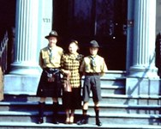and met Eleanor Helen Junior. She could tell me where various members were from, by listening to their speech. All though they all spoke English each area in the LDS district spoke a little different.

The Ellison left Glasgow Scotland on the 19th of March, spending the 20th at Sea and arrives at Hull England on the 21st.

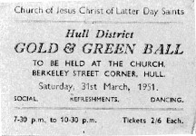Hull, England was heavy damaged during the war that only ended just in over five years previous. Many part of the City were still bombs out. Food was still rationed. I attended the Hull District Gold and Green Ball. Hull had one of the few pre-war LDS Chapels in England. The war damage to the chapel was only minim and the surnaming area was heavily damaged. What was one of the better areas of Hull, England was now one of the low class areas.

One may ask, how did a three striper seaman sailor get the navy to send this Navy Destroyer to three ports, one after another, so that he could attend the LDS Gold and Green Balls in London England Glasgow Scotland and Hull England? My Answer is that I went over their heads to higher authority.

We left Hull England on the 26th and arrived at Hamburg, Germany on the 27th of March. Germany was still occupied by the allied forces. The Ship was considered as part of the Army of Occupation and therefore we earned the right to wear the “Navy Occupation Service Ribbon.

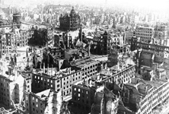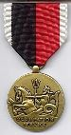The **Army of Occupation Medal** is a military award of the United States military which was established by the United States War Department on 5 April 1946. The medal was created in the aftermath of the Second World War to recognize those who had performed occupation service in either Germany or Japan. The original Army of Occupation Medal was intended only for members of the United States Army, but was expanded in 1948 to encompass the United States Air Force shortly after that service's creation. The U.S. Navy and Marine equivalent of the Army of Occupation Medal is the Navy Occupation Service Medal.

The Army of Occupation Medal was awarded for qualifying service.

* Germany (May 9, 1945 to May 5, 1955

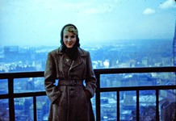I was able to take tours of Hamburg. The main part of the City of Hamburg was still flattened and all the bricks and debris had been cleaned up. I was able to walk down some of the Streets of Hamburg. A tour guide told us that his home once was located where we were standing. We were invited to programs telling us more about Germany and their post War plans.

I met a girl on a tour and she was trying to learn English. She tried to tell me a little about Hamburg and War conditions which they had to live in.

We sailed from Hamburg Germany on 31 March and returned to Plymouth, England on the 2nd of April.

We left Plymouth on April 6th and April 7th, we arrived at Weymouth England where we were spent a couple of weeks. I think that were “treading water”, waiting for their replacement assigned Ship that may have been a little delayed leaving the United States. As one of the England’s most beautiful seaside resorts, and blessed with one of its sunniest and warmest climates. I saw very little War damage in this area.

I remember a girl that I met by the Name of June. She milked seven cows’ morning and night. She took me home to meet her family. She lived in a nice home, but had a terrible smell. You opened the back door of the kitchen and there were the cows. I guess they got use to the smell.

She was a sweet young girl from a good family and an good friend but wouldn’t accept my warnings about a married fast talking sailor from the ship that I was on. I really felt bad that the sailors were taking advantage of English girls. Most of these English girls was so gullible and would believe about anything. They even believed that the western united States were just like the cowboy films that were showing at that time. We departed Weymouth on the 2oth of April.

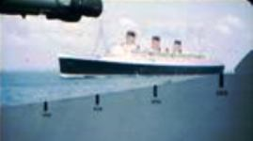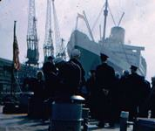On the 21st of April, we went up the Times River and tied up the ship in Greenwich, London, England, near the Famous London Bridge. (That LondonBridge is now in Arizona). This gave me the opportunity to see more of London, visit with Margret and her family. I went on several visits with the LDS Missionaries and I was able to visit a couple of Amateur Radio people. I joined the “Radio Society of Great Britten” and applied for a British Amateur Radio” G” station license using one of their addresses, but was turned down as I wasn’t a citizen. They were still in an Energy shortage and their homes were very cold and you had to ware you coats inside as well as outside.   
  
Shortly after we tied up to the dock, The Queen Mary I tied up just behind us. The Queen Mary is a very famous ship, but has now been replaced. The Queen Mary’s creation and launch was nothing if not extraordinary and her story is rich with history, elegance and grandeur. From the time her construction began in 1930 in Clydebank, Scotland, the Queen Mary was destined to stand in a class all her own.

For three years after her maiden voyage, the Queen Mary was the grandest ocean liner in the world carrying Hollywood celebrities like Bob Hope and Clark Gable, royalty like the Duke and Duchess of Windsor, and dignitaries like Winston Churchill. During this time she even set a new speed record, which she held for 14 years. But when the Queen Mary docked in New York in September 1939 that would be the last time she would carry civilian passengers for many years.

As World War II started, the Queen Mary's transformation into a troopship had begun. She was painted a camouflaged grey color and stripped of her luxurious amenities. Dubbed the "Grey Ghost" because of her stealth and stark color, the Queen Mary was the largest and fastest troopship to sail, capable of transporting as many as 16,000 troops at 30 knots.

On October 31, 1967, the Queen Mary departed on her final cruise, arriving in Long Beach, California, on December 9, 1967. She has called Southern California her home ever since. The Queen Mary is now a floating Hotel, Attraction and Event & Wedding Venue, home to three world-class restaurants and an icon in Southern California. I took the pictures from the rear deck of Ellison DD864.  
  
I was in downtown London the evening that Lighted Sign and advertising were permitted to be turned on. This type of lightening was not permitted since the starting of the World War II. Many of the Citizens had never seen lighted Signs. This was to be a big thing, but when the big moment came, I only saw a light here and there. It was disappointing to me, but the local British People was excited. The United States never really had to turn this type of lighting off, and I had been to New York City’s Time Square shortly before coming to Europe and seen all their lighting. Street lights in London had started Turing on about four years prior.

We left Greenwich on the 27th of April and sailed to Portland England arriving on the 28th. Portland was close to Weymouth. And back to Sea on the 30th until the 2nd of May when we returned to Plymouth.

We were completely detached from the normal Navy duties on board ship. Any time that they had working parties such resupplying, cleaning, painting, etc., we were considered not part of Ships Company. They called us “Spooks”. We stood watches in our own “SPOOK ROOM” a little room that had been modified for our mission before the ship left the United States. Sometimes our watch schedule was 24 hours a day and sometimes only 8 hours a day. I was made the maintenance man of the team and if I had everything working a properly taken care of, I could come and go as I wanted when we were in port. When we were on 24 hour, I had to share in the watch schedule.

When we were at Sea, I would try to get my work done so that I could go a shore and see as much as I could of where we were visiting. Then some times when we were at sea, when it was rough, I would spend time putting my last meal in a bucket or over the side of the ship.

When we visited a port, I would first try to find if there were any LDS members or activities. Then I would look in the Amateur Radio Call book to see if there were any Amateurs listed in the Area. Other than that, I was just a sightseer.

The Ellison DD 864 had completed it assignment and it was time to head back to the United States.

The Ellison was a great ship. The Officers and men were outstanding to be assigned with.

Sometime between the 2th of May and the 8th of May, We packed up all of our classified equipment and our own sea bags and placed them in to a Motor Whaleboat for Transferring to the Meredith DD 890, requiring several trips. It was a major task of installing our equipment in the special room that was ready for us. This was a heavy work load for me to check everything at our in the new location.

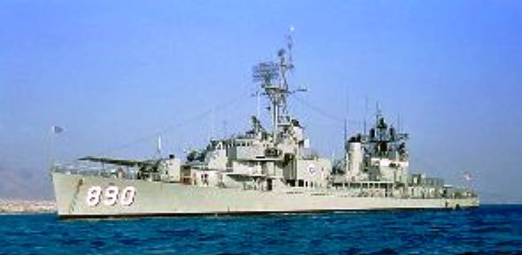

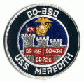**USS *Meredith* (DD-890)**, a [*Gearing*-class](http://en.wikipedia.org/wiki/Gearing_class_destroyer) [destroyer](http://en.wikipedia.org/wiki/Destroyer), was the fourth ship of the [United States Navy](http://en.wikipedia.org/wiki/United_States_Navy) to be named for [Jonathan Meredith](http://en.wikipedia.org/wiki/Jonathan_Meredith) [USMC](http://en.wikipedia.org/wiki/United_States_Marine_Corps), a [sergeant](http://en.wikipedia.org/wiki/Sergeant) who saved the life of [Lieutenant](http://en.wikipedia.org/wiki/Lieutenant) [John Trippe](http://en.wikipedia.org/wiki/John_Trippe) of *Vixen*, during the [Barbary Wars](http://en.wikipedia.org/wiki/Barbary_Wars). She was laid down at the [Consolidated Steel Corporation](http://en.wikipedia.org/wiki/Consolidated_Steel_Corporation) at [Orange, Texas](http://en.wikipedia.org/wiki/Orange,_Texas), on 27 January 1945; launched on 28 June 1945, sponsored by Miss Juliette S. Kopper, great-great-great-grandniece of Sergeant Meredith; and commissioned on 31 December 1945.

The Meredith DD 890 left Plymouth on the 8th of May and sailed for Gibraltar – Owned by the English and located on the southern tip of Spain. We spend the next couple of days as Plane Guard for an Aircraft Carrier (I don’t remember the name). When aircraft were launched or landing, two Destroyers were require to follow the Aircraft Carrier in case a plane went own. We had the experience of the loss of one air craft and a pilot.

We arrived at Gibraltar on 11 May 1951. At that time, you couldn’t go from Gibraltar to Spain, but had to go to another country that had authorization to enter Spain. Yes, I did visit Spain, but least my hand did. I reached through the fence so that I touched the Ground belong to Spain.

Gibraltar was much like Spain as many years; there were no barriers between the two countries. At the time I was there, the gates were close and there was a large fence/wall between the two areas. We only spend a day there and the put to sea again.

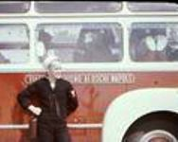Somewhere around this date, I was able to take the “Radioman third Class petty Officer exam and was promoted to Radioman Third Class Petty Officer.

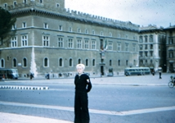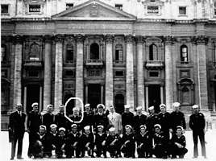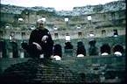We arrived at Naples, Italy on the 14th of May. Someone, (maybe the U. S, Embassy) set up a two day tour up to Roma. The Bus was new and modern. I don’t remember where we stayed, but it was near the Vatican. An audience was scheduled for a visit with the Pope. There were number tour guide assigned to us for this visit. They took us over to an area next to where there was a large crowd of people waiting for the Pope’s appearance. At the last moment , the tour guides joined hands and pushed to the center of the crowd next to the roped off area, push the crowd back and pulling us in front of the crowd, placing us next to where the Pope would be. The crowed didn’t seem to mind, we were all in uniform and we received respect from the crowd.



The Pope (Pius XII?) offered me his ring to kiss, but of course I didn’t. I was embarrassed! They pushed those people back and put us in front. I thought it very rude. It was very nosy with every one screaming **Viva il Papa! Viva il Papa!** Long live the Pope! (Italian)

We left Roma around noon on our last day. Traveling down the road toward Naples, we came into a small village with a group of about a couple of hundred people. They were having a party and soon as they seen us, they blocked and surrounded the bus, Singing and yelling parses. They about pulled us of the bus and continued their song and dance. They were showing our appreciation for the military defeating their enemy (Germans). You could see that there had been a major battle in that little Village. You could see the bullet marks in the building and some buildings were still showing the results of the battle. It looked like it could have happened the day before, not five years before. They had a hard time letting us go and a lot of us had tears in our eyes from the experience.

We left Naples on the 19th of May and spent several days at sea arrived at Augusta, Sicily on the 24th. This was the area that Sicily was invaded during WWII by the British and American Forces.

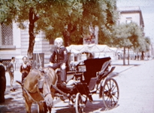Leaving Augusta on the 24th and arrived at Palermo, Sicily on the 25th. There was no indication that there any sign of the LDS church in the area, I took a Taxi to look up an Amateur Radio Operator that I found in the Call Book. The taxi was a Horse pulling open buggy. Going down a coble Stone narrow road, about a dozen boys, about 10 years of age came at us from all sides. The driver using the buggy whip beat them off from getting to me, and outran them going down the street. I had seen others that thee young ruffians had caught, taking wallet, rings, everything in your pocks and leaving you with a beaten body. The taxi driver took a picture of my sitting his driver’s seat.

I knocked at the door of the Amateur Radio Operator. When he came to the door, he asks me if I spoke Italian. No, I said do you speak German? I said no. Do you speak French? I said no. Then he said, I donna speak English very well, but I will try. We spend a time on the Air and let me do the(CQ) calling. He said that they replied saying what good English that he spoke. I think that the Amateur Radio Person was a University Instructor. I was able to return to the ship with our any further problems.

We left Palermo Sicily on the 29th of May

On 1 June we anchored at Paulon Bay Athens Greece. It was exciting to visit the Acropolis – Parthenon from Ancient Greece; I walked the Streets of Athens, seeing as much as I could. I was in uniform, walking alone somewhere in the City of Athens and saw a man walking toward me. He looked like a typical shabbily dressed Greek citizen, but a defendant American voice, said “Hey buddy! You need to get out of here fast as you can. They are having a Communists rally here in just a few minutes” and he kept on walking past me without another look or hesitation. I walked rapidly back to the main part of the City.

The next day, the Greek Government hosted a reception for the crew of the Meredith in one of the Parks. At that time, Greece had a Queen who visited the reception and chatted with us in very good English. We left Athens Greece on the 8th of Lune. On the 10th of June, we pulled into Malta and several men left the ship. We were not permitted to leave the ship and went back to Sea the same day.

We joined the Sixth Fleet (Guess 30 ships, including several Battle Ships, Aircraft carriers off and on during this tour in the Mediterranean). As I noted before, I was the Maintenance man for our team. One of the counter balance weights came of our Radar Receiving Antenna making our classified equipment non-operational. There were two Russian Submarines shadowing the U. S. Sixth Fleet and the Commander of the U. S. Navy 6th fleet wanted to keep track of these Submarines’

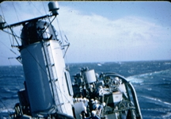Now I understood why the training on Finger-printing Radars Signals that they taught us back at school in Cheltenham. I was still the lowest ranking team member and was trained on the equipment, but Chief and Warrant officer operated the classified Radar Finger Printing Equipment while we were with the fleet. This was of main purposes of why we were on this assignment. We were told that we were probably on ones in the world at that time that could finger print radar. This was to be the first proof of its capability.

Our Team commission officer said that the Admiral said that we needed to know where those Russian Submarines’ were and the evaluation of the system has to be done. And he was looking at me. I ask him, are you saying that I have to climb up on the Antenna structure above the “smoke stacks”(see the picture) and work on the rotating antenna? Those seem to be the story. That was the reason for the ship being there he told me. The Meredith requested permission to drop out of the Fleet to repair the antenna.

So the Meredith DD 890 came to a complete stop- at least forward and backward, but there still was a rocking ship as I climbed up to work on the Antenna. One moment, you would down and see the water on one side of the ship, then the ship would rock and the water on the other side of the ship would be under you. I was so sea sick and felt like Throwing-up.

When I looked down, there were 250 ships company looking up and watching me. I was one scared sailor. With the help of the Lord, I was able to repair the Radar rotating antenna and we were at flank speed, catching up with the Fleet.

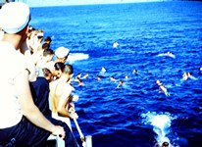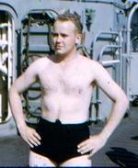It was quite hot that time of the year in the Mediterranean and in that we were alone at that time, the skipper decided to stop the ship for a Swim call. It really felt good to put you swimming suit on and get into the Cool Water. Little did I know that one of the Scariest times of my life was just ahead? The sea had been just like glass, without a ripple of a breeze. Suddenly a strong wind came up and blew the ship away and created high winds. It seemed that for hours that I could not see the ship or any of the Ships Company (sailors) that were in the water. No land, no nothing except-water. It was probably on 15 to 20 minutes. I was in the middle of the Mediterranean ocean, no life preserver, No land, no ship, or people in sight. I swam as hard as I could in the direction that I had last seen the Ship. It was big relief when I saw the tip of the ship’s mask between waves. The wind died down and I was able to make it back to the ship. They did send the motor whale boat our after swimmers that were still in the water.

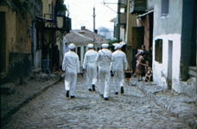On June 15 we arrived at Salonica, (Thessaloniki) Greece. I look at the pictures of Salonica now on the internet now and what a difference. When I was there, there was just a few dozen town building next to the Ocean for the down town which had power and lights from an old rusted U. S. LST”s ship(large Landing craft) generator that was partly Beached. There were no docks and we had to anchor out in the bay and come to shore using the Motor Whaleboats.

I talked to a Greek Citizen who spoke very good English. He invited me to his home and I was really excited to get the opportunity. It was a typical housing area with small walk ways between rows of primitive housing. I say small walk ways as they were not something that you could drive a car down. The walk ways were made of Pebble’s. The dwellings had an outside room where they built a fire to cook food. There was not running water that I saw and I don’t know what they did for bathroom facilities and the smell let you know that they were nearby.. This Greek man had some nice furniture, which I didn’t see in other dwellings. Windows were open with no glass and used a board or cloth to cover the windows.

He wanted me to meet his “step” daughter. She and her brother parents were killed in the war by the Germans. He said that protected her and keeps her away from any males and that she spoke English. He tried to get her to talk to me. The question that she asks me was “are their kitchens in all American Homes? I had to ask the question several times and I couldn’t understand the word “Kitchens”, when I answered yes, she got a surprised look on her face. She was a beautiful young girl of about 18 years of age. Then I got a surprised offer! He offered to “Give” her to me if I would marry her and take to the United States. Nice offer. But not one of our customs. Arranged marriages were common when I was in Europe.

He walked me back to town and the ship. He asks me to sending him pages out of telephone books. I was not sure of his request and of course didn’t send him any. Salonika is the now the third largest city in Greece and one of the most important harbors in the Mediterranean

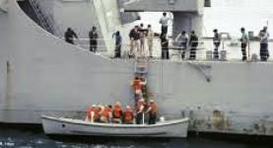We left Salonika on June 20th and arrived at Izmir, Turkey on June 21. Again no docks and so we anchored out in the bay. The conditions were terrible. Those going ashore had to take an indoctrination to give the strict regulations as we did not have good relations with Turkey at that time.

The procedure to get into the Motor Whaleboat was that they would put a harness around you and swing you our over the water, above the Motor Whaleboat. When the waves would bring the Motor Whaleboat up, they would drop you in the boat releasing the rope connected to the harness. If you didn’t make it into the boat the first time, they would pull you up and try again. It was the same getting back on the ship. The motor whaleboat would take you to the beach where the waves were small.

Once on shore, you didn’t talk to anyone or travel/walk anywhere. It was kind of a dull experience.

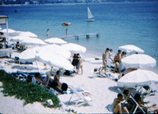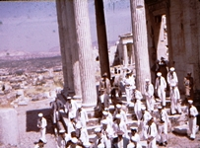We left Izmir Turkey 25th of June and went to Leros Island, Turkey. Due to the Bad weather, they didn’t let us go ashore and that the Weather was too bad to go through what we did in Izmir, Today, Leros is some kind of a holiday vacationing place. I guess that we left the same day for Rhodes, Greece

Rhodes, Greece had Castles and I remember, there were so many things to see it was a fun visit. We left Rhodes Greece on the 29th of June, for Piraeus, Athens Greece.   
  
This is the main port of Athens and largest port in Greece and also one of the most important in the Mediterranean. Again, more sightseeing, and we toured the Athletic arenas where the ancient Olympics were held.

We left Greece on the 6th of June spent more time with the 6th Fleet and arrived in Gulf Jaun, Cannes, France on the 8th of July, they had a beautiful beach with half or nude women.

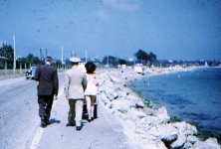Also pictured is of my Team Chief and Warrant Officer (in civilian clothing) walking along the Beach in Cannes France.  
  
 It had been a long time since I had a glass of Milk so I ordered one. It was terrible, goat’s milk, I think. We did get a change to go to a restraint and order some great food.

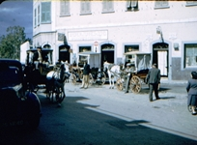We left Cannes France on the 9th of July, spending time again at Sea and Plane Guard and went to Gibraltar on the 12th for refueling. Gibraltar is Spanish culture and a lot of Spanish influence.

We arrived in Plymouth, England on the 16th of July. Plymouth was a Navy Town and center of most of the British Fleet. There were many ships in the harbor including British military and many foreign ships also. We did a lot of work on the equipment.

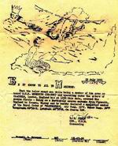We left Plymouth, England on the 20th of July were at sea for next four days. On the 23 of July, there seems to be a lot of excitement and it was announced over the Ships Audio system that all members of the ship were now members of the “Royal Order of “Bluenoses”” ***You are a member of the crew on board The U.S.S. Meredith DD-890 and operating under the orders of CinCNELN, London, England has at 1250 this date, crossed the Arctic Circle – Being on a Northerly course reroute from Plymouth England to Tromso, Norway and is hereby declared a qualified member of the Royal Order of “Bluenoses”. The Air Temp was 58 F and the water temp was 52 F Longitude 09 -36 Latitude 66-33 and on course 028”*.** A certificate was issued to all Ships Company, signed by R. R. Green, Commander – the Captain of the Meredith DD 890. It took me a while to find out what it was all about. I found that it is an ancient custom when you crossed the Arctic Circle going north, you become a member. This tradition was celebrated in many ways and in the old sail ship days, everyone would get drunk. That didn’t happen on the Meredith DD890 however.

**Tromso Norway**, 100 miles north of the artic circle, called the gate way to the Artic. People have been living in the [Tromso](http://www.iglobetrotter.com/norway/tromso/tromso-front-page) region since the end of the ice age. In 1794, Tromso was awarded city status. The fact that there were only about 80 people living in the city didn’t seem to curb people’s urban aspirations. In the 1800’s Tromso got the nickname ‘Paris of the North’. The occupation of Tromso was more or less peaceful, and the city itself escaped any major damage during the war.

**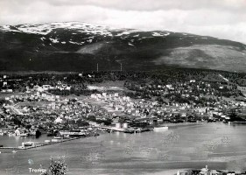**Tromso acted as the capital of the free Norway for three weeks following the occupation of Oslo and the South in April and May 1940. The government and the royal family all fled to Tromso at the outbreak of the war, and stayed there until the English cruiser “Devonshire” took them across to England on the 7th June 1940.   
I remember that the population of Tromso was less than 10,000 when we were there. Today it is over 50,000. We tied up at the dock as shown in the picture

We arrived at Tromso, Norway on 24th of July 1951. We were the first U. S. War Ship in the Tromso port. It was not known when or if, a U. S. Man of War ship had ever been in this part of the world. It was felt that do to the requirements of our mission may have been the reason for the assignment. Our mission was to “Finger Print Radars and to find telemetry signals from Russian Missiles. Of course it what top secrete as to what our assignments’ were. We were called “Spooks”, like we were on the Ellison, our little room on the Meredith was installed in the States before the ship set sail for Europe.   
  
The City went all out for us with parties. This was an exciting event for the People

I found no LDS members there and again tried to find an amateur Radio person. I ask about him talking to one of the City high level officers. She put me in a taxi (a real car) and he took me out into the Country on an old mostly dirt road up in the mountains.

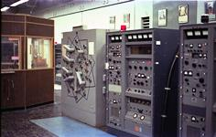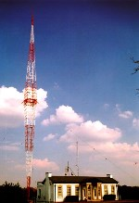The taxi stopped and let me out in from of what I could tell, it was a high power Radio Transmitter Station. I think that it was a “Radio Free Europe” beamed into Russia. Radio Free Europe was created and grew in its early years through the efforts of the [National Committee for a Free Europe](http://en.wikipedia.org/wiki/National_Committee_for_a_Free_Europe) (NCFE), an organization that was formed in [New York City](http://en.wikipedia.org/wiki/New_York_City) in 1949. The committee was composed of an "*A* list" of powerful U.S. citizens including former ambassador and first NCFE chairman [Joseph Grew](http://en.wikipedia.org/wiki/Joseph_Grew); [*Reader's Digest*](http://en.wikipedia.org/wiki/Reader%27s_Digest) owner

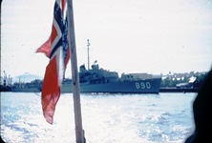I went up to the door and pushed the button. A man came to the door who was apparently the Engineer and after a scuffle with the language found that he was the Amateur Radio person that I was asking about. He was very shy and knew no English. We spend about an hour or so and I figured that I need to get back to town, but how? After walking hours, I finally got back to town, around 2 in the morning. It was July and the Sun never went down. I got back to the ship, dead tired and ready to get some rest.

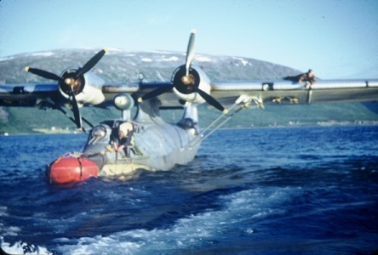 However, there was notice for anyone who was interested in a tour of the area, had to be at the Ships Gangway before 0600 (Tromso time). Not many were excited about it as who would want to get up that early just to tour the area. Well I was there at 0500 and the first in line or at least about the first of the line. I think that they counted down to the 12th man and told the rest that that was all the room they had.

We boarded a Norwegian motor whaleboat and they took us out to two Canadian built PBY5 Catalina flying boats. The Consolidated PBY Catalina was the U. S. Navy's most successful patrol flying boat of the war but naval aviators also used the PBY to attack ships at night, and to search for and rescue people stranded at sea.

Many aviation experts considered the PBY Catalina obsolete when the war started but combat proved the critics wrong. The 'Cat' had two noteworthy attributes that made the airplane prized by American aviators and the flight crews of other Allied nations: great range and excellent durability. By VJ Day, August 15, 1945, Consolidated and its licensees had built 3,282 PBYs, more than any flying boat or seaplane ever built.

The PBY-5 was the patrol plane that located the Famous German Battleship Bismark. It was the scout plane that located the Japanese fleet near the Midway Island in the pacific Ocean.

The PBY5’s were especially useful to the Norwegian Air Force because they had lots of water, but very few Ground air fields.

They opened the bubble on the side of the air craft and put 6 of us in each Air Ship. I took a couple of pictures with my camera and was then told that picture taking was not permitted.

We took off about 0600 and headed north to Hammerfest. Hammerfest claims to be the northernmost city in the world, although the title is disputed by Honningsvåg, Norway

After their victory in the [Norwegian Campaign](http://en.wikipedia.org/wiki/Norwegian_Campaign) of the [Second World War](http://en.wikipedia.org/wiki/World_War_II), the Germans soon fortified Hammerfest and used it as a major base. The importance of Hammerfest to the Germans increased dramatically after their [invasion of the Soviet Union](http://en.wikipedia.org/wiki/Operation_Barbarossa) in 1941.

Hammerfest was forcibly evacuated by the [occupying German troops](http://en.wikipedia.org/wiki/Occupation_of_Norway_by_Nazi_Germany) in the autumn of 1944 and then looted and burned to the ground by them when they retreated, the last of the town having been destroyed by the time the Germans finally left on 10 February 1945. Only the town's small funeral chapel, built in 1937, was left standing by the retreating Germans. At the time of our visit, it had been only six years since the end of hostilities and very little money to rebuild, so there wasn’t much of the town at that time.

During summer massive [reindeer](http://en.wikipedia.org/wiki/Reindeer) herds migrate from their winter pastures. The pilot of the air ship that I was on was the Norwegian Air Commander. He went down and chased Reindeer herds.

I told the pilot that I had been doing some flying training so he let me sit in the right seat and do some flying of the PBY5. There was not hydraulic on the controls and it was all manual operating of the controls. I had a hard time as I didn’t have the strength that was required.

We flew down the Russian Boarder from the top of Norway to the bottom then over Finland. They had fear of the Russians and had armed 50 Caliber guns in each of the blister Windows.

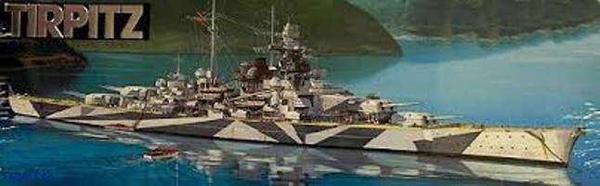After Flying over Finland and returning to Tromso, we flew lover over the Battleship Tirpitz which was sunk by the British in one of the coves near Tromso. The ship was capsized with only the bottom showing and still housing thousands’ of German Sailors bodies inside. The Tirpitz wreck is in a hidden location and the Commander of the Norwegian Air Force (and our pilot) said he didn’t think that any Americans had seen it.

The German Tirpitz and the Bismarck were the two largest battle ships in WWII. The British sank the Bismarck in 1940 but it took until 1944 to sink the Tirpitz after many tries using Submarines and Lancaster British Bombers.

September 1941 Tirpitz was a member of the so-called "Baltic Fleet" related to the German invasion of the Soviet Union, Operation "Barbarossa". While still on trials, Tirpitz joined a powerful assembly of German warships off the Aaland Islands to deter the Soviet fleet from venturing out of Kronstadt. The "Baltic Fleet" consisted of Tirpitz, Admiral Scheer, Emden, Leipzig, Köln and Nurnberg, together with numerous destroyers, torpedo boats and mine sweepers.

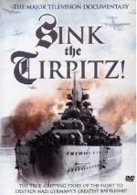The German Navy decided to send battleship Tirpitz to Norway on 10 Jan 1942 to tie down Allied naval resources in the North Atlantic. 14 January 1942 Tirpitz, escorted by the destroyers Richard Beitzen, Paul Jacobi, Bruno Heinemann and Z29, transferred from Wilhelmshaven, Germany to Trondheim, Norway. It was 4 days later than originally planned. Tirpitz arrived, with the destroyers, at Trondheim and anchored in Faettenfjord January 16, 1942. She was moored next to a cliff, which protected the ship from air attacks from the southwest. The ship's crew cut down trees and placed them aboard Tirpitz to camouflage her. Additional antiaircraft batteries were installed around the fjord, as were anti-torpedo nets and heavy booms in the entrance to the anchorage. Life for the crew of Tirpitz was very monotonous during the deployment to Norway.

The Tirpitz has been cut up and the steel used to build many bridges throughout Norway.

Movies have been made of the sinking of the Bismarck and the Tirpitz. Sink the Bismarck movies are seen in the US, but movie as shown on the pictures seem to be available only in Great Britain. I tied to order it twice, but they sent “Sink the Bismarck” instead. There are many Tirpitz documentaries’ available on the internet.

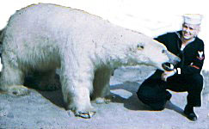We got back to Tromso around 5 PM. That was a long trip with out food or water, but it was worth it.

I did look up another Amateur radio who was living in Tromso. He had been living in New York and a radio operator servicing on a Norwegian ship. He was engaged to a girl and living with her in Tromso while on six month vacation. They were doing what they called a culpability test to see if they should get married.

He told me about the group of Norwegian commercial sailors who purchased a number of cheap “Engagement rings” and would hand the out to girls up and down the coast of Norway and live with them a night or so and then take them back the rings, saying that they were not compatible. Men were hard to find in Europe as so many had been killed in WWII. I found that where ever I went to a dance around England, or Norway, I never had to ask a girl for a dance, they there was several asking me due to the shortage of men.

We left Tromso on the 27th of July and, continue down the inland waterway.

We were the first “U. S. man of war” to sail down the “Inland Water way” We had two Norwegian Pilots to help us with the navigation between Tromso and Bergin Norway.

|  |  |  |  |
| --- | --- | --- | --- |
|  |  | |  |
|  | |  | |

We at arrived at Narvik and tied up during the early morning hours. This was the first visit of an U. S. Navy Ship. A Planning Committee had been developing this celebration for months. They decided to combine this celebration with their 50 year railroad anniversary. There were representatives from the Norway National Government, city officials, The Norwegian Naval District Officer and the American Naval Attaché Lt. Holter (USN) and the Norwegian Army. It was a big thing for the citizens of Narvik.

Narvik experienced heavy war damage in that they had resources used by the Germans. They re-built a lot their city in since the end of the war just five years earlier.

I found that there had been a large LDS group, but the mostly immigrated to the US back in the 1800 and those that didn’t go, fell away from the church. I am told that there is an   
L D S Ward there now.

We Left Narvik on the 30th of July and arrived at Bergen Norway on the 1st of August. Now we were just another ship in the harbor and no one was excited.

I found that there was an LDS branch in Bergen. I visited the Chapel which was above a store in downtown Bergen, but couldn’t contact any members in the short time that I had.

We left Bergen on the 3rd of August; we spent time at Sea, arriving at Isle of Wright, Cows England the 6th of August. We were representing the United States at the International Yachting Regatta. It is also called the Sailing regatta. It has always been the largest, longest running and most prestigious sailing regatta in the World. There were two destroyer dressed up with all the flags. One was the U. S. Navy Meredith and the other was a British. The seven days that we were there, were the main days of the activity. There were a lot of “parting” going on the water and all around the City of Cowes. “The Spook Room” closed while we were there and we had no watches assignments and were free to do as we wanted for the week that we were there. Our ships motor whale board made hourly trips to shore about every hours.

|  |  |  |  |
| --- | --- | --- | --- |
|  | J:\@@@RUSS BATEMAN pictures MASTER folder\109-Navy\DD890meredith\cowes-dress ship_22-150.jpg |  |  |

**Cowes Week** is one of the longest-running regular [regattas](http://en.wikipedia.org/wiki/Regattas) in the world. With 40 daily races, up to 1,000 boats, and 8,000 competitors ranging from Olympic and world class professionals to weekend sailors, it is the largest sailing regatta of its kind in the world. Having started in 1826, the event is held on the [Solent](http://en.wikipedia.org/wiki/Solent) (the area of water between southern [England](http://en.wikipedia.org/wiki/England) and the [Isle of Wight](http://en.wikipedia.org/wiki/Isle_of_Wight) made tricky by strong double tides), and is run by Cowes Week Limited in the small town of [Cowes](http://en.wikipedia.org/wiki/Cowes) on the Isle of Wight.  
 As well as the sailing activities, the week includes a large number of onshore events including live music and cocktail parties. Marquees are erected in the marinas serving food and drink, and the crowds overflow from busy public houses and restaurants around the narrow high street - the town becomes a hive of activity into the early hours of each morning. Around 100,000 visitors are attracted to Cowes by the festival atmosphere of the event each year in addition to all the competitors. A lot of the royalty from all over the British Island make the trek for the occasion.

It was only five years since the end of the War and every one showed appreciation to us American Sailors for the support of the United States in the WWII War effort. Again, I felt guility for the glory that we receive and we were not the ones that foght and died for this honor.

All the members on the our ship were issued the pass (shown above) that gave us access to every thing free. Every where their were a lot of girls and a small number of boys due to the losses of the War. The first night I attended the dance and spotted this beautiful girl. For the first time, I ask a girl for a dance. After a short hesitation, she excepted. and we danced every dance together that evening and every evening during the festables. We seems to “hit it off well”. At the end of the evening, I suggested that we continue the next evening. She looked at me and didn’t say anthing. A shot time later, I noticed that she was wearing an engament ring and I appoligized. After a short pause, She told me that she was engaged to a “Bus Condutor” up in England and he didn’t like dances and agreed to meet me the next eveining.

I didn’t find out until twoward the end of the festible that she was a member of the royal family, but lived in Cowes. He Aunt held some high royal position, something to do with the Island of Wright. The Aunt was really up set with her and her parents as she had arranged a marrige of this girl to another member of the Royal Family (fifth or sixth cozen )and lived in London. So this beautiful gal and her parents defide the Royal Aunt, but she said that she still had to marry this bus conductor up in London. I had a hard time understanding arranged marriges. ( See my chapter on “FRIENDS”)

It was a special experience to have been a ships company member representing the United States.

We departed Cowes, Island of wright, on the12th of august 1951.

We headed for Casablanca. We weren’t permitted to go ashore. We returned to be operational with the 6th fleet again.

We left the 6th Fleet and returned to Plymouth, England.

2 September, I requested leave and was granted and took the Train to London and then changed trains to Glasgow.

4 Sept –I returned to the ship which I met at Dundee Scotland.

7 September New Castle. England

20-The Meredith returned the Plymouth England.The USS Meredith DD890 had completed her tour of duty and was returning back to the United States. This again was good ship with good officers and I appreciated the opportunity to serve on her.

On 22 September, Our Comm unit **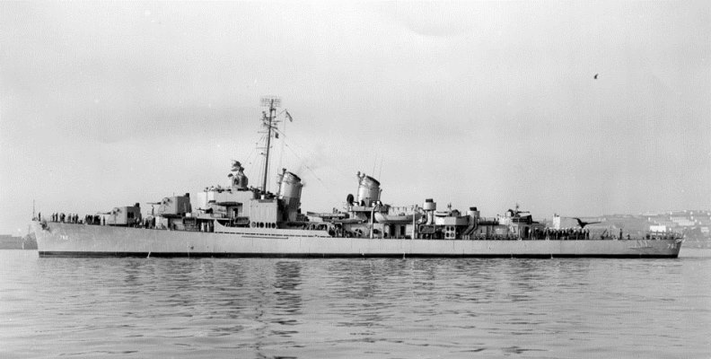**32 team was transferred to the Henley DD 762 **CLASS - ALLEN M. SUMNER** As Built.  
Displacement 3218 Tons (Full), Dimensions, 376' 6"(oa) x 40' 10" x 14' 2" (Max)  
Armament 6 x 5"/38AA (3x2), 12 x 40mm AA, 11 x 20mm AA, 10 x 21" tt.(2x5).  
Machinery, 60,000 SHP; General Electric Geared Turbines, 2 screws  
Speed, 36.5 Knots, Range 3300 NM@ 20 Knots, Crew 336..

The Henley was not a good ship to be on. The food was bad and our team receives an unwelcome to the ship. We were giving birthing with the ships company, Even though we stood watches, no one was permitted to be where around 100 bunks for part of the ship personnel sleep area. So after some watches we had to stay in our special Spook Room and try to get some sleep. They demanded that we take assignments with the crew working parties and we not given open gangway privileges that we had on the other ships. The character of the ship depends on the leadership.

The first time we went to sea, I was taking a picture of transferring a man to the Henley from another ship using a cable between the two ships. A person started screaming at me to put my Cameras away. “You can’t take any pictures on the ship” This was a peace time navy and I had no problems on my two previous ships. It turned out to be the Ships captain doing the screaming.

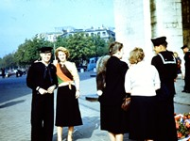29 September the Henley DD 762 went up the River Seine 315 km to Rouen France. It was just like driving in the country; The River was not very wide, but deep enough for the ship. Rouen was one place that my Father during World War I and my Brother World War II and then me visited while we were in Europe. We were able to take the Train on up to Paris and spend three days.

3 4, and 5 October Paris France

I went up with a friend, wasn’t LDS, but did drink or smoke and enjoyed see the things in Paris France. We did the Eiffel Tower, Joan of Arc, and a number of the historic sites. Along the way a girl started following us and it didn’t take long to understand what she was after. She was one of those professional, beautiful girls that wanted to make some money. We told that we were not interested in what she had to offer and kept trying to sell what she had to offer. We couldn’t get rid of her until I came up with an idea. I put my arm around my friend, giving him a hug and telling her that we wanted to be a lone. She asks, “are you that way”? I said yes and she left immediately and we were able to continue see Paris without interruption.

The girl in the picture was not that girl that I was talking about. My friend and I met her and some other very people at the Arc de Triomphe and spent a about three hours learning their view of the French history.

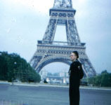Due War Damage, the Eiffel tower wasn’t open to go inside of to any of the upper levels

8 October (port in Southern England)

13 October, a Chief Petty Officer, my team member relief came aboard and I was told that I needed to leave the ship as soon as possible to catch the train to London for transportation back to the States. So I went to my quarters and started packing my Sea Bag with my cloths and went in to take a shower. When I came back, everything was taken. I told this Boatswain’s mate who was in charge of the area, that I was being transferred and getting ready to leave the ship. He told me that I had to work two hours extra duty for every item in my sea bag.

So all I had was my towel to wrap around me and I headed up to the Officers’ quarters (which is a no no for an enlisted person) Most of the ships officers were there sitting around a conference Table. I told them my story and the ship’s captain told me, I was not to have come up to the officers’ quarters, but followed the instructions of the Boatswain’s mate. And I would have to do the two hours as stated by the Boatswain’s mate (would have taken weeks extra duty). My Team Warrant Officer told the Ship’s captain that my relief had come aboard and I was being transferred back to London. The Captain (I think that he was Lt. Commander said that I couldn’t be relieved by a CPO and would have to wait until they sent a similar rated man. My Officer, A Chief Warrant with over 35 years of service put his finger about three inches from the Captains’ nose and told him that he would be writing a report station the cooperation the Ship gave while Comm Unit 32 was on board this ship and that if he didn’t “snap too” he knew people that he would sent his report to and that he would never get other command in the Navy. The captain said that he would take care of things and I was on my way to London an hour later.

I never heard of how things went for the Comm 32 team after I left.

13 October 1951, I arrived at the Navy Department in London and Stayed at the Park House until I could get on a flight back to Washington D. C.

I don’t have the date that I arrived back in Washington D. C.Up on arriving back in Washington D. C., I spent a day at the U. S. Navy Transit Barracks and then sent over to the Naval Security Station.

I was made a contractors Escort at the Security Station while my papers were process, converting me to be a Communications Technician (CTR) instead of a Radioman. I spent about a month watch Contractors to their work. The area was a top secrete activity.

12 November. Usual for the Navy, but I was ask where I wanted to go. I ask for the Navy Security group at the Navy Imperial Beach Communications Station South of San Diego, California. I was assigned there for schooling and duty. My new rating required me to be proficient in Cyrillic code.

The **Russian Morse code** approximates the [Morse code](http://en.wikipedia.org/wiki/Morse_code) for the [Latin alphabet](http://en.wikipedia.org/wiki/Latin_alphabet). To memorize the codes, [mnemonics](http://en.wikipedia.org/wiki/Mnemonic) are used, called "melodies" (напевы). A "melody" for a morse code for a character is a phrase which is sung (hence the name): the [syllables](http://en.wikipedia.org/wiki/Syllables) with [vowels](http://en.wikipedia.org/wiki/Vowel) а, о, ы correspond to dashes and sung long, the other syllables and the syllable "ай" correspond to dots and sung short.

While in school, I decided to go to the FCC field office and take the 3rd class radio Telegraph Test required to be an ocean going vessel Radio Operators. I sat down and the FCC inspector turns on the code sending machine and I start writing it out in Cyrillic letters. Being a Cyrillic code operator was top secret and when I started realizing what I was doing I started try to erase the letters that I was writing. The FCC inspector stopped the code machine and told me to go and walk around the block.

When I came back, I had no trouble passing he code test. I took the test for the 2nd class radio telephone test and past ok. I took the test for the first class Radio Operator and didn’t pass but did pass the test years later when I retook the FCC test. I could have worked as a radio operator on commercial ships. Every time I would be tested for promotion, I had to qualify in the Cyrillic Code. I never copied live Cyrillic Code. My assignment was Chinese Cut number system.

**USN Naval Radio Station, Imperial Beach, California**

**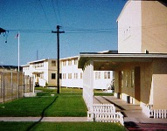**At Imperial Beach Naval Radio, a lot of my time was in direction finding where I did some operating but mostly maintenance. At time when they had a special operations and we were net control for the Pacific area, we would key a “W” ditdahdah. We started using a teletype tape and later put notches in a plastic wheel and a micro switch that would pick up the notches on the plastic wheel. There were three notches placed on one side of the large clear plastic wheel. The first one was a small notch that would give you a short “Dit”, the next two were twice the size that would give you a dah dah. I took about five seconds for the wheel to rotate. Stations like in Adak, Japan etc would listen for the “W” tones so that they knew that they could hear us when to send out a coded message telling the frequency and name of the station or other characteristic of the signal that we were looking for.

Many marveled us for our skills in speed Code. When you repeat sending out a call letter, you learn to recognize the call even at high speed like 35 Words per minute. But when it came to the coded message, we slowed down to about 5 WPM so that all stations could be sure that they got the message correctly.

I was promoted to be the Direction Finding Material Chief. I was only 3rd Class Petty Officer, but replaced a retiring Chief Petty Officer. This assignment was to do the maintenance of the Radio Direction Finding”DF” equipment and assist with the overall operation of the Direction Finding Station.

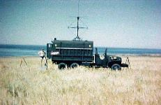At time I was assigned special projects. An example, my division officer took me to Camp Pendleton, California, a Marine Training Facility. We met with a committee that was planning a large training mock invasion exercise. They noted that the direction finding group could get their equipment working and it had failed on previous exercises. My assignment was to meet with the DF group several days before the exercise and to gets their equipment working and to remain with them during the operation to insure that the equipment continued to work. A lot depended on this equipment.

This was a lot of pressure on me. For some reason, the equipment was only available two days before the operation started. Felt that this was a lot to expect of me, what if I couldn’t be successful? I met with the Marine five man team two days before the start of the mock invasion. We set up on the beach and turned the equipment on. It was more luck than knowledge or skill, I got the equipment working. So we had two days to kill before the invasion, so what to you done on a beautiful California Beach? You play like a tourist and put your swimming suit on. The picture sows me in my swimming suit on back of the Marine DF Truck near the beach.

“CAMP PENDLETON – Under a steely-dark predawn sky a company of infantry of Marines riding inside amphibious assault vehicles stormed Red Beach and secured a seaside urban village.

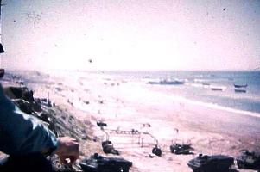Tuesday’s amphibious landing included 18 assault vehicles and more than 2,000 infantry Marines and Navy sailors. Two Landing Craft Air Cushion hovercrafts commanded by the U.S. Navy's Assault Craft Unit 5 landed on the beach, following the amphibious vehicles in support. The exercise trained the Marines in command and control operations as they pushed through a beachfront.

The annual training exercise known as Steel Knight costs about $2 million and is one of the base’s largest. It prepares Marines for what its amphibious roots.”

The invasion picture was taken by me. It was an experience to be in the middle of a mock invasion.

I returned to the Base one Sunday Evening to find that Security Police stopped me at the Gate. We have orders to escort you to you locker, have you pack your things and depart the base. Tomorrow morning, you will report to the U. S. Naval Communications Station at the foot of Broadway, San Diego.

I had been given special assignments before like the time that I was loaned to the Marine Corps detachment at Camp Pendleton.

But this time, it was cold and rude. Once taken off the base, where was I to stay? What was my assignment? I drove back to Bishop Willardson home to see if I could stay there.

Monday morning, I reported into the Communications Department for my new assignment.

Huh! Who are you again? Wait and I will do some checking. The Watch supervisor came back. “You are assigned to work with the night shift in the communications Center, Come back at Midnight. I went back at Midnight and checked in with the Shift Supervisor. Huh! Who are you? I don’t have an assignment for you. Just take it rest and nap if you want or you can go back home to bed!.

Something wasn’t right. I called my division Officer back at Imperial Beach. The person that answered the call told me he was sorry and couldn’t take my call. This really concerned me as I really got a long good with him in a lot of personal activity such as Pistol Team activity and felt that he was a close friend.

I tried to go back to the base to see if I could find out what was going on, but the Security Guards would let me on base. Friends that I had at the base wouldn’t take my calls.

Every night, I would I reported in to the Communications Center, they had nothing for me and had no information on my status. I was serving as the San Diego Area M-men-Gleaner area President at the time and going to San Diego Jr College. I would report in every night and go back to bed, but had a hard time sleeping. I had a strange feeling that I was being followed. I Felt that someone was watch me about every place that I went. I could see head light behind me when I would go to a meeting that didn’t let out until after dark. I spend a lot of time on my knees asking “Why ME”? I wondered if I had seen to many movies and I was becoming paranoid.

This went on for several weeks, then one night I did the routine of checking in and told to go home. When I arrived back at the Willardson bout 1 AM, Verta Willardson, the Bishops Willardson’s wife was waiting up for me. She was that the Bishop was stopped and integrated by the FBI that evening. They had told the Bishop that he couldn’t tell me anything at the incident, but didn’t say he could tell his wife, and his wife told me about the incident. Not knowing what it was all about, I felt that I had better go back to the Communications center and spend the night. Then back to be paranoid that people were following me.

One night I check in and was about to leave, when I was told that I needed to report to an certain officer at 8 am the next morning, so I stayed, but didn’t get any sleep. I found the designated Officer’s office. He immediately took me to a room where there were to civilians dressed in suits. The first man showed me his Identification, which read “Naval Intelligence” Then the second man showed me his Identification “FBI” The FBI person got out a writing pad and started interrogating me, writing notes. Both men adjusted me so that he could look directly at me while writing his notes, without taking his stare off my face.

The FBI Agent “Interrogated” me for five hours asking questions, writing things down, still looking at me and not where he was writing. This really put a lot of stress on me.

What were the questions? The radio that I had in my car- What was that for? How often did I go into the Bar that was just our side of the Navy Imperial Beach Base? How well did I know this Girl (showing me pictures) and how often did I spend time with her on the Beach? What were all these meeting that I was going to in different areas of San Diego County? He kept repeating some questions to see if I could answer them with the same answer. I was upset to eat any breakfast and the Interrogation went on beyond lunch, I become really stretched out. All of a sudden, they told me that I could go. Go where I wondered?

Back to the same routing again for several more weeks, then I check in one night, I was told that I was to report to Area Commanding Admirals Office the next morning a 8 AM.

After another night not being able to sleep, I went in to the Plush office where I was directed report to. I told them that I was told to report to the Commanding Admiral. I was told very bluntly, that he wasn’t available and the future that I had to go through channels if I had a complaint . Being very confused, I turned around and started walking down the hall when I heard my name being called. There were a number of personnel in the Hall way, but then I could see that it was a man with gold from his wrist to his elbows that was calling me. I quickly recognized that he was the two Star Commanding Admiral officer of the Naval District.

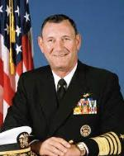With a number of by-standers stopping to watch, the Admiral said he was happy to restore be back to duty. Some didn’t calculate in my mind, an Admiral who was over several thousand men restoring a lowly 3rd class petty office back to duty. I have always been a little slow on reacting and not understanding what was going on, was speechless. He shook my hand and returned back to his office not allowing me to ask any questions.

Without even trying to find something to eat, I drove to the Imperial Beach Naval Communication Station. I drove up to the gate at the Base and showed my I. D. card and was waved though driving to my division officers’ office. When he says me, he apologized for not returning my call and told me that he was ordered not too. I ask what it was all about. And they said that they didn’t know.

Things went back to normal. A new Officer that had just come in from Washington D. C. joined our group. He was a very nice person and we got a long very well. I was the NCOIC in charge of the Direction finding station and shared the same office with the newly arriving Officer. One day as I was working with paper work at my desk, he pointed over at me and said “you’re the one that I heard so much about! I ask him to tell me about it.” He said no, that he could say anything.

There were two members assigned to the Security Group that had new black Desotos, mine was a two door and his was a four door. We both disappeared of the base and same day, but the other Desoto Owner, never came back and were never heard of again.

Bask at the base; orders received that ordered me to be placed back on the intercept assignment, noting that specialty as an intercept operator was too important for me being assigned to maintenance

J:\@@@RUSS BATEMAN pictures MASTER folder\109-Navy\Imperial Beach Naval Communication Station\CT2-03.gif Due to a shortage of qualified operators that could copy the Chinese, I had to leave my assignment at the Direction finding station and do the night shift copying a Chinese Circuit. It was pretty dull as you never knew what they were saying. Once in a while you would get something like this” send slow you dog”. You also had to listen for the words “UP” and “Down” and when you hear one of the other, you quickly grab you frequency tuning knob and follow the station up or down.

As a specialized intercept operator, my shift would be 10 pm to 8 AM for two nights and then off for two nights. I would start work at 10 pm and get off at 8 AM and hurry to San Diego Jr College for a 9 Am class. I would get out of school at 3 or 4 PM get about 3 or 4 hours of sleep and back to work the next night a 10 pm. Then off again at 8 AM, back to school until 4 pm and then I would have the next two nights off. I fit my duties as Area Stake M-men & Gleaner president where I could.

Shortly after this experience was the exam time for advancement and some way I was able to pass and was advance to be a 2nd Class CT. It was back to the routine but till my enlistment was up. I had found a beautiful Redhead, took Sixty day leave and we were married.

Of course, I was called in to the base commander office and ask to extend. They had orders for me to be transferred to an Island in the South Pacific that has a name that I can’t spell or pronounce. So I had a decision to make. Extend and be transferred to the isolated Island where you can’t take your wife or not extend and live with a beautiful red head and work at Convair earning more in about a month more than I did in the previous year in the Navy. (See chapter 09 – Convair)

