THE BEST YEARSTO BE ALIVE IN THE HISTORY OF THE WORLD

Russell Rulon Bateman History

**Chapter 05 My Employment Prior to Military Service**

When I was 11 years old, my Father told me that I was old enough to work and earn my own way through life as his Father taught him. He would prove me with a nice place to live and food, but I needed to learn how to work and manage my money as he had to do.

He said that he had arranged a job for me to work on a farm in Enterprise. He was working in the Enterprise area, so he could take to the farm where I would be working. My job was thinning Sugar Beets. The row of Sugar Beets was to long that I could hardly see the other end. By the end of the hot day, I finally got end of that row about the time that my father came to pick me up. I received my days’ pay of 35 Cents. Yes, I was proud that I had worked and earned my first pay.

I didn’t go back to the farm in enterprise again for two reasons, one is that Dad didn’t have work in the enterprise area and so I had no way to get to the farm, and I told my Dad that I felt that I could find better work. I know that my dad was disappointed in me, and told me that it would be up to me to find my employment.

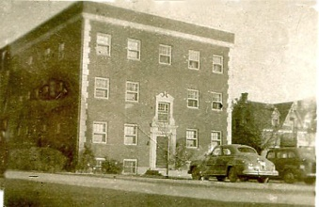

We were living the Eden Apartments at that time and I found plenty jobs around the neighborhood doing yard work. At 10 cents an hours, I was very busy. I needed a place to keep my tools and stuff and I rented on of the vacant apartment garages. I don’t remember how much rent I paid, but it was something like $2.50/month. Now I had a place for my stuff,

I added another business to my schedule where I would go down to the city park and collect night crawlers (worms) for fishing and I would sell them at $.10 a dozen. I received more of an income from this business than the yardwork.

We moved from the Eden apartments over to the apartment above the mullet jewelry store. For the first time I had my own bedroom but I sure missed the garage where it could store all my stuff so had looked for jobs I didn’t have to have tools. My brother went into the military at this time and now I had access to use his bicycle. I was able to keep the bicycle just inside the door as shown in the picture to the far left which was a stairway going up to her apartment. This gave me a lot of mobility to be able to move around instead of having to walk everywhere went.

An example of that was the summer that I was able ride the bike to work at the Cedar city Turkey picking plant. I don’t remember were there I was 13 or 14 years of age that I was hired that summer for picking turkeys. The turkeys would be hung from the ceiling and you could adjust to the height that was convenient for you to pick the feathers off the turkey. It was a terrible job and I really hated it but some days I could earn as much as three dollars a day which was very good wages for a kid my age.

I was able to get a job working at the theater as a custodian to give the customer owning a day off my pay for that were free passes to the shows at either of the theaters and Cedar city.

 After getting bored watching the shows, I spent all my time in the projection booth learning to operate the projection equipment. One night I was in the booth by myself running the equipment when John wrote very the manager came to the booth and tell me all along. He was very upset because films in those days were very dangerous. He asked where Henry Grimshaw was and I told him I think he went next door to the confectionary store. He went next door and asked Henry about leaving this young kid up in the projection booth running the machines. Henry told him no problem as I had been running machines for weeks. John Rowberry came back up to projection booth and watched me the rest of the evening.

After the show and I was closing down the machines he asked me to drop by the same in his office at the other theater the next evening. I was excited that I was going to be able to get a job as a projectionist, I talk to him he told me at the age of 13, I was really too young to be an usher but if I would be an usher for 2 or 3 years then he would hire me as a projectionist. Within three months I was hired as a projectionist five nights a week, this opportunity came to me as in many other fields that there is a major shortage of people in the technical field due to the demands of the military and the war effort.

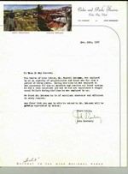

*“To Whom It May Concern;*

*The bear of this letter, Mr. Russell Bateman, was employed by us in the capacity of a projectionist and a soundman for over a period of three years. During the time he was employed it was necessary for him to maintain and service our sound system. He did an excellent job and we did not experience a single sound failure during the time he was employed with BIOS we found Mr. Bateman to be excellent character and efficient in every respect any favors a you may be able to extend to Mr. Bateman will be greatly appreciated by the writer’s. Yours truly, John Rowberry”.*

I also hung around radio station KSUB and became a good friend of Herschel Urie’s who was the chief engineer and manager of the station. I think part of the interest in Maine was that I had a beautiful sister that he was interested in. Many times, I had wished she was interested in him because he became a college professor at Weber State College.

I first went on the radio was at age 14 when Herschel let me do some announcing and play the 16” 33 1/3 record programs. These were programs like “Hymns of all Churches and Jack Armstrong.

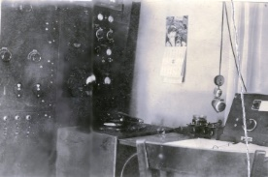Radio KSUB was running only about 80 Watts back then and the transmitter and studio was located on the corner of the BAC (Branch Agriculture College – now called CSU). Our on air monitor was an old AM table top radio that you had to turn down the volume before going on the air with the microphone. Several times I didn’t turn the volume down and it created a squeal over the air.

One time we had a capacitor fail and due to ward shortages, we drove to St. George and barrowed one out of an Amateur Radio Operators transmitter. (See my chapter on Amateur Radio),

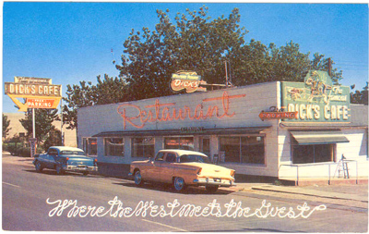After I moved back to St. George I still had ties with KSUB. KSUB had increased power and could be head in St. George in the day time. I ran the first radio broadcast out of St. George. Herschel shipped a Remote Control Box to me on the bus and I connected it to long distance telephone lines back to Cedar City. It was the big revival Football Game between BAC (Cedar City) and Dixie (St. George). It worked out so well that Dick Hammer, owner of the famous “Dick’s Café” with the sponsors of Shell Gas, did a week broadcast out of St. George’s Dick’s Café. I can remember the opening theme song *“ Stop at Shell and get some Gas. Then all your worries then shall pass” The was a live Country Western Band. I was the Engineer and equipment operator for the weekly program for over a year.*

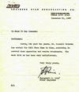

*KSUB – Southern Utah Broadcasting Co. 31 December 1947*

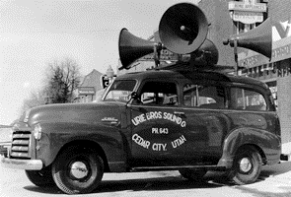

*To Whom it Mau Concern:*

*Gentlemen:*

*During the past two years, Mr. Russell Bateman has worked for K SUB from time to time, assisting in control room operations and remote broadcasts. His work with us has been very satisfactory. Very truly yours. Herschel G Urie Chief Engineer “*

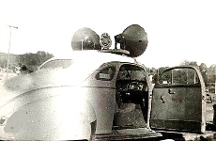

I also operated the first and only sound system South of Cedar City. Sponsored by Urie Brothers Sound, I mounted one of their systems in my new 1948 red Studebaker car. St. George only had a weekly newspaper then. I advertised important events by driving up and down the streets of St. George announcing the special event. I was invited to all football games and other events. Some things I charged for and some I donated my time.

Urie Brother Sound company 389 N. third West telephone number 131J Cedar city Utah 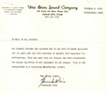December 31, 1947

to whom it may concern:

Mr. Russell Bateman has operated one of our sets of sound equipment for the past year and will continue to operate this equipment indefinitely. This has meant that Mr. Bateman has been responsible for the proper operation of all the equipment in his charge. This he has accomplished in a very completely satisfactory manner.

Very truly yours Herschel Urie.

**1948-01-13 March of Dimes** Washington County news (Volunteer assignment)

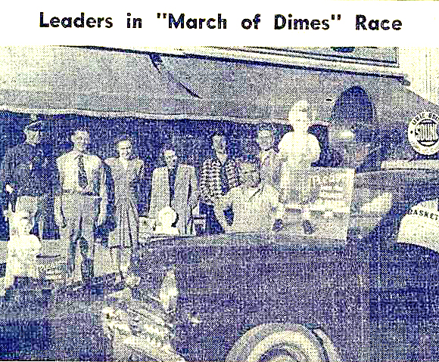

*Left to right: Orin (Zug) Bennett, Larry Leonardi, Mrs. Evelyn Lee, Miss Erma Bentley, Mrs., Maxine Spencer, and Mrs., Ann Peterson, with Russell Bateman in the foreground*

*Under the direction of Frank Holland has County chairman; Larry Leonard, city chairman****, Russell******Bateman*** *with his sound system common and the entire and efforts of Evelyn Lee, Ramon Bentley, Maxine Spencer, and Peterson, the March of Dimes race developed as a unique stunt and cleared over $70 for the polio fund.*

*Everybody was held if he appeared on the streets and rhyme minded those young ladies to play the game – and made a real game of it too.*

*The BPW members donated their services, also, on Thursday, Friday, and Saturday evenings at the theaters with their” polio cups.”*

I 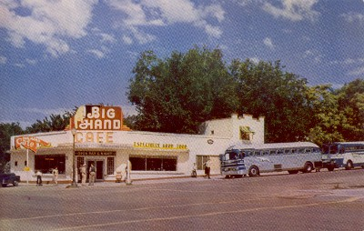 picked up jobs where ever I could find them. For several weeks, I washed dishes at the St. George Big Hand Café. It was a Bus Stop and a very busy restraint. There was no automatic dish washer, all by hand.

It was not a fun job. One summer, I worked at Service Stations. For several months, I worked at the Cox Texaco Service Station on Bluff Street. At that time, it was the first Service Station after leaving Los Vegas. I worked 12 hours a day, seven days a week for $100/month. I later changed to work at Pioneer Service Station which was in the middle of town. The pay was better where I earned $90/month for five 8 hours shifts.

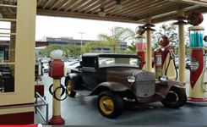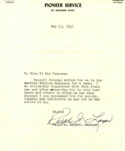

*Pioneer service St. George Utah May 13, 1948*

*to whom it may concern:*

*Russell Bateman worked for me in the service station business for a year I am intimately acquainted with this young man and after observing him in his business and others in which he has been engaged I can recommend him for energy honesty and initiative in any job he makes strife to do signed Rauf J Lauper manager*

1946 Gas cost 21 cents a gallon and was measured my reading the marks inside the Glass holding containers located on top of the gas pump. After dispensing the gas, you would refill the glass holding container by pumped the gas using a hand pump. The wind shields were always washed, and oil levels were checked on every car. The air pressure in the tires was check when the customer requested.

I was hired as a Janitor at the St. George Telephone Office on 1 April 1946. My beginning pay was $22week and on March 2 I received a rise to #32.50/week. I usually went in in the early morning before going to school and again right after school. Part of my assignment was cleaning pay telephone and telephone booths around St. George and keeping the sock room organized.

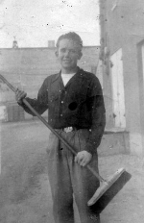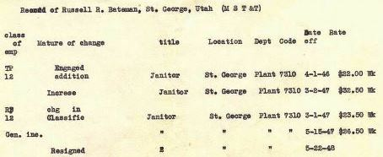

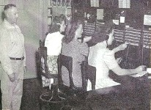The manager of the St. George Office (plant 7310) was Tom Jones. Alvy Mulstine was the combination man. Alvy installed all the telephones in the St. George and Hurricane area and the “Magneito” lines running up to Pine Valley. We had a manual four position switch board that was normally manned with three telephone operators. I was not part of the Union and took a shift in manning the Switch Board answering emergency calls during the telephone operators strike. If I was in the office at noon, I turned the switch that operated the daily test of the voluntary Fire Department Siren. A number of times, I turn the red light on that was located in the middle of the intersection of main and Tabernacle for signaling the duty policeman to call the switchboard. I resigned on 22 May 1948 when I moved to Salt Lake.



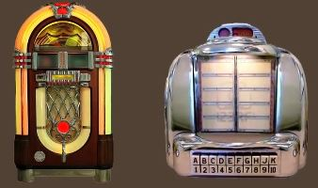In those days, Jut boxes were very popular in areas like restraints and some stores. The music was played from 78 RPM or 45 RPM records that were contained in side of the main unit. Some locations had remote control boxes. A nickel deposited would play your selected song. This was largely the only place you could this music.

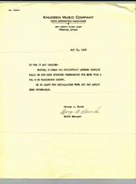*I was the on call Jut box repair person in the St. George area.*

*KNUDSEN MUSIC COMPANY – COIN OPERATED MACHINES 287 North Third East, Provo, Utah.*

*To Whom It May Concern:*

*Russell Bateman has successfully answered service calls on our coin operated phonographs for more than a year in Washington County.*

*He is adapt for installation work and has always been dependable.*

*George A. Burch Route Manger.*

I was also schedule to attend an Organ installation school, San Francisco for the St. George McAllister Music Store, but I was canceled as I was leaving town. I think that the school found out that I was just a High School Kid and the School was for only Organ Service Professionals. Mr McAllister had to go back hiring Organ Installers from Provo and Las Vegas.

When I moved back from Cedar City at the end of 1945,

McKay Larson hired me as a projectionist at the Gaiety and Dixie Theatres, working five nights a week. After a few weeks, McKay left for the service or defense job. The owner Merv Reber offered me McKays position of managing the projection booths at both of his Theatres. I would work five nights a week at the theatres and train and hire other to work the nights. It was then, my responsibility to insure that there were trained projectionists in each theatre each night. It was also my obligation to provide all the maintenance and repair of the projection and sound equipment.

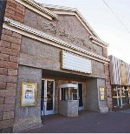

McKay Larson returned back to St. George in February 1948 and wanted his job back of the theaters. Merv Reber promoted me to manage the Gaiety Theatre. This assignment included opening and closing the theatre’s and working with the cashier and ushers. I did go back and do some projection work due to sickness and other emergencies.

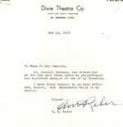Dixie Theatre Co. Dixie and Gaiety Theatres, St. George, Utah

12 May 1848

To Whom It May Concern:

Mr. Russell Bateman has worked for me for the past three years as projectionist and assistant manager of one of my theatres.

I have Russell to be very efficient, honest and dependable while in my employment. Signed, RM Rebber.

I was doing quite well as a High School kid. I had a checking and savings account and the only kid in my High School that owned a new Car. (see Chapter 16) It really irritated me when people, including the Dixie College President Art Brune making statements of “how nice it was that my father buy me a new car. My Father felt that his son should be on his own. My parents provided me with a loving home and food to eat but felt that was good training for me to provide my own money for everything else.

Herschel Urie and his brother were able to obtain a new mobile P. A. System which they provided for my use with the agreement that I provide them 50% of any revenue that I received. So I had the first (and only) P. A. System (30 Watt Audio Amplifier) South of Cedar City. Two large mobile mount speakers were part of the system. I got very popular and was invited to everything game or other activity. St. George had a week newspaper and previously the only way to advertise any event. Football games, church activates, and things like the Red Cross, I didn’t charge for. Things that I received revenue for, I charged. My voice was the most heard voice in St. George for a couple of years as I drove up and down the streets announcing the upcoming activities.



After Graduating from high school I moved to Salt Lake and was hired by Sear and Roebucks to work in the Tire Shop. I also worked part time for Poll and Austin Sound and doing things like the 1948 Democratic Convention at the Salt Lake Fair Grounds.

After working there a couple of months, I knew that mounting tires and seat covers, that was not the occupation that I wanted. I didn’t have money to school. I talked with the Navy recruiter and was enlisted to go to Radio Material School.

Not long after, I was asked to run a weekly Country Western program out of Dick’s Café that was sponsored by Shell Oil. I held on to the remote equipment so that they didn’t have to send someone down for the weekly broadcast.

After I graduated from High School and had the resume letters in hand, I headed for Salt Lake to find bigger and better things. I applied for a number of different jobs. Sears & Roebuck offered me a job working in their tire shop in Salt Lake City.

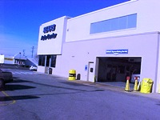

No this didn’t happen to me, but I did some hard praying as I watched a car on top of a hoist, jacked up trying to replace the muffler. I still have nightmares remembering the car swaying back and forth about to tip off.

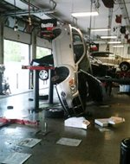

The next few weeks changing tires, installing Seat Covers, I finally advanced to be in charge of the battery Shop. Previously, it seemed to easily get employment but now I realized that to step us into the kind of jobs that I wanted, I needed Education.

See my chapter 07-Navy