**THE BEST YEARS TO BE ALIVE IN THE HISTORY OF THE WORLD**

**Russell Rulon Bateman History**

**Chapter 4 Where I-WE have lived-owned**

**Route 1, Idaho Falls**

My family was living on a Farm which was at that time, five miles north of (then) Idaho Falls. The Address was given as “The Farm just North of Beaches Corner”. “**Beachs Corner** is an [unincorporated community](http://www.ask.com/wiki/Unincorporated_community?qsrc=3044) in [Bonneville County](http://www.ask.com/wiki/Bonneville_County,_Idaho?qsrc=3044), [Idaho](http://www.ask.com/wiki/Idaho?qsrc=3044), [United States](http://www.ask.com/wiki/United_States?qsrc=3044). Beachs Corner is located at the junction of [U.S. Route 26](http://www.ask.com/wiki/U.S._Route_26?qsrc=3044) and [Idaho State Highway 43](http://www.ask.com/wiki/Idaho_State_Highway_43?qsrc=3044) 5 miles (8.0 km) northeast of [Idaho Falls](http://www.ask.com/wiki/Idaho_Falls,_Idaho?qsrc=3044).” Today, Highway 91 going through that part of Idaho is now called I-15. In the early days is just called the Yellowstone Highway. Beachs Corner is a populated place located in [Bonneville County](http://idaho.hometownlocator.com/id/bonneville/) at latitude 43.542 and longitude -111.964.The elevation is 4,790 feet. 834014

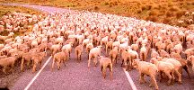Beaches Corner had a gas station and convenience Store. We never had any money and I don’t remember of ever even going there.

Back at the time that I was born I think that there was an address of Route 1 box?? Highway 91, Idaho Falls, Idaho. Highway 91 went directly pass our 80 acre farm. It was the main route north to Yellowstone Park. I remember in the spring and fall, large heard of sheep were driven up the highway, cause cars to have to easy their way through the sheep heard.

On our farm there was the house that seemed large as a small kid, but wasn’t. In the ground floor it had a large kitchen, which it seem that was mostly used as a family room. There was a living room-dining room that was only used on Sunday. The living room heated on Sunday using an oil stove, using the coal kitchen stove in the kitchen for regular heating. The picture is of the farm today and is owned by a Female Doctor

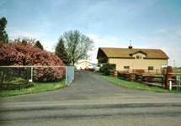We had a Magneto Telephone. It was a rural telephone with every on in your area on the same telephone line. To get the operator, you would crank the little handle of the side of the wall telephone. The telephones seem to be ringing all the time. Our ring was something like three long rings and two short. There was a wet battery located down the basement that would go dead and had to be replaced to use the telephone. I don’t remember use the telephone and didn’t know anyone to talk to that had a telephone. Telephone was not to be used by kids.

Originally, there was my parents’ bedroom down stairs, later they moved into one of the upstairs bedrooms and converted the down stairs room into a “separator room” after they bought the machine that would take the Cream out of the milk. Previously, pans would be set all over to let the cream come to the surface of the pan, and skimmed off. The Cream could be sold and we would take a little bucket of cream out to the road every morning to be picked up.

The Barn we not much of a building but it keep the snow off the cows and dad and my Brother Orden who milked the cows morning and night. The milking routine started at 4 or 5 in the morning. As dad was a school teacher in Idaho Falls, the milking had to be done in time for dad to get to town to teach his class.

The Grainery had wheat that I played in like sand at a Beach. You could dig a hole and cover up in it. I didn’t know the danger of suffocating. The potatoes cellar was dug in to the ground with dirt covered over it. It was large enough to pack a Wagon or small truck into it. My only skiing experience was off the potatoes cellar.

My interest, even as a very young boy was the Machine Shop. It was loaded with antique tools. A previous owner must have done a lot of work in the shop. I don’t remember seeing my father with even a screw driver in his hands. Mother seemed to be very hand with most type home repairs.

There was a brick garage about 30 ft in front of the house and a Pump house that contain the Well water pump. There was an outhouse the side of the house I don’t remember seeing it used and I do remember the indoor bathroom being installed or remodeled. I remember taking baths in the Kitchen in an oblong copper tub. This tub was stored long after we quite using it.

Our crops were sugar beets and grain and my father share cropped that type of farming. It was exciting when the “thrashers” came to process the wheat fields in the area. The whole area worked together and we have a large dinner setting up tables around the front lawn.

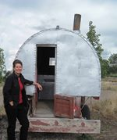We went to Church at the Lincoln LDS Ward. The Lincoln Branch was organized in 1904. In 1904, the population of Lincoln was 500, 83% LDS members. The population in 2000 was still 500 people.

The Children in our farm area went to a small two or three room school. In that Dad was a school teacher at that time; we drove the 5 miles to school in Idaho Falls.

When we lived in the Farm, the depression affected every one. I remember a Sheep herder that was unable to find employment and my parents permitted him to park his Sheep Herders Wagon on our Farm in the winter. The picture of the Wagon is as I remembered the wagon where the sheep hearer, his wife and one child 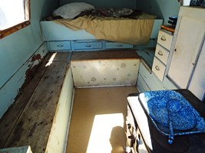lived. I remembered in going out to visit during the winter as Mother was concerned about the very cold weather. The picture is typical of the sheep herder’s wagon. Three people lived in this cramped space during the winter.

**Garland, Utah**

*My father had a Master’s Degree and wanted to work for the government*. He was employed with a government Agency call “Farm Security Administration” and we moved to Garland, Utah. This was a major change of life style for us. Previous, we grew about everything that we ate, made most of our cloths and worn old shoes or went bare foot. In Garland, everything had to be purchase. It was sure 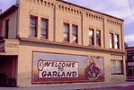different to eat Store purchased food. Now my father had a job that paid considerable more than the Idaho Teacher salary I attended the third grade in Garland.

We lived in an apartment that was associated with a hotel in the middle of town. The lions club meat in a room below us and we would hear them “roar.”

I was now a City Kid instead of called a Farm Boy. It took a lot of reorient myself to live in a City where I could have friends and not have to get up at 4 am every morning to do choirs.

**Morgan, Utah 1938 East State Street and N Commercial St**

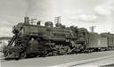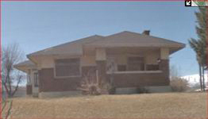Dad was transferred to Morgan Utah. We rented a house, across the street from the major railroad. It was in the days of the Steam Engines. It took weeks to learn to sleep with noise created by the train traffic. Trains were coming or going day and night.

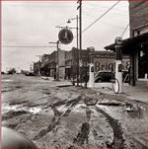 We had to ride to school in a bus, and that was a different experience. I attended part of the

Third Grade in Morgan. Most of my street was dirt (muddy).

My parents purchases me a season pass to Como springs. I spent the summer swimming and playing at the Como Resort.

*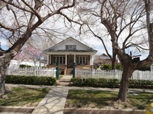***Saint George, Utah 172 North 100 West 1939**

My father was still trying to get a permanent job with the government in agriculture. They said that they had an opening, but it was a terrible place to live. Dad said that he would take anything. The terrible place to live was St, George. It was a population of 3400 and St. George had no air-conditioning.

A few of the wealthy people had fans. My family purchases an evaporative air condition as soon as they were available. This home was located just South of the Historic Brigham Young Winter Home Where the Center of the LDS Church was centered in 1877. When we lived there, Doctor Gates owned the home and had his office in the Brigham Young Bedroom. I was in the home several times, but only met Mrs. Gates. I remember peeking into the back window of the Brigham Young Office building and see it piled with furniture. This home was converted into an office and still is there today. It's

**St. George Utah about 205 North 100 West 1940**

Next we move on to a home at about 205 North 100 West. I don’t remember much about it but it was a Spanish style home. It has a barnyard located where the St. George City Offices located now. I remember that we had chickens at that time and I was permitted to take an egg and occasionally to the bakery and exchange it for a one cent candy that contained two to three chewy candies and a tiny toy and were called “Gust whats”. I don’t have a picture of this home and it was torn down to build the city offices.

**St. George, Utah 246 East 100 North 1941**

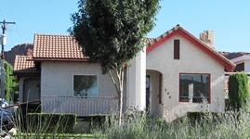I don’t remember why we moved so often I just remembered that we lived in these homes from the time we moved in to St. George in 1939 to 1941. I remember that three was living in this home on December 7, 1941. We will we were in the church that Sunday morning and heard about Pearl Harbor and Church was dismissed and we all went home. One of the things that I remember about this home is that my brother or my anti-bedroom downstairs and there was a door opening to the outside and going up steps. It’s

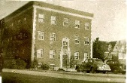**Cedar City, Utah 83 North 100 West. Eden Apartments. 1941**

Not long after the war started my father was transferred to Cedar city, homes to rent was very difficult to find and the only place that my parents could find was to rent an apartment at the apartment. Our apartment was on the front north corner on the third floor. The only thing that was available was a one-bedroom apartment storm five member family had squeezed in to that one-bedroom apartment. My brother or deny slap on a Murphy bed in the front room which we hadn’t have to pull down every night when we went to bed and put it back up the next morning. My sister Helen slept on a roll away in the kitchen and again that had a deep open up and put away each day. Then my parents had the bedroom. The apartment came with a garage which we stored our car in. I was able to get enough income from jobs doing yard work and her sinks to rent a garage to get my stuff in.

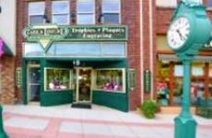**Cedar City, Utah 83 North Main Street. 1943**

My parents held a three bedroom apartment which was located above the Mullet jewelry store on Main Street. Access to the apartment by a private door next to the jewelry store and then going up the steps to our apartment. My brother had been drafted in the Army until I have my bedroom to myself. I had to give up my rented garage at the Eden Apartments but I did have a small room next to my bedroom that I could put some of my things in. This meant that we lived in the middle of Cedar city right on the main drag.

The only benefit of Orden going in to the Army was that I inherited a nice bike and I could keep it in the Stair way.

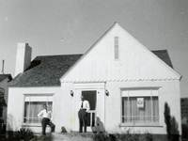

**St. George, Utah 276 West 100 North Sept 1945**

My Father was transferred to Enterprise, Utah, but we were not able to find a home with indoor toilet’s facilities and Mother refused to live in a home that only had an out-house.   
So the transfer was to St. George instead. This time, Dad purchased a two bed room home next door to the home that we had rented at 246 West. My Sister Helen had moved to Salt Lake City and enrolled in a Nursing program.

The home had a partial basement and it was decided to excavate for another room for my bedroom. We cut a window in the foundation and dug out the area for the room by using the window to take the dirt out. That project seemed to take a long time, to take the dirt out and to form and bring concrete in. Finally the project was finished, adding a door and the window.

My parents wanted a guest bed room for when we had visitors like her Uncle, Apostle Joseph F. Merrill who stayed with us a couple of times when he was in St. George for conference and other assignments.

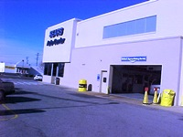**Salt Lake City, Utah Rose Park, June 1948**

Not having the money to continue on to college after I graduated from high school or the money and desire for a mission. I got a job at the Salt Lake Sears tire store. I lived in a garage in new homes being built in the Rose Park area and served as a night watchman. I realized that I need more education as I didn’t want a career in the Sears tire shop.

Looking around at what opportunities that I had, I fell prey to the promise of a Navy recruiter who promise me training in a Navy Radio Material School. So, I joined the U S Navy.

**San Diego U S Naval Training Center July 1948**

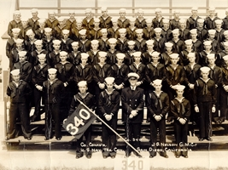I arrived at the Naval Training Center for my Basic Training and was assigned to Camp Decatur, company 340. The Basic training took 11 weeks to complete. I spent my off time at the LDS Services Man’s home

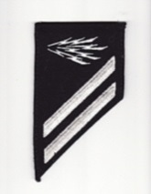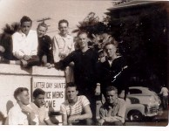 At the end of Basic training (“Boot Camp” I was assigned to the Navy Class “A” Radio School, not the school that I was promised.

**U. S. Naval Station, Kodiak, Alaska February 1949**

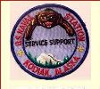I was assigned to the Kodiak Naval Base for a week or so while waiting for a flight out to Adak. I looked up some friends that I had met in Radio School and went in to Kodiak Village to find several that I was ask to say hello to. I attended dances for several nights, but didn’t dance, just attended.

**Umnak Air Force Base, Umnak Island, Alaska**

Flying in an R3Y four engine cargo Aircraft on our way to Adak, we made an un-scheduled stop at Umnak AFB. We hit a severe weather head, damaging the air ship, making the hydraulics system to fail and making a forced landing. We were told that the Lord blessed us as this WWII landing strip was the only one with in a hundred miles that we could land. All the Islands in the Aleutians Islands are covered by mud and Tundra. (See Alaska chapter)

**U. S, Naval Radio Transmitting station, Rocky Point, Adak, Alaska**

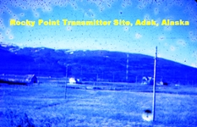My first assignment was to stand Transmitter watches. I think that I spent about six months in this assignment. The normal tour of duty on Adak was one year as Adak duty was considered to be a hardship to have to stay longer. That changed after the Korean War Started and no transfers until after the War.

**Great Sitkin NOB, Alaska**

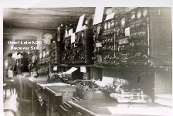Great Sitkin NOB was a secrete Base develop toward the End of WWII. It was a supply depot that was stocked with supplies for the invasion of Japan. I was the only Radioman as part of the 50 man maintenance team. Nothing had changed since the end of the War. No pictures were permitted.

**Heart Lake Navy Receiving site, Adak, Alaska**

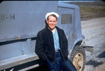I was transferred to the Nave NOB receiving site. The receiving site was located about 40 miles from the Rocky Point Transmitter Site to reduce interference. Monitoring many radio frequencies was done at this site for communications with Navy Air Craft, Ships, and Teletype to NOB at Seattle and commercial Ships in Distress. There were no living facilities at Heat Lake and we computed from NOB with a “Bomb Buggy”.

**Radio City, Adak, Alaska**

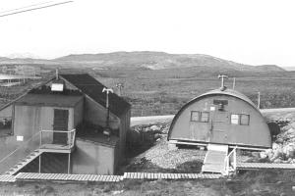I was station at Radio City for six months. Radio City was a Naval Security Station. Quanset huts were where the personnel lived and some of the other building such as the mess hall were wood buildings. Wood steps and walk ways were common as the mud and tundra were difficult to walk on.

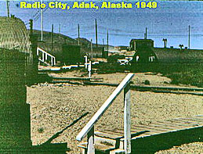

**Naval Operating Base, Adak Alaska**

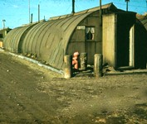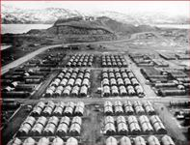I returned to the Adak NOB for a short time. Most of the buildings were Quonset huts. Things were just like it was at the end of the War.

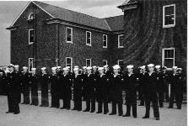

**Cheltenham, Naval Radio Station, Cheltenham, MD - 1**951

Cheltenham NRS was an Intelligence operating base and Training center for the project that I was assigned too. It was located near Washington DC when I spent my week ends.

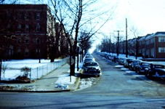My week-end home was called “The Sheridan Embassy” It was a three story apartment that housed 16 priesthood holders that worked for several Federal Government agencies, but as the FBA, CIA. The “house Mother” as he was called worked for the Department of Agriculture and was the “in charge person.

**Park House, Marble Arch, London England, 1951**

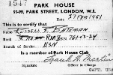“You will proceed on 21 February 1951 and report to the U. S. Army Air Base, Westover, Field, Mass. For further transfer on 25 February 1951 to Commander in Chief, Naval Forces, Eastern Atlantic and Mediterranean London, England for duty with U. S. Naval Communications Unit No.32” was the first paragraph of my transfer orders to Comm Unit 32. When in London, I was housed at the Park House, a Hotel leased by the Air Force near the Marble Arch in Downtown London, England. I had a chance to tour England for a couple of weeks waiting for my assigned ship to arrive at Plymouth, England.

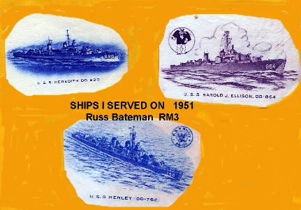I will serve on three ships on the Comm 32 Assignment while being assigned to the Navy Department London England .

“**On 10 January 1951, the ELLISON departed Norfolk on her fourth trip to European-Mediterranean waters. Following two months of renewing old acquaintances in the Mediterranean, the ship accompanied the U.S.S. PERRY (DD-844) on a tour of various ports in England, Scotland and Germany.**

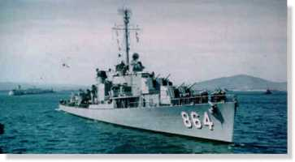

I arrived in Plymouth England by train on 6 March and found my assigned ship

**USS Harold J. Ellison DD 864 (Gearing Class) 6 march 1951**

Builder: Bethlehem, Staten Island

Laid Down: October 3, 1944

Launched: March 14, 1945

Commissioned: June 23, 1945

Fate: To Pakistan August 1, 1983

****The Ship was modified to add our “Spook Room” before it left the United States. The Comm 32 Team Officer was assigned a room in the “Officers Country”, The Chief in the Chief’s quarters and the enlisted men in a sleeping room for just our team. My Arrival filled the shortage of the previous member that was transferred to a Special assignment on a Submarine.

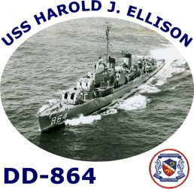

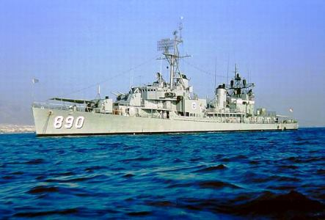

**USS MEREDITH DD 890 (Gearing Class) 11 May 1951**

• USS Meredith (DD-890), a Gearing-class destroyer, was the fourth ship of the United States Navy to be named for Jonathan Meredith USMC, a sergeant who saved the life of Lieutenant John Trippe of Vixen, during the Barbary Wars

Builder: Consolidated Steel, Orange Texas

Laid Down: January 27, 1945

Launched: June 28, 1945

Commissioned: December 31, 1945

Decommissioned: June, 1979

Fate: To Turkey June 29 1979, renamed Savastepe.

J:\$-@@@RUSS BATEMAN pictures MASTER folder\109-Navy\Radioman Seaman second 2-75.jpgJ:\$-@@@RUSS BATEMAN pictures MASTER folder\109-Navy\Radioman Seaman second 2-75.jpg Stricken in late 1994. Broken up in March 1995.

**USS Henley DD-762 (Sumner Class)22 Sept 1951**

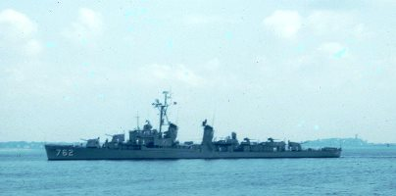

Builder: Bethlehem Steel, San Francisco (Union Iron Works)

Laid Down: February 8, 1944

Launched: April 8, 1945

Commissioned: October 8, 1946

September 23, 1950

Decommissioned:

Fate: Naval Reserve Force 1964

Stricken July 2, 1973 and broken up

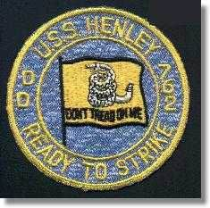

**Naval Security Station, Washington D.C.**

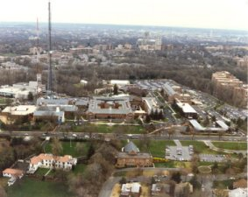Assignment: Contractors Escort. I was assigned to a team of Contractor Escorts that would accompany Contractors where ever they went on the Naval Intelligence Facility.

J:\$-@@@RUSS BATEMAN pictures MASTER folder\109-Navy\Imperial Beach Naval Communication Station\CT2-03.gif

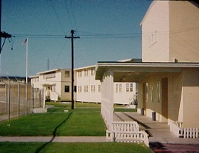**Naval Radio Station, Imperial Beach, California 1952**

I spent my remaining time in the Navy going to Military schools and various assignments.

I enrolled at San Diego Junior College

**National City, California; Our first home was previously a care take home. 20 March 1954**.

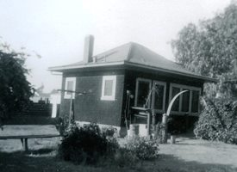

I have been looking for a home in the National City area and selected a apartment that was being refurbished by one of the National City Ward Members. However, it was not ready for us when we were married.

We found a little bungalow that was available. It had a small kitchen – living room. The bathroom and bed room was very small. The bed room was a converted porch and only had enough room for the bed. The rented home provided furniture and that help as we have no furniture of our own.

**3408 Tolas Ct., National City, California 10 July 1954**

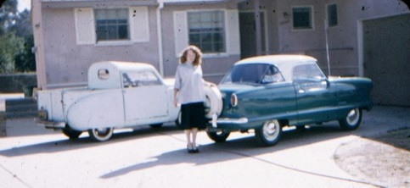Maurice Black was a friend that I meet at work. We talked about purchasing a home and he suggested this new sub-division that was being developed in National City. We purchased homes next to each other with adjacent driveways. The floor plans were similar, but opposites. The homes were three bedrooms, bath and a half. The prices for the homes were $11,900. I applied for a VA loan. 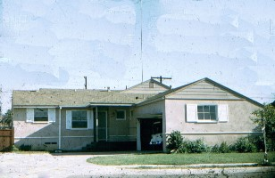

We had a nice three bedroom home, but no furniture. I remember sleeping on the floor and no other furniture in the house. We gradually purchased used furniture, paying cash for whatever we purchased. We needed a gas stove and purchased a Chambers through our Bishops Store. I remember it was a struggle paying for it as it was very expensive.

To limited costs, we purchased to miniature cars, Nash Metropolitan and a Crosley Pickup. The Nash was new and a nice, but small car. The Crosley was used and had mechanical breaks. To stop, you step on the break and take both hands off the steering wheel, and if you pulled hard enough, you could stop.

**Julian-lots 1 thru 4 inclusive, Block 41 in Kentwood in the Pines Unit 2 18 November 1955**

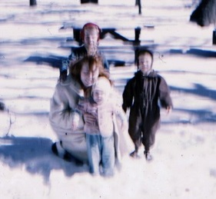

I always had a dream of a place up in the mountains. I saw this advertisement and went up to see in in November 1955. The cost was $550 and the terms were reasonable to we purchased it. We would go up with boxes and bring back snow to have a snow ball fight on the Green lawn in the sun shine.

**Delmar Mesa Ranch, Route 1 Box 49, Delmar California 31 March 1956**

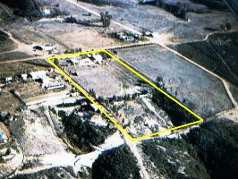Gaye and I decided to take a ride up in that part of the country and ended up in the Del Mar Mesa area. We drove in to an area of about six homes and found that it had been a Jehovah Witnesses settlement, but several had moved. There was a for sale sign on one of the farms so we stopped to talk to the owner. They were directed to move somewhere back east and needed to sell their property. The property was 10 acres with a very small house, an old garage and chicken coop. The Ocean was four and half mile to the west. Water had to be hauled and dumped into a cistern. There was seven miles dirt road to the property.

The $6,000 price was right so we purchased it. We rented out National City home and moved to the Ranch. We did some remodeling and developing of the property.

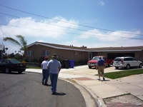

**3408 Tolas Ct., National City, California**

We moved back to the National City home as our renters moved out and we had to do some refurbishing and repairing and get it ready to sale.

10 July 1978??

**Pine Valley Utah**

**St. George Utah, 600 South about 750 East June 1962** No picture. Home was where the Dixie University Football field is now located

In that we were not able to make a go of the St. George Business, we had to seek employment.

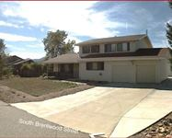 **8684 W Brentwood, Littleton, Colorado**

I had a job offer from Martin Denver and we rented a home in Littleton, Co. I worked for Martin Denver Test division in an area call the Cells which was a tower where the Titan IV researched and developed.

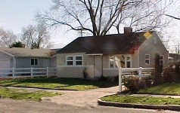**975 S. Fayette Ave., Salt Lake City, Utah July 1962**

Returning from Colorado, Gaye’s Sister-in-law found a place that we could rent. It was a little small for us, but it gave a place to get organized and settled back in Utah.

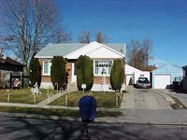**1138 West Girard Ave.,(Rose Park) Salt Lake City, Utah 31 July 1962**

We paid $13,612 for this home. It had a basement and a Garage. It was not a bad home, but small. We had a teriable neighbor that had a bright light just our side out bedroon window and made a lot of noise. He wouldn’t work with us at all. This was the time that NACP was breaking theBlack( Negro) in White neighborhoods. The nieghbor sold his home at a high price as this was the first Black home in the area. The Black neighbors were better than the people befor them, but it made it just about impossible to see the home when we wanted to up our home.

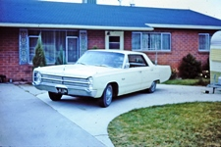**3222 South 525 West, Bountiful Utah** $21,000

We purchased this bountiful home as an upgrade to give us more room for our family.

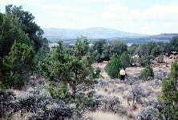**Lots 338,339,340 Unit 5, Vista Valley Estates, Duchene County Utah** 13 February 1979

We purchase three lots in Duchene County as an investment. We gave these to our oldest Son.

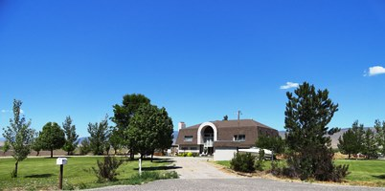**Route 1 Box 49, Monroe, Utah (Austin )** 6 August 1992

Gaye and I did most of the construction of this 6400 Sq Ft home. It had a 100 PF Basement fallout shelter on a 5 acre lot.

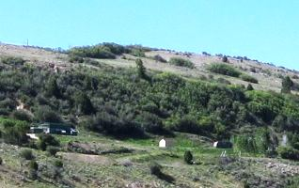

**Acords Lakes**

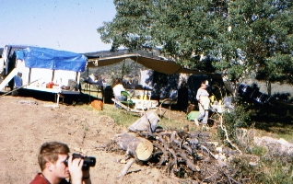

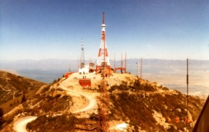

**Farnsworth Peak, Salt Lake City, Utah**

I worked at Farnsworth peak for about 15 years. We would work/live on the peak for eight days and then would be off for thirteen day. So I lived one third of the time on the peak.

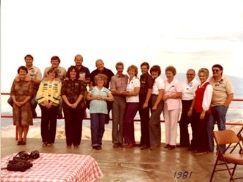

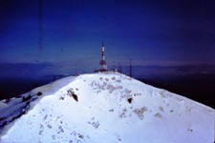

**Dixie Communications Store-St. George**

We moved to St. Georg to take care of Gaye’s mother

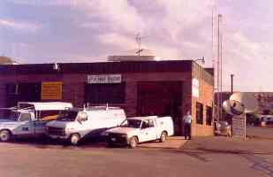

**459 East 700 South, St. George, Utah**

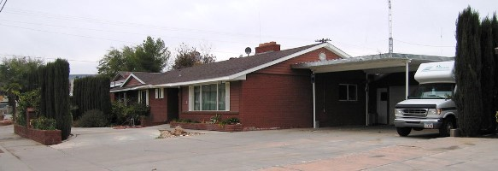

**970 East 700 South Unit 2, St. George, Utah**

**345 North 540 East, Monroe Garage, Monroe, Utah 84754**