THE BEST YEARSTO BE ALIVE IN THE HISTORY OF THE WORLD

Russell Rulon Bateman History

**Chapter 02 LDS Church membership**

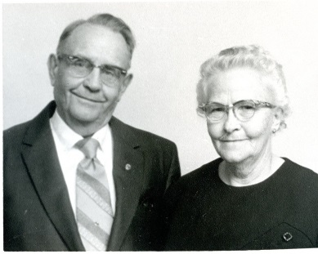I was borne of goodly parents who taught me right from wrong. I started my live living on a Farm, north of Idaho Falls. We attended church in a rural church-school located in a community that was called Lincoln where dad served in the Bishopric.

The Farm Boys at church was different than the City Kids that I went to school with in the Idaho Falls elementary School.

My Father was first Counselor in the Lincoln Ward Bishopric. The population of Lincoln was 500 people in 1930. Lincoln was located east of the city of Idaho Falls. The Lincoln Ward was part of the Idaho Falls stake. Our farm which was located on Highway 91 was located five miles northeast of Idaho Falls in an area called Beaches Corner. The LDS church members who lived on farms in our area attended church at the Lincoln Ward. I think that the Lincoln Ward meetings were held in the old small rural schoolhouse which was first built in 1899 by people living in the Lincoln area.

I remember going to the Idaho Falls Stake Center for my baptism and shorty after moving to Garland, Utah. I don’t remember much about the church or facilities in Garland and later Morgan Utah..

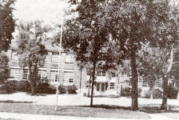We moved to St. George Utah in 1939 and I was nine years of age. We lived in three different homes in the northwest area of St. George and the St. George elementary school served as our Chapel-meeting place for church. I remember in the fifth and sixth-grade I could say I sat in the same seat six days a week and that was because my priesthood class also met with in the same room that I was using for school. During these years I was active in the various activities of the ward and attended church regularly.

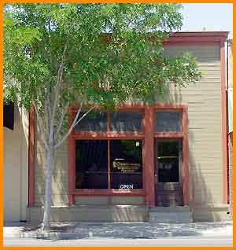I remember the Sunday that Pearl Harbor was bombed was a church when we heard the news and church was dismissed early. It was difficult to get news during this time as the only newspaper available was the weekly Washington County news. In the daytime there were no radio stations that we could pick up on our radios. In the evening we could pick up Los Angeles California station and a Denver station and I don't remember but possibly a Salt Lake station. I don't know how we received the news about Pearl Harbor except it was brought and announced during church on Sunday. The news had to come in by telephone St. George.

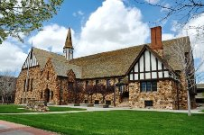Shortly after the start of World War II my father was transferred to Cedar city. When we lived in the Eden Apartments, we belonged to the Cedar City Third Ward where my father was the Group Leader in the High Priests Group. When we lived in the apartment on Main Street, we were members of the Cedar First Ward, the chapel was located in the North West part of Cedar city. When moved from the Eden Apartments to the apartment above mullet jewelry store on Main Street, we changed to attend church at the famous “old rock chapel.”

Returning to St. George we again attended church in the old St. George Elementary School.

A few months before I reach the age of 16 (1946)a man by the name of Fred Booth who owned a repair garage befriended me although I didn’t realize it at the time I later found that he was a member of the Ward’s and made a project to encourage me and my activity in the church.

I expressed an interest in having a car when I become 16. He found that 34 Ford that didn’t have an engine any upholstery or tires and I was able to purchase it for $75. Working with me we acquired a rebuilt engine tires and other things and he help me restore this two-door coupe. (see chapter on my cars)He spent a lot of time on me and later I wondered if I had really expressed my appreciation for all that he had done for me. Many years later, his son Dr. Both was speaking at a meeting that I attended and I was able to relate to him how much I Appreciated what his father did for me.

My last two years in high school I was managing the projection was in the two St. George theaters, working as a custodian at the telephone company, and working at several other jobs, made it difficult for me to attend my meetings. Sunday morning was the only time I can find to service the projection equipment in both theaters. My mother was very upset due to my inactivity in the church. I did live my religion other than that.

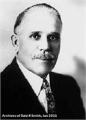I remember my Mother was very excited that her uncle was coming to Visit. I didn’t understand as we had relatives come to visit us. I remember meeting my mother’s uncle but again I was busy rushing off to work and didn’t stay to visit. My mother’s uncle’s name was Apostol Joseph F Merrill who was the visiting general authority at the conference held in the St. George tabernacle. I think that he only visited a couple of times. (My mother asked me to stop by and see your uncle when I was passing through Salt Lake. I walked into the main church office entry area and asked the receptionist if I could see Joseph F Merrill. Was asked if I had an appointment and I said no. She said sorry you have to have an appointment to see elder Merrill so I asked if I could leave a message for him and she said yes I’ll take the message, tell him that that I stop by and I was a son of Idella Van Orden Bateman. She said we just a moment and I’ll check. And it did not take long for uncle Joseph came out and invited me into his office and has witnessed reset the in his office he reached back and got the Van Orton history book and he says lessee know what page are you on. I had a nice visit with Uncle Joseph and is quite an experience to meet an apostle in his office.)

My last two years of high school, I was only attending my church meetings occasionally. I was working at three jobs and only had Sunday mornings to clean and lubricate the projection machines at the two theatres. I have been ordained as a deacon or priest and teacher under the normal age as set by the church.

No one ever encouraged or even talk to me about going on a mission. I honestly felt the boys were sent on a mission to reform them. Many of the boys that were 19 were called on missions and from what I knew of their lives it was an effort to reform them. Although I was not attending meetings as I should or paying tithing I still felt that I didn't need to be reformed.

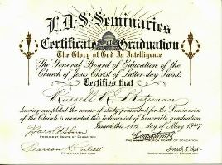In my last year of high school, I was engaged to Ora Larson but we were not planning a temple marriage. We were both somewhat active in the church but did not have the testimony of the truthfulness of the church and Temple Marriage. Both of our parents had been married in the Temple, there was no moral problems, but we did not have the testimony of paying tithing. We both attended seminary and in my last year of seminary and she kept up my notebook so that I could go to work and not attend class. I did not realize at that time that I missed one of the greatest opportunities as my instructor was Brother Corbett a very special person. We both graduated from seminary.

One of the church assignments I did enjoy when I was called to work on the New West Ward Chapel building. This was to be the second LDS chapel in St. George at the time. The other Chapel was called the South Ward Chapel and it was located just over two blocks south of the tabernacle.

Ora broke their engagement after I moved to Salt Lake and her later marriage was not a temple marriage. This was very hard on me as she had been my High school’ sweetheart. The move to Salt Lake was at the suggestion of her aunt who felt that Ora’s domination Mother would limit a successful marriage.

Living in Salt Lake I did attend church with my brother and his wife. I attended dances and other activities.

I realize the need for additional education and working in the Sears and Roebuck tire shop was not the level of work that I wanted. I had no money to continue on to college or trade school. I investigated the military to see if I can find the education that I needed. A Navy recruiter promised me the education and electronics that I was seeking and I listed in July of 1948.

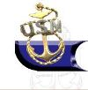While in boot camp at Camp in San Diego we were required to attend church of our faith. At that time in my life, religions and seemed not to be very important to me and I think I may have been opened to about anything. On my first leave I remember getting off the bus at the foot of Broadway not having any idea where I going go or what I was going to do. While standing on the street another sailor came up to me and told me he was from Salt Lake City. It seemed good to be able to talk to someone from Utah. He encouraged me to go with him to the reception center that was located near that location.

After arriving at this reception center he told me he had to go somewhere and wait there and he would be back shortly. He did not return and later on I realized he was not from Salt Lake City but was conning me to give me up into this reception center. A young male man in a suit, carrying a Bible, came in and headed directly for me. This was his first words to me were you are going to hell unless you are re-baptized. He told me that no matter what I had done in my life, lied, stole, murdered, I could be baptized -- born-again and I would be saved. What he preached to me was certainly different than anything I had ever heard in my lifetime. After being preached to the poor couple hours I was happy to leave and get back on the bus to go back to the base.

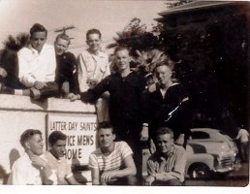Back in boot camp I was being constantly asked questions about the Mormon Church. I will never forget the time I was asked to you believe in the “Joe Smith story?” I said that I had never heard the Joe Smith story. I guess I was a little dense, but it took me a while to realize they were talking about the Joseph Smith story. The questions on my belief seemed to never quit. And I even started asking myself what I believed.

I don't remember being impressed with the LDS meetings held on the base that I felt I needed to get contact with the church. Looking for a chapel telephone number in the telephone book or maybe somebody told me about an LDS serviceman's home. The next time I was permitted to leave the base I headed for the address of the LDS serviceman's home. I was able to meet some very special LDS military members, some of them were return missionaries.

This was the time of my true conversion to the principles of the LDS Church and the next few months I was very active with the LDS group and attended LDS dancers. By the time I had completed my basic training and the Naval Radio School I had a strong testimony of the Church.

Bishop Paul Robert Chessman ordained me an Elder in the Melchizedek Priesthood. I had met Navy Lt. Chaplin Chessman through my church activities in the San Diego Area and we became good friends. He had a lot to do with my strong testimony. He encouraging me to ready to be ordained an Elder and gain a strong testimony. As I recall, he was about 27 years of age at that time and knew the procedure to get authorization for my ordination. My St. George home ward was where there were my records were kept and the procedure had to be approved by my home ward bishop and stake president.

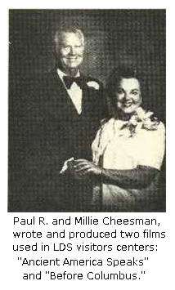

Paul Robert Cheesman was not just an ordinary Bishop or Navy Chaplin. Cheesman was born in [Brigham City, Utah](http://en.wikipedia.org/wiki/Brigham_City,_Utah) and was a member of [The Church of Jesus Christ of Latter-day Saints](http://en.wikipedia.org/wiki/The_Church_of_Jesus_Christ_of_Latter-day_Saints) (LDS Church). His parents died while he was still young and he oversaw his own education. He received a degree in education from [San Diego State University](http://en.wikipedia.org/wiki/San_Diego_State_University). In California, he was also a public school teacher, and he later worked as a [seminary](http://en.wikipedia.org/wiki/LDS_Seminary) teacher for the LDS Church.[[1]](http://en.wikipedia.org/wiki/Paul_R._Cheesman#cite_note-SMW141-1) During the Korean War, he served as a chaplain in the United States military. In 1944, he married Millie Foster, with whom he had six children.

Cheesman taught in BYU's Department of Religious Education from 1963 to 1986. He received his master's degree in 1965 and doctorate in 1967, both in Religious Education at BYU. For a time, he served as director of scripture studies and director of [Book of Mormon](http://en.wikipedia.org/wiki/Book_of_Mormon) studies in BYU's [Religious Studies Center](http://en.wikipedia.org/wiki/Religious_Studies_Center). Cheesman was known for research of correlations between the Book of Mormon and pre-Columbian American discoveries.

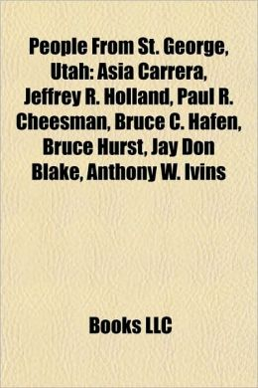

Cheesman served in various callings in the LDS Church. He served as a [Bishop](http://en.wikipedia.org/wiki/Bishop_%28LDS_Church%29), [District president](http://en.wikipedia.org/wiki/District_president), twice as [Stake president](http://en.wikipedia.org/wiki/Stake_president), and as [president](http://en.wikipedia.org/wiki/Mission_president) of the [Louisiana](http://en.wikipedia.org/wiki/Louisiana) [Baton Rouge](http://en.wikipedia.org/wiki/Baton_Rouge) [Mission](http://en.wikipedia.org/wiki/Mission_%28LDS_Church%29) from 1980 to 1983. After retiring from BYU, he was director of the church's New York Visitors Center. In New York, Cheesman suffered a massive heart attack and returned to Utah for surgery, when he died in 1991.

We maintained contact with Paul and his wife, Millie over the years and visited at their home in St. George a number of times. They lived less that two blocks from where we live at time of this writing.

Cheesman was heavily involved in [Central America](http://en.wikipedia.org/wiki/Central_America), where he developed a collection and strong interest in pre-Columbian archaeology.

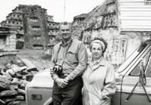Paul wrote over 20 books, many Illustration manuals and Paul Cheesman’s legacy remains not only in his family, but also in his publications and contributions to the academic fields he loved. Cheesman’s life was a constant quest for truth. This journey took him through various research related experiences that allowed him to use both his temporal and spiritual knowledge. As a devout Latter-day Saint, the spiritual side of Dr. Cheesman consistently remained in the forefront of his work. The temporal evidence supplied by archaeological records complimented his religious convictions. By popularizing the study of scriptural archaeology, Cheesman’s work opened the doors for a number of foundations and organizations to maintain the groundwork he laboriously laid throughout his scholarly life. He will forever be remembered as an early pioneer and “popularizer” of Book of Mormon archaeology, a scholar, teacher and true missionary of the Lord. His collection of writings is stored in the Harold B. Lee Library.

|  |  |  |  |  |  |  |
| --- | --- | --- | --- | --- | --- | --- |
| H:\$-@@@RUSS BATEMAN pictures MASTER folder\209-LDS\Chessman folder\51Ib57q-pML._AA160_.jpg | H:\$-@@@RUSS BATEMAN pictures MASTER folder\209-LDS\Chessman folder\51KOpTDpCZL._AA160_.jpg | H:\$-@@@RUSS BATEMAN pictures MASTER folder\209-LDS\Chessman folder\51rQ3u0T5JL._AA160_.jpg | H:\$-@@@RUSS BATEMAN pictures MASTER folder\209-LDS\Chessman folder\410Mae12FhL._AA160_.jpg | H:\$-@@@RUSS BATEMAN pictures MASTER folder\209-LDS\Chessman folder\411XmAxDuPL._AA160_.jpg | H:\$-@@@RUSS BATEMAN pictures MASTER folder\209-LDS\Chessman folder\515CYECTVQL._AA160_.jpg | H:\$-@@@RUSS BATEMAN pictures MASTER folder\209-LDS\Chessman folder\5177gFrF81L._AA160_.jpg |

I have a great appreciation for Paul Robert Cheesman for what he did for me.

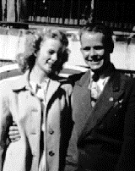I was going steady Virginia Headlund, a very beautiful Blonde. We never talked about engagement or marriage or anything of a serious nature. I knew that I would transfer overseas. She was a special friend and very active in the Church, She went on to marry David Martin, who later became owner of Martin door and a Stake President.

My overseas duty station was Adak Alaska which was located in the Aleutian Islands. After arriving I could only find about eight members of the church there were stationed on Adak Island. Out of the eight members of the church that I could find I was the only one there that had been ordained an elder the others were priests. I wrote to the to the church military LDS serviceman coordinator’s office and they send me material and assign me as official LDS group leader for the island of Adak.

It is very difficult on Adak to organize a regular meeting schedule due to the limited transportation available from the various Navy facilities on Adak. We were able to get the group together occasionally to hold a meeting. I was the assigned as the group serviceman’s coordinator for the two years that I was on Adak that I didn’t feel very comfortable due to the remote assignments of the personnel on the island.

As an example I was stationed at the Great Sitkin Navy base (see my Adak History, Chapter 7) an island about 20 miles by sea from Adak and one time another time I was assigned at Radio City which is on the other side of the island and made it very difficult to try to commutes to the main base. I was not comfortable with trying to be the LDS Servicemen’s Group leader when I was limited in my ability to set up meetings. By time I spent my six months at radio city the group, was disbanded and we lost track of each other.

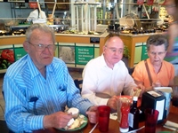One of those members was Jim Benson, from Parowan Utah and Albert Halliday another. We did remain friends for many years and got together once in a while with several other friends that we served in the military with. In May 2015 there were only three of us left. We held our 66 year reunion, 66 years since we served in Adak during the Korean War. Jim Holland was very active in the Shriners Hospital for Children, a network of 22 medical facilities across North America and an Amateur Radio W6UDE, who took over the Adak Amateur Radio Station in Adak after I left. He was not LDS, but fit into our group and put up with us. Jim drove to St. George from Phelan, California and Albert and his wife drove down from Salt Lake City. The others were to ill or had past away.

I was given 30 days leave, When I arrived back in the lower 48. I went to the St. George temple for my own endowments

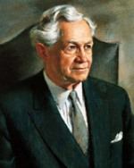

After leaving Adak I guess I was still as an a LDS military group leader but had no opportunity to function in that capacity while attending school at Cheltenham, Md., was only a few miles out of Washington DC. Washington DC was a great place to be active in the LDS church. One of my greatest experiences was when I arrived at the Washington DC 16th St., Chapel (sometimes called “The Washington Chapel”), about an hour early due to available transportation. I was in uniform and waiting in the entryway to the chapel before the meeting started. I was startled to see several other men that had arrived early and one of the men came over to talk to me. I recognized him immediately as being Pres. David O McKay. We chatted for somewhere between 20 minutes to 30 minutes with no one else involved in the chat. This was a very special experience that I have always remembered.

*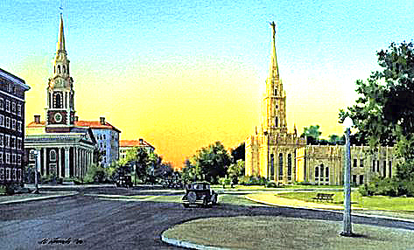*[The Washington, D.C. Chapel](http://www.keepapitchinin.org/2012/09/26/guest-post-the-washington-d-c-chapel/): Sometimes called the Washington Ward, *of one of the most interesting buildings in 20th century Mormondom.*

Amidst opposition from Protestant ministers, the land for the Washington Chapel was purchased from Mrs. John B. Henderson and the deed was sold to President Heber J. Grant (as trustee for the church) on April 9, 1924.

Building commenced in 1931 under the direction of two Mormon architects: Don Carlos Young, a grandson of Brigham Young, and Norwegian immigrant Ramm Hansen. The construction strongly echoes the design of the temple at Salt Lake City with a single spire terminating in a ball on which stood the figure of the angel Moroni. The ten foot tall Moroni, fashioned by Torlief Knaphus, and covered in gold leaf, was a replica of the angel atop the Salt Lake City temple – making it the only chapel in the Church ever to have a statue of the Angel Moroni on top.

President of the Washington Branch at that time was Edgar B. Brossard, a member of the U. S. Tariff Commission. Music was under the direction of Edward P. Kimball, senior organist of the Salt Lake City Tabernacle, who had been sent to Washington to become organist of the new chapel. Until his untimely death in 1937, Kimball gave free organ recitals in the church six nights a week, a custom continued by his successors, one of whom was Alexander Schreiner, until 1949.

In 1940, the branch became the Washington Ward. During World War II, the church sponsored Saturday night dances in the cultural hall. It was still the case when I was there in 1951 where our LDS group attended the weekly dances.

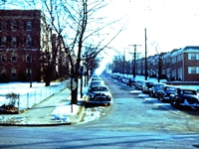About the first Sunday that I came in to attend church at the 16th Street, Chapel (as it was called then)and met several other members most of been somewhat older than I. I was invited to spend my weekends with them in various church activities. They lived in a large four-story apartment that was called the Sheridan an embassy. That was because it was located on Sheridan Avenue.

There were about 16 male members living in that facility and they had a couple of extra empty bedrooms and invited me to stay there on weekends. The house mother as he is called was J Moyle Anderson. He made the assignments as to who fix the males wash the dishes clean house etc. and also the room assignments is to that in which bedroom. Most of these male members were employed in the Washington D. C. Area. J Moyle Anderson was a Department of Agriculture employee. Some others work for the FBI, CIA and other government agencies. They were all between the ages of 20 and 31 years old.

It was a special opportunity to be a member of the 16th Street active LDS group. This group including female members were very active in the church but was busy with their occupations in the average marrying age was over the age of 30.

It was neat to be there at the Christmas season and our group of about 30 members sang Christmas Carol in 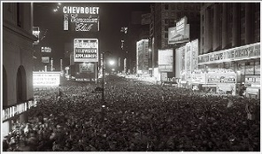various areas of Washington DC. I was invited to make the annual trek to New York for the big New Year’s Eve celebration at times square. There was a group of LDS girls that had two large apartments in the New York area. Our group of guys from the Sheridan Embassy in Washington DC would drive up to New York City parking the car on the outskirts of town then taken the railway or buses into where the girls had their two apartments near the middle of New York. The girls would leave the upper apartment for us to use and they would all get together in the lower apartment. These apartments are located in the Times Square area so as a group we would go out for the big celebration at times square.

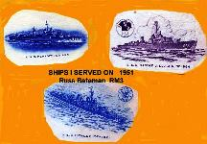I was assigned to the U. S. Navy Department, London, England and served on three Destroyers in the European area. I could not find another member on any of those three ships that I served on.

When I arrived in London I had a two week layover waiting for my ship to reach the British Isles. I was able to work with the missionaries and accompany them on some of their visits. I enjoyed spending time at Hyde Park with the 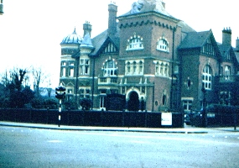missionaries we stand on the box and prostrate to those passing in the park.

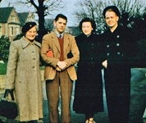 I met Margaret Singer, a member of the local ward in London. I also spent time with her mother and her brother learning a little more about London. Her mother had been waiting months for some surgery which was required for her to regain her health and was bedridden most of the time. She was a member of the British health system and had waited months to get this medical health.

**LDS Mission Home –London-England**

Margaret would always get on the “tube” to return home after church and church activities. I offered several times to company her and she was very reluctant and accepting the offer. However one time she agreed and we got on the tube. The tube is British Underground Railroad and we left to her apartment arriving about 9 PM. We had hardly got there when she started encouraging me to start heading back to my hotel which is located near marble arch in Down Town London. I felt she was just trying to get rid of me. However I found out why she was so concerned about me getting on my way. I had to transfer two different train routes. When I arrived at my first point of changing trains there was a conductor waving to me to hurry to get on the train. When I arrived at the next transfer point the agent told me “sorry Laddy, there is no more trains tonight”. As I left the underground train station they close metal gate behind me arriving upon the main level thought I would look for a bus or taxi to get me back to my Hotel-Park House. It was nearing 11 PM London time and the streets were empty I couldn’t see any buses or taxis available. So using a map that I had I started walking through the dim lighted streets on the way get to my hotel. Her concerns were real and I had no idea that London would close up at 11 PM. It took two or three hours for me to walk the distance to get back to my hotel.

I was in downtown London at the time the British government permitted additional lights to be turned on other than the dimly lighted streetlights. There were a lot of excitement for this event but when they turned them on. I could hardly see a neon light or any other type of advertisement. I realized that the citizens and not seen lights for the previous 10 or 12 years due to the blackouts.

I was able to attend the Golden green ball in London at that time. And then probably due to divine intervention this ship that I was assigned to, arrived at Glasgow Scotland so that I could attend the golden green ball in Glasgow and then again the Ellison DD864 pulled into Hull, England and I was able to attend of that Golden Green Ball.

|  |  |  |
| --- | --- | --- |
|  |  |  |

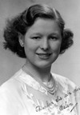At the Golden Green Ball in Glasgow, I met Helen Eleanor Junor. She was a member of the very dedicated LDS family. I took several days leave and came back to Glasgow to see Helen, work on the refurbishment of the Glasgow Mission Office and attend Area Conference. I slept in the same bed that George Albert Smith slept in several months before when he was visiting Glasgow.

It was interesting the different dialect in just a small area of that mission. Helen could identify just where people are from by listening to their accent. Helen was a very special, talented Girl. She had her papers filed to immigrate to the United States, sponsored by her Aunt in Salt Lake City.

I wanted her to be a special friend as Margaret in London was a special friend. Helen lived a very sheltered life, she had never had a boyfriend they were very few LDS boys in England or Scotland. And I’m afraid that she read too much into our friendship as we never talked about engagement or marriage. I really feel bad about the possible hurt that I may have caused her. I was only able to see her once after she moved to the United States. My Navy obligations limited by access to Salt Lake. Another major restriction was that I was in naval intelligence and we were not permitted to marry a noncitizen

England and Scotland were only place I could really run onto members of the church. In Bergen Norway, I found the Chapel in downtown Bergen’s but when I got there the doors are open but there was nobody there. The Chapel and offices were located above a store. The facilities appeared to have no classrooms so I was curious high they would run the church program with only a cultural and a couple of other rooms.

When I couldn’t find any church activity or members I would look for him to radio operators and I did find a few of those in various countries’

I was in Portland England’s when my replacement came aboard. I left the ship as soon as I could and returned by railroad to London and reported into the Navy Department’s. I didn’t even get a chance to stay overnight or visit any of the friends I’ve made before I caught a flight returning to the United States.

For the next two months I was stationed at the naval security station in downtown Washington DC. I had picked up the new 1951 DeSoto so I had plenty of transportation and got a chance to get back into the LDS community’s. (See Chapter 16)

Because of what they called a hardship duty been on the ship I was asked my choice of duty stations that I’d like to transferred to. Because of the really great time I had with the church group in the San Diego area, I requested to be signed to the naval security station at Imperial Beach California which was just south the San Diego.

I attended church in Chula Vista, and I was asked if I would come early to where they held church and help clean up their beer bottles and other stuff from the night before. The Ward rented space to hold their meetings in what was kind of a pool hall environment.

I don’t remember why I attended Ward just north of Chula Vista and that was the National City Ward. I seem to really fit in and really liked the Bishop Vincent’s Willardson. I really felt like I fit in there and enjoyed attending meetings. Most every Sunday I was invited to attend dinner at the bishop’s home along with several other servicemen.

I love to go to the dances in the LDS activities in the San Diego area. It was a little difficult getting a date with the LDS girls, partly because I was in the military. Some of my friends encourage me to run to be elected the M-men & Gleaner San Diego area president. I can’t 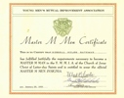remember the name of my campaign manager but she was a good friend’s and gave me some good guidance for the campaign. At the meeting where they elected the next years president and M-men and the Gleaner represent, my campaign manager wrote up a few suggestions that I should say when I gave the speech before the group and after my speech I went over to the table and sat down and there’s something about getting ready to go to work. The gimmick I had was some kind of a pencil that held water and we put some dry ice in this pencil and it was smoked and I guess I was quite impressive but some way I was elected president for the coming year.

A friend of mine, Dean Stokes was elected M-men Representative and a girl that I didn’t know was elected Gleaner Representative.

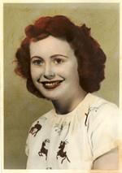My bishop, Vincent Willardson, called me into his Office. He told me that I was at an age that I should be planning to be married. My failed engagement six years previous was noted as the reason I still wasn’t interested in marriage. I total him I was having too much fun to be married and I wasn’t in any hurry to marry and hadn’t found the girl that I wanted to marry. He asked me what I wanted in a girl that I would marry. I answered that I wanted a girl from a small town with a strong pioneer background that was beautiful, highly intelligent, talent, and would make a good mother.

He kinda indicated with a question whether I had the qualifications for such a girl. He challenged me to earnestly pray for a girl that would be a good wife. And I followed and did a lot of praying was suggested by my bishop.

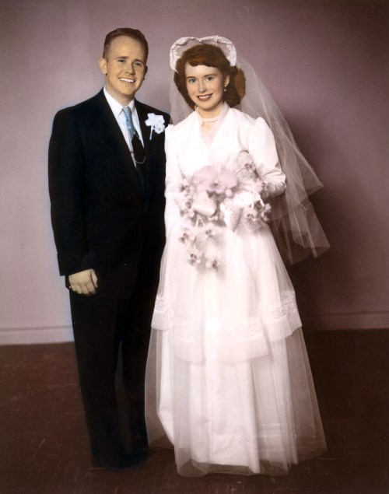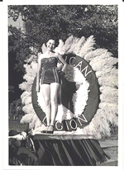A short time later, I was up visiting my Mother and there she was. Everything that I had ask for packaged in to a bright red headed girl. She sang at some kind of a talent program. This was too good to be true but the Lord blessed me.

About a year later, just before I was discharged, we were married on 20 March 1954 in the Saint George Temple.

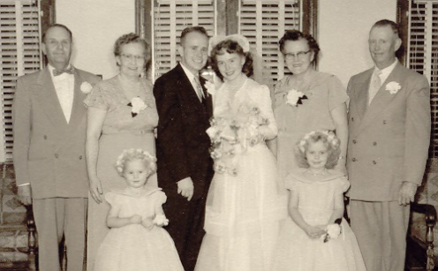

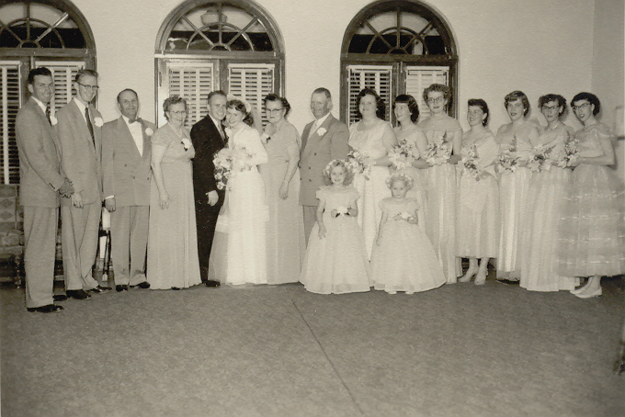

The reception line-left to right:

My High school best friend Karl Barton, best Friend from San Diego- Lloyd Ellsworth, My parents Alfred and Idella Bateman, Russ & Gaye (Myrna Gaye Barton)Bateman, Gaye’s Parents Alice & Ross Barton, Gayes Sister MarGenne (Barton) Rowley, Carol Jean Stocks(Lundberg),Rita Rae Haywood (Webb),Betty Seegmiller, Carol Terry (Formaster), Shirley Larkin (Schmutz) Jeanenne Cox (Jones). In the front are Rebeca and LuWen Kenworthy my Sister’s Daughters.

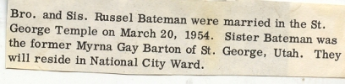

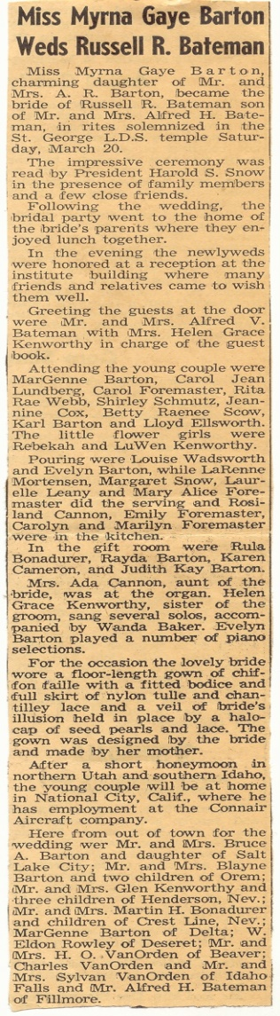 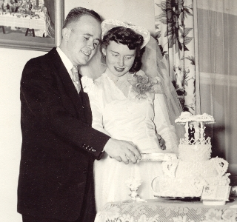



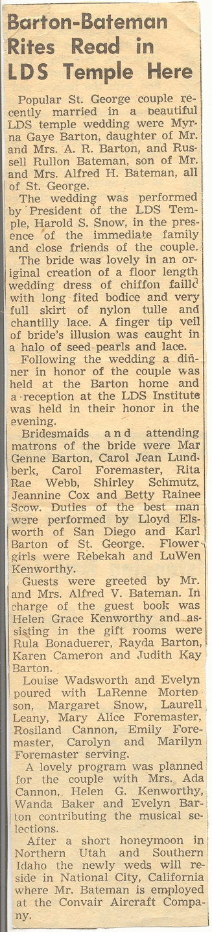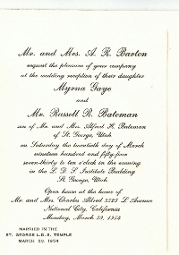

Wedding Shivery Down Town San Diego

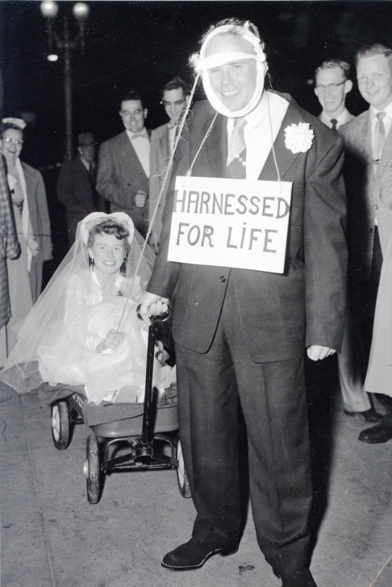

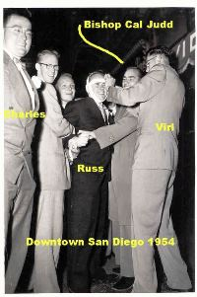

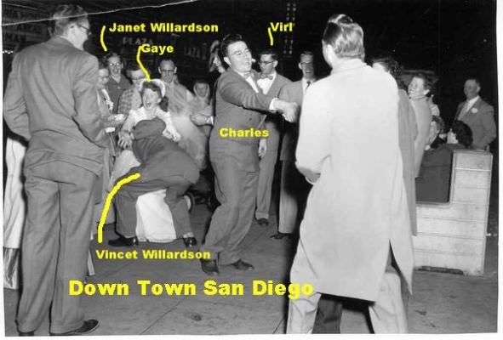

Our“Honeymoon” was traveling up north this scene family and temples as we travel to Salt Lake Logan and up to Idaho Falls Temple. In Logan my uncle Merlin Van Orden who is in a supervisory position took us on a tour through the complete Logan Temple.

The memberships were in the national city Ward but we had rented a small very small house in National City. My church calling was teaching teenage members and we had such limited classroom space that sometimes we had to teach the class sitting out in a car or on the lawn. Shortly after we remodeled the Chapel and in this is something done by the members and I spent a lot of time in construction the additional class rooms

We purchase the Delmar Mesa Ranch which is located south east of Delmar about 4 ½ miles from the ocean. My calling was clerk that time at the San Dieguito Branch. TheSan Dieguito Branch covered how large area starting a tour that the San Diego Temple is presently located running North to The Marine Corps Base, Camp Pendleton and West to Escondido.

We purchased a new home in the Claremont area of San Diego and most my church callings of the time was in a program called the Adult Aaronic Priesthood program. This program was finding in active members and work with them to get them active in the church again. This program was very successful as we activated many members of the church back into activity.

I was also active on the construction of two word chapels back of the time where members built their Ward chapels.

When we moved back to St. George I was called the as a home teacher supervisor in the southeast part of St. George.

I don’t remember that I had a church assignment other than home teacher when we lived in Littleton Colorado, we lived a long distance away from the closest Chapel and I know it was somewhat over an hour drive to that location.

My assignments while living in Salt Lake, Rose Park area and then bountiful was working with the youth. I was called to be the priesthood advisor of the boys in the teachers Quorum. They were having a hard time finding an interest for these boys to keep them active in the church. As an activity for these boys I started to give them training classes to pass their amateur radio license. They all passed the FCC requirements for a general class amateur radio license and we got them active in various amateur radio activities one of the majors activities was putting together the state of Utah emergency operating communication center which is located in the basement of the ejecting all National Guard Armory in Salt Lake.

All the eight boys receive their individual awards and went on to be very productive citizens. Several went on to get their FCC commercial licenses and remained active in the communication field. One of them enlisted in the military in the communication field. (See chapter 16)

I was a member in the Air National Guard when 130th insulation squadron and was the squadrons LDS group leader. Our National Guard drilled two days a month and was part of the Salt Lake international guard unit which had facilities of the Salt Lake city airport. For number years I would conduct a meeting before normal working hours at the National Guard base. The base chaplain required me to be reset apart for this assignment via I Councilman from the stake that this facility was located.

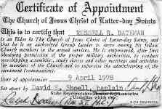

When I was transferred to the Richfield area, we were a member of the Monroe Fourth Ward. I was still serving in the Air National Guard unit and conducting meetings as a LDS group leader for our squadron

We were members of the Monroe 4th Ward. I was called to serve as a high councleman in the Monroe Utah Stake under President Hi Ipson. I was assigned to the Joseph Ward. Our stake had an Stake center located in Monroe Utah. It was an older building the considerably better than any of the chapels in the Monroe stake. All the other buildings in the Monroe stake area where old structures with a limited classroom capabilities.

The church identified these buildings as in adequate for the existing church program and that they all needed to be replaced. However these are specified to combined wards into one building and this created some major problems with 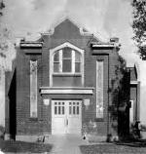many of the old-time members. Some of the members and Joseph Ward said they would refuse to drive to the new Chapel to be located in a community near them called Elsinore. Some older members wrote letters to the President of the church threating to leave the church and offering to purchase the old chapel. I don’t know of any Joseph Ward members that did leave the church. It took a while but the members of the Joseph Ward were successfully relocated to share the new Chapel that was located in Elsinore.

At the time I served as a high Councilman in the Monroe Stake, we would have Sunday school and priesthood in the morning and return in the afternoon for sacrament meeting. The church guidance was that the sacrament meeting should last one and a half hours. I remember one Sunday when I was the high Council speaker in the Annabella Ward, the meeting was scheduled to start at 4 PM and it 10 minutes after 4 pm, sacrament had been passed and everything was completed and the time was turned over to me to speak. To meet the guidance I would’ve had a spoke for one hour and 20 minutes. We had a very short meeting that Sunday.

I only served in the high Council for 3 ½ years and was released when the new stake President Woodbury replaced Pres. Ipsen. This was due to my requirement of being in Salt Lake for my employment with Bonneville international and my obligation to spend one Sunday at the air National Guard per month.

In 1996 our RV Club was ask to participate in the Utah Centennial Wagon Train, celebrating the celebration of Utah’s 100 statehood birthday and the Saints wagon trains that settled Utah. The wagon train started in (Logan) Cash County Utah would travel to Iron County (Cedar City). I thought I could be of help in organizing my experience. My assignment was to be a Water Boy. I was assigned Cove Fort to Cedar City. We drove to Cove Fort to be there when the Wagon Train arrived.

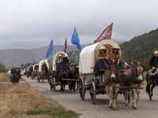A state of Utah truck pulling a large National Guard water trailer was turned over to me. It was my assignment to drive to designated locations where the wagon trains would stop. I need to arrive in time to set out the watering troughs for the horses and fill them with water. My wife, Gaye would follow me driving our station wagon which we lived in while supported the wagon train for several days until we reach Cedar city.

St George East Stake President Randy Wilkinson called me to work under High Councilman Dan McArchur. Dan was the current mayor of St. George and I was ask to help him some of his assignments. The main project was to create The East Stake Emergency Preparedness plan as directed by President Ear l C. Tingey, Utah South Area Presidency. Later In preparing this plan, I was working with Dale Larkin, Second Councilor in the Stake Presidency, In developing this plan, We did several studies developing the plan So that we knew the needs of the members.

President Larkin requested that I develop a Manual to be used by the Stake. I was given the Title of St. George East Stake Emergency Service Director, an assignment that I held for several years. I was also assigned to work under High Councilman Jim Ward.

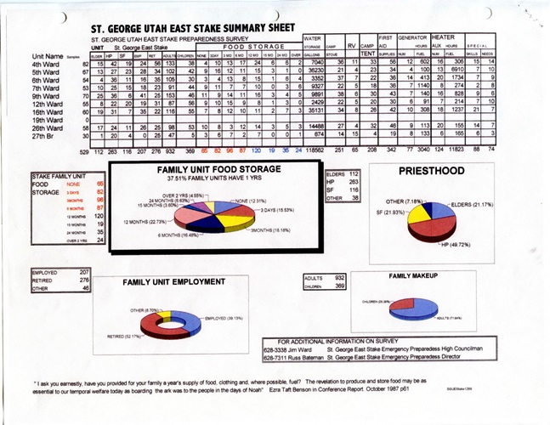

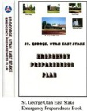

We had our own “EBS” radio station K232CY 94.3 FM and our own Amateur Radio repeater-K7SG 145.49 located on Scrub Peak South West of St. George. I owned these facilities and could dedicate them to the East Stake emergency Service plan.

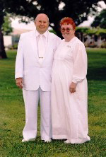In 1994 wife gave was working at the Temple typing names and is that was being phased out, she became a guide. When I retired from Bonneville international, I started doing some shifts as a guide to fit the same schedule that she had. It wasn’t long before were recruited as temple ordinance workers working two shifts a week. I was very reluctant in this assignment because I had such a difficult time memorizing and to be a temple ordinance worker there’s a lot of memorizing required. When I was set apart I was given the blessing that I would be able to do this memorization that would be required. And the blessing worked as able to in short time memorize all the

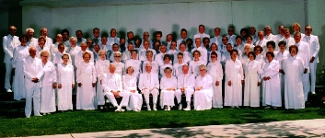Information that I needed to. I served in about every position that ordinance workers accomplished. I also served as assistant supervisor prepared to time.

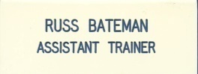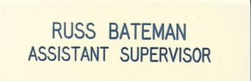

As we completed our four years we were set to go on a full-time mission at the Temple visitor center. I was offered the full supervisors position which is a year assignment but we had already agreed to serve the mission of the Temple is center but we had committed to serve at the Temple Visitors’ Center.

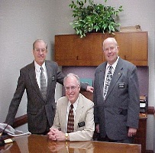

My wife and I, started work at the visitor center under elder Thomas. He was replaced by elder William Critchlow III. I served as an Assistant to the Elder Critchlow for over seven months which gave us some additional experiences. This mission gave a lot of varied experiences and opportunities. It was really neat to study each of the Historic Sites and learn the history behind them. Our study gave us the opportunity of traveling to many of the locations where there were special things that happened in the building of Southern Utah. We could feel the Joys, hardship and dedication that those pioneers experienced in those early days.

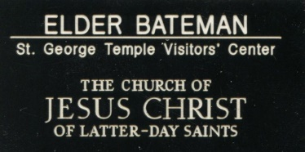It was special to work with those exceptional missionary couples and feel of their sprit. They have taught us so much. They are such dedicated, loving and willing to be giving of their time to the Lord. It will take us some time to get used to not running to a schedule to see where we will be today and who we get to serve with. We serviced under two great director couples. Our farewell party was attended with all the Senior 54 Missionaries now serving here on the Mission. They had many good things to say that we’re sure far exceeded what we have done. What we have accomplished we are grateful to our Heavenly Father for the opportunity and his trust in us. My wife Gaye and I have felt of his love all the way, and are so thankful for having served.

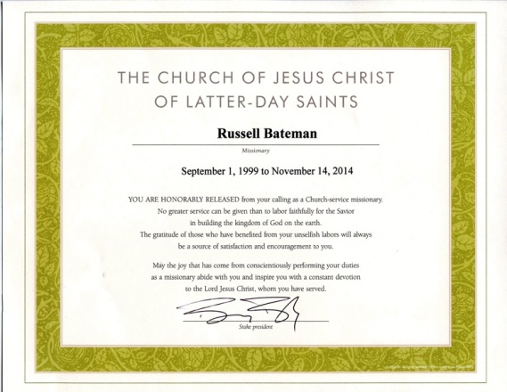We completed our 15 month mission and were released. Shortly after being released, I was called by elder Critchlow to meet with him. He told me that Salt Lake advised him that we needed a website. He extended a call to me to be the webmaster as a service missionary. I told him that I knew nothing about coding websites. He put his hand on my shoulder and says that you’re new calling. Again because of the blessing I received that I could do that assignment I was able to in a short-term learn the coding of the websites. Not long after that I was also assigned as a service missionary to do the co-forte website concurrently with my existing assignment. And then later I was called to do the St. George family history website also can concurrently. In the Temple visitor website and Cove Fort website I served as a service as a service missionary until 14th of November 2014.

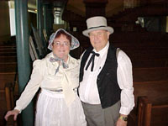A St. George City program to publicize the historic sites in St. George. This program is supported LDS members role-play in various parts of early pioneers in the various historic sites such as the tabernacle and the Brigham Young home. My assignment was role-playing for Erastus Snow as shown in the picture of my wife and I in the St. George tabernacle. We participated in this program for several years and one year I was the day captain for Erastus Snow part of historic St. George life.

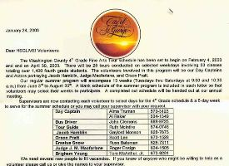

**Senior sampler**

St.George Cedar in Mesquite Friday, July 3, 2009 by him 21 issue 27

**SUP Holds Dinner Meeting** by Charles Summerhays.

Russ Bateman was presented with modern Pioneer Awards

*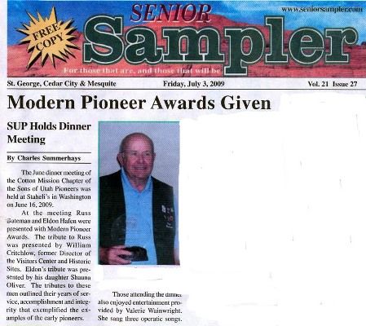The June meeting at the Cotton Mission Chapter of the sons of Utah Pioneers was held at Staheli’s in Washington on June 16, 2009.*

*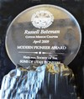At the meeting Russ Bateman was presented with modern-day pioneer awards. The tribute to Russ was presented by William Critchlow, the former director of the Temple Vista centers and historic sites mission. Attributes Russ outlined his years of service, accomplishment and integrity that amplified examples of the early pioneers.*

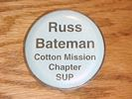My Brother recruited us into the cotton mission chapter of the sons of Utah Pioneers shortly after we moved back to St. George. We were both active many years in the chapter. I have served on the board for over 14 years and presently I am that time the technical director for the chapter. This is an organization that my wife can participate with me and we have traveled on many treks with the chapter. One time we traveled back east for one of the national encampments and with the Critchlowes, toured and many of the history sites throughout the Eastern states.

**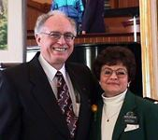**

In 2011 I was called to be the Ward clerk and served in that position for two years. Due to my hearing abilities and not able to understand what was said in meetings to take notes I was changed to be an assistant clerk assigned the Ward history. I was released that assignments in February 2015.

At age 85, I have been released from all my church assignments except tor Visiting Teaching. I am at the dusk of my life’s work. My wife and I will be burred in the old St. George Cemetery.

